TASKS – group 1a

S01 – The poet's statue in front of the school
[gr.1] CHANGE the name of the poet into numbers:
Change each letter into a number. Calculate the sum of the numbers you've got.

AB = ______ (A = ____ , B = ____ )
Use this »decode table« to change the letters into numbers.
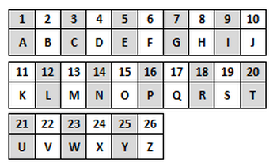

S02 - Monument at the square , next to the pharmacy
[gr.1] Count all the equally big peak-less stone pyramids that surroud the monument. (At the top and at the bottom!)
CD = ______ (C = ____ , D = ____ )

S03 – Steps leading to the »Twan Hall«/ Seat of the Municipality
[gr.1] How many »hills« are there in the municilapity coat-of-arms? E = ______

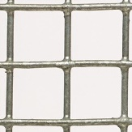
S04 – The castle
[gr.1] How many (same) square iron grid windows has the castle got?

FG = ______ (F = ____ , G = ____ )

Put the numbers for A, B, C, D, E, F, and G into the formula below, so that you can work out the coordinates that will lead you to the »treasure«. Have fun!

TREASURE LOCATION – FINAL COORDINATES
You will find the final coordinates if you work out the formula below:

N45 (A-G)(E).(B+F+G)(E)(E) E013 (F+G)(G).(D-G)(A+C)(C)

TREASURE LOCATION: N45 __ __ . __ __ __ E013 __ __ . __ __ __

Put the coordinates into Google Maps Directions and choose the Walking option.
TASKS – group 2

S01 – The poet's statue in front of the school
[gr.2] CHANGE the surname of the poet into numbers:
Change each letter into a number. Calculate the sum of the numbers you've got.
Use this »decode table« to change the letters into numbers.
AB = ______ (A = ____ , B = ____)

S02 - Monument at the square , next to the pharmacy
[gr.2] How many stone plaques has the monument got? C = ______
[gr.2] How many times does the surname »SIRK«
appear on all the plaques? D = ______

S03 - Steps leading to the »Twan Hall«/ Seat of the Municipality
[gr.2] How many peaks has the »crown« above the municipality's coat-of-arms have?
E = ______

S04 - Castle
[gr.2] How many olive trees are on the North-East side of the castle? F = ______

[gr.2] How many street lights do you see within the castle walls,
in the castle yard (in front of the castle)? G = ______

Put the numbers for A, B, C, D, E, F, and G into the formula below, so that you can work out the coordinates that will lead you to the »treasure«. Have fun!

TREASURE LOCATION – FINAL COORDINATES
You will find the final coordinates if you work out the formula below:

N45 (E)(A+C).(B+C)(D+G)(B+E) E013 (C)(F-E).(E-D)( G-D+C)(D)

TREASURE LOCATION : N45 __ __ . __ __ __ E013 __ __ . __ __ __

Put the coordinates into Google Maps Directions and choose the Walking option.

