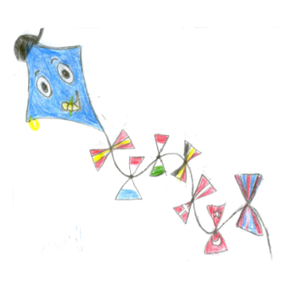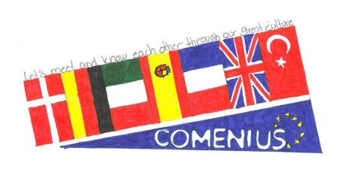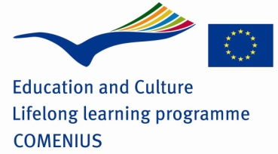

Keywords booklet

about

***friendship and tolerance***

MULTILATERAL COMENIUS PROJECT

“LET’S MEET TO KNOW EACH OTHER THROUGH OUR GREAT CULTURES”

2013 – 2015





**Friendship**

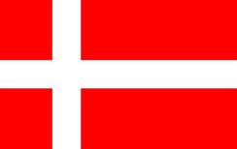

**venskab**

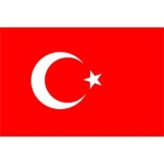

**Arkadaşlık**



**Amicizia**

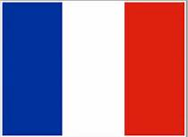

**Amitié**

**Amistad**

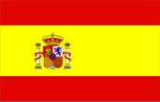

**Freundschaft**

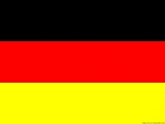





**Hospitality**



**GÆSTFRIHED**



**Misafirperverlik**



**Ospitalità**



**Hospitalité**

**Hospitalidad**



**Hilfsbereitschaft**







**Love**



**KÆRLIGHED**



**Sevgi**



**Amore**



**Amour**

**Amor**



**Liebe**







**Fun**



**sjov**



**Eğlence**



**Divertimento**



**Amusement**

**Diversión**



**Spaβ**



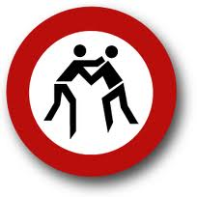



**Don’t fight**

 ingen vold

**Ingen skænderi**



**Kavga etme!**



**Non litigare**



**Ne pas se battre**

**No pelear**



**Nicht streiten**







**Children**



**børn**



**Çocuklar**



**Bambini**



**Enfants**

**Niños y niñas**



**Kinder**



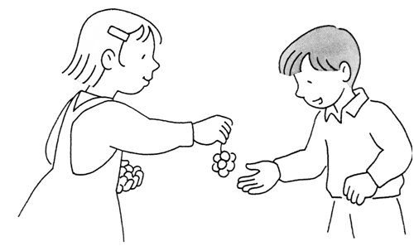



**Share**



**dele**



**Paylaşmak**



**Condividere**



**Partager**

**Compartir**



**teilen**







**Future**



**Fremtid**



**Gelecek**



**Futuro**



**L’avenir**

**Futuro**



**Zukunft**







**Tolerant**



**Tolerent**



**Hoşgörülü**



**Tollerante**



**Tolérant**

**Tolerante**



**tolerant**







**Good luck**



**Held og lykke**



**İyi şanslar**



**Buona fortuna**



**Bonne chance**

**Buena suerte**



**Glűck**

