3 events in 2013- GERMANY

Circus Project in March
All students took part in the circus project for one week. The Circus „Bellissimo“ was our partner.
Following acts we have shown in our 3 evening performances: trapeze act, horse- riding, acrobatics
on a rope, dog and goat training, clowns and juggling.

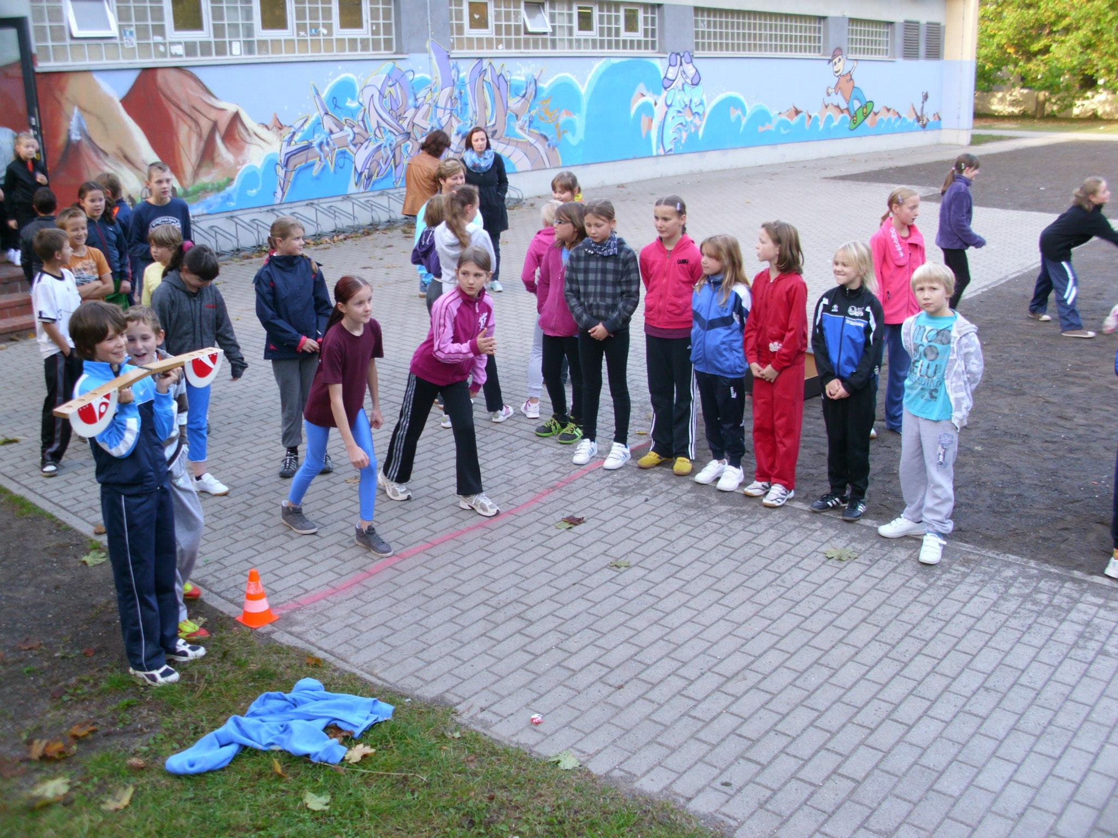

Sponsored Run in June
Every student run rounds as many as possible. Before the have looked for one or more sponsors.
The result of our run was: 4600,- €! It was an really successful day!
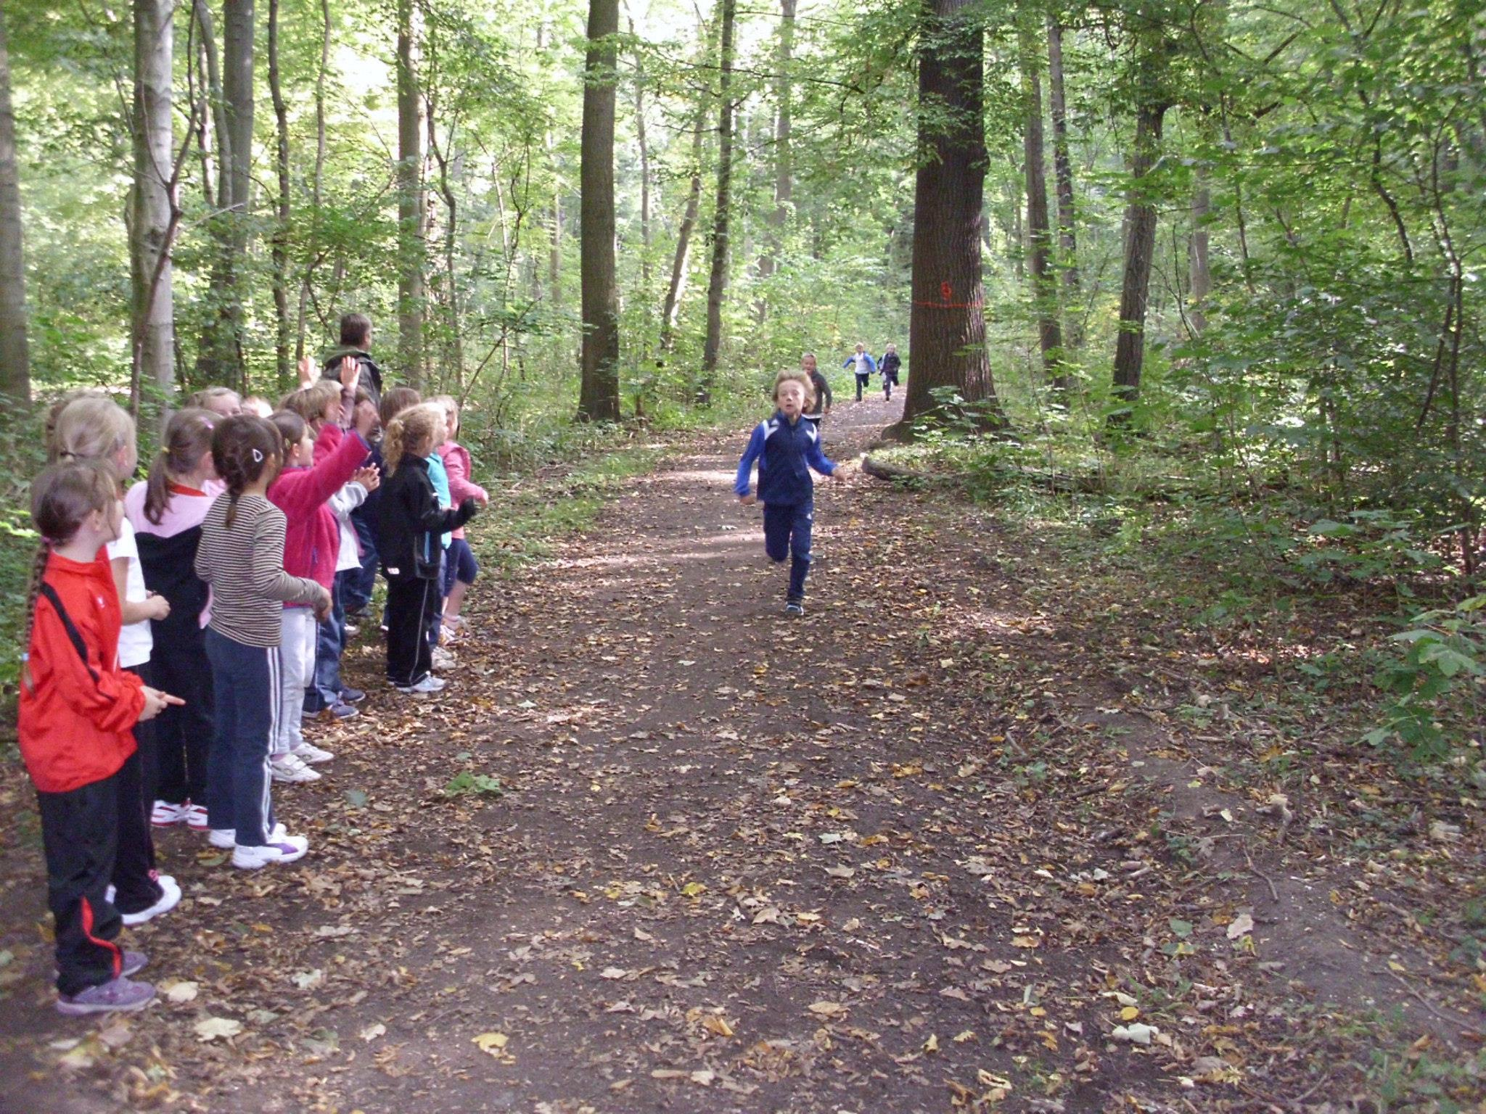

Spanish Cooking in October
After the trip to Spain, Madrid we decided to cook a typical Spanish meal. Our Comenius group
went to the children restaurant in Leipzig. We cooked 5 diffent kind of „Tapas“ there.
