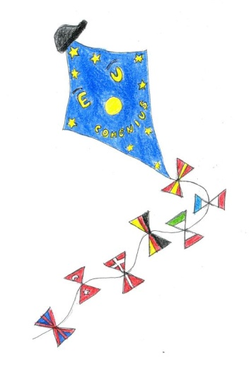
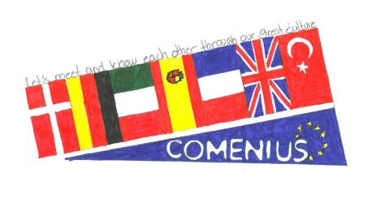
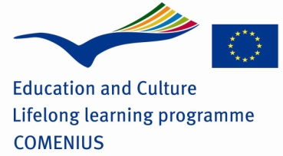

FINAL questionnaire – COMENIUS Project
1. - Who was Comenius?
________________________________________________________________________________________________________________________________________________
2. - How long did the Comenius Project last?
___________________________________________________________
3. -Match the flags and countries:

United Kingdom | 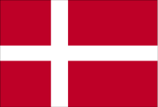
Denmark | 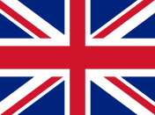
Turkey | 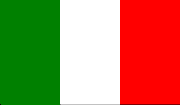
Italy | 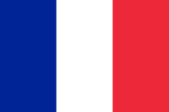
Spain | 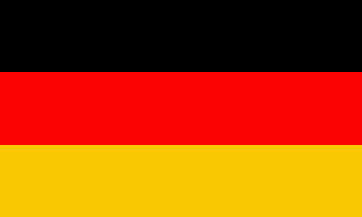
France | 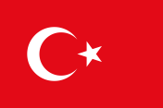
Germany | 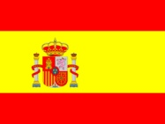
4. - Which activities did you like the most?
______________________________________________________________________________________________________________________
5. - Which words did you learn from the partners' languages?
___________________________________________________________
6. - Which partners’ countries have you visited?
___________________________________________________________
7. - Which partners’ countries would you like to visit?
___________________________________________________________
8. - Now that we have finished the project, Can you name the capitals of these countries?

Turkey: ______________
Denmark:_____________
Spain: _______________
France:_______________
Italy: ________________
United Kingdom: ____________
Germany:______________

9. - What did you learn from this project?
___________________________________________________________
___________________________________________________________
10. - Would you like to participate in another project?
___________________________________________________________

