Ebola in Spain
Ebola arrived in Spain because of the infection of a Spanish priest, who went to help people already infected in Africa. Teresa, a nurse at the hospital “Carlos III” in Alcorcon, was infected by one of her patients, “The priest.” The nurse got infected because of not taking enough precautions. The nurse had a dog, Excalibur that they had to sacrifice. They didn´t test him or know if he had Ebola. Finally, Teresa Romero was hospitalized in high isolation. After some time, Teresa recuperated and went home with her husband. It is the first case of a person infected with Ebola who has survived. It´s a medical success, they are extremely happy to have been able to cure the Ebola disease.

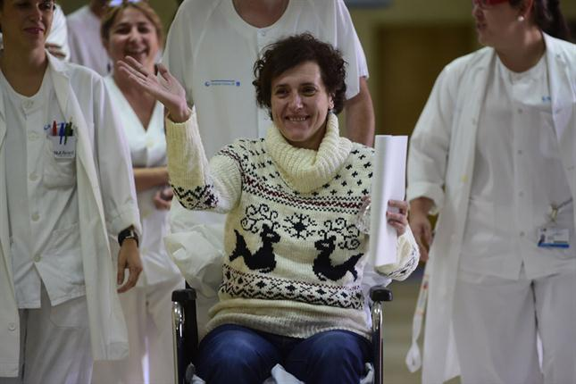

News reported by Alba, Samu, Kelyn, Marina, and Abel

The Formation of the Chorus at the Primary School “La Escuela”

This year at the primary school “La Escuela,” the music teacher, Paloma, has decided to organise a chorus at school where all the students, who want to participate, can go. They rehearse in some alternative playgrounds. They are distinguished for their voices, high-pitched, medium, and deep.
On December 19th 2014, the students will put on a performance in which there will also be dances. It will be carried out during the recess hour, where they will sing songs like the “Bellas Melodías.” All of the school’s students will also go to see it. The songs will be in Spanish, and afterwards, we will all eat the Christmas grapes.

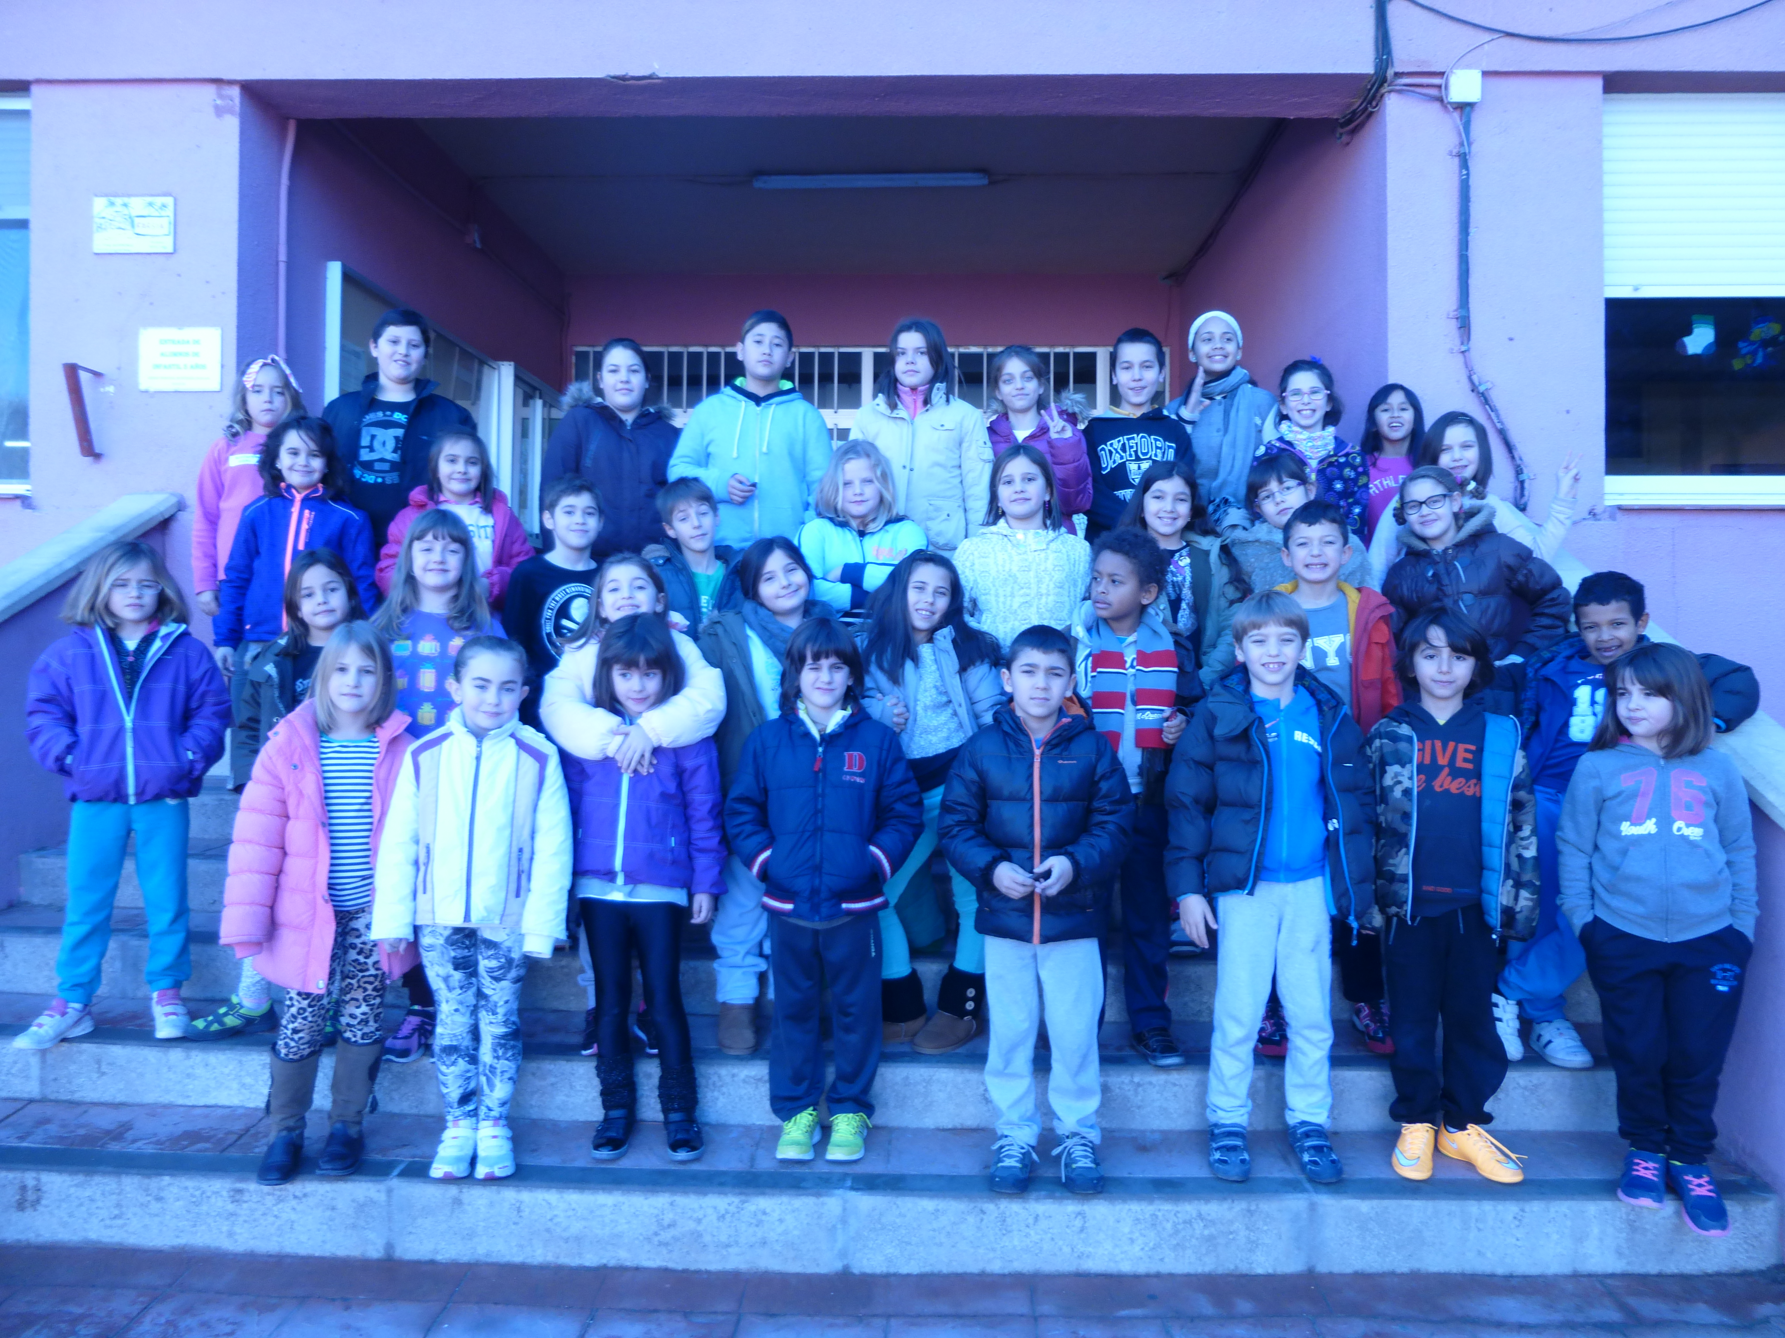

Done by Catalin, Alejandro, Javier, Aroa, Oana, and Guillermo

The Proclamation of King Felipe VI
On June 19th 2014, the prince of Asturias was proclaimed king, following the abdication of King Juan Carlos I. The name, which he will reign under, will be Felipe VI. This event was celebrated in the parliament building with the presence of his wife Letizia, who is the current queen, and their two daughters Leonor and Sofía.
To celebrate, they drove the streets of Madrid in an official car to greet all of the citizens, who were outside of their houses waiting for them.

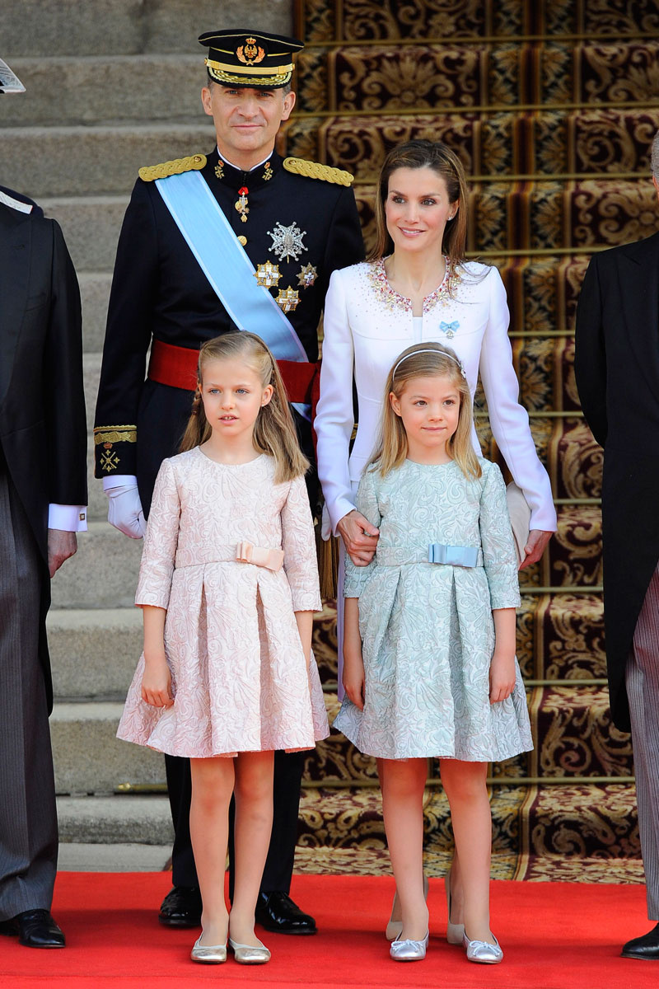
News reported by: Eva, Lucía, Ángel, Bruno, Gabriel, and Daniel

