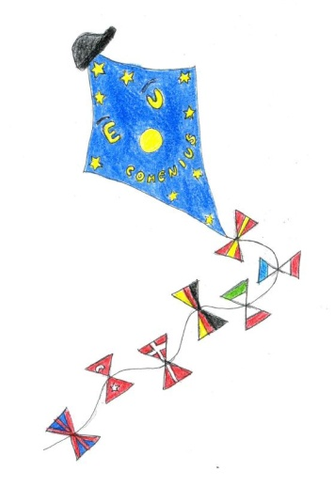
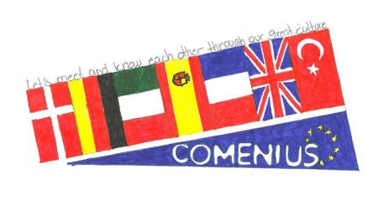
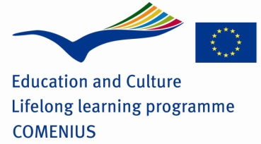

Program of the Comenius meeting in France

Tuesday 4th November
Arrivals in Brignoles
Wednesday 5th November
8:30 – 10:00: School Welcoming
- Traditional songs “A la claire fontaine” and “Cadet Rousselle”
- Presentation of the school’s blog and the Comenius project
- Introducing partners, teachers, and involved partners.
- Speech by the children of the school’ sport club USEP and the Ms Hakenholz’class
- Welcoming German pupils in Denis’class
- Questions about the program and a few words about our Comenius reporters
- Game for knowing each other
10:00 – 10:30 Break
10:30 – 11:30: Visiting of the school and some of the classes
Rolande / Guilaume : 1st grade
Mathlide/ Muriel/ Virginie : 2nd grade
Sophie / Marion / Cécile : 3rd grade
Célia / Ghislaine 4th grade : choir at 11h15
Stéphanie / Denis : 5th grade
A visit of the Kindergarten is also possible
11:30 – 13:30: Spanish inn for lunch in school
13:30 – 15:30: Many kinds of games with the children of the school’ sport club USEP
15:30 – 18h30: Local culture
- Guided tour of the Abbaye de la Celle
- Tour and wine tasting in the “Maison des coteaux varois”
19:00 – 23:00 Common dinner at Christine’s house with a typical Provencal cooking
Thursday 6th November
8:30 – 10:00 Meeting: Friendship story (videos + keywords booklet about friendship and tolerance)
10:00 – 10:30: Break
10:30 – 11:30: Teaching
Luiz : 1st grade / Marta : 2nd grade (Mathilde) / Kristina : 2nd grade (Virginie) / Claudia : 5th grade (Stéphanie)
11:30 – 13:30: Common lunch at the school canteen
13:30 – 16:30: Meeting: “The Europe of our dreams” (Flags, posters, words…)

Friday 7th November
8:30 – 10:00: Meeting: conclusion, certificates…
10:00 – 10:30 Break
10:30 – 11:30: Meeting: Preparation of the next meeting
*Students in each partner school will sing "If you are happy and you know it." in English, in mother tongue and in one partner's language. The performances will be recorded.
* Each partner school will send some information (in English and in mother tongue) and photos about famous people to put in the common calendar for 2015.
* All partners will make postcards about Christmas, New Year and winter customs in English and in mother tongue. They will post them to their partners.
* Each partner school will make a common notice board in their European Comenius Corners called "What happened in our partner schools and countries in 2014?"

11:30 – 23:00: Trip to Marseille (with Christine, Guillaume, Rolande, and Marion and her father in law who will be our guide)
Saturday 8th November
Free day until 19:00 (meeting point in Brignoles)
or
Local culture 10:30 – 12:00
Meeting with the “Chantier”,an international association of traditional and world music in Correns , the first bio village in France. You will meet the famous musician Miquèu Montanaro who created this association.
+ Sightseeing 12:00 -19:00
20:00 – 24:00: Final common dinner in a restaurant at Le Luc en Provence

