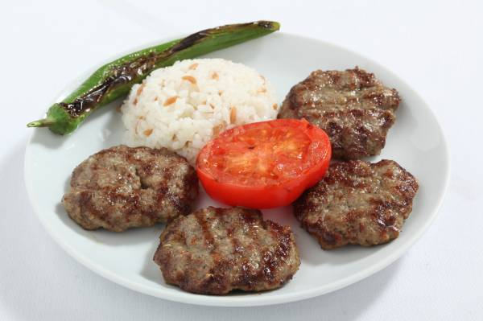

MEATBALLS

Ingredients:

- 500 grams of minced meat
- 2 grated onions
- The inner parts of 4 loaves of stale breads
- 1 egg
- 1 sugar-spoon of salt
- 1 tea-spoon of black pepper
- 1 tea-spoon of cumin

Preparation:

- Mix all the ingredients.
- Give shapes to the meat mixtures.
- Fry the meatballs in a pan, in an oven or on the grill.
- Enjoy your meal

