Uni-man of Atlantis

Creators: Zeynep Köprülü, Berke Apohan, Bora Maraşlı, Caia van Leeuwen, Dylan Hodkinson

Characters:
Narrator
Uni-man (Achilles)
King Basil
People of Atlantis (extras)

SCENE 1

Narrator: Once upon a time in Atlantis mermaids lived ruled by King Basil. He discovered the secret of Achilles, a half-breed merman and unicorn. When you took his special suit away he would turn into a regular mermaid with no unicorn powers. Those powers protected the balance of the universe by keeping the whole Atlantis under the sea. But King Basil wanted to gain all mighty powers and break the balance, so he stole Achilles’ suit and locked him away in the dark, dark depths of the palace knowing that it would cause the city to break in two. Atlantis broke down. One on land, one in the ocean and chaos spread through the universe.

Achilles: You can’t lock me away! You know the damage it’ll do to the city.

King Basil: No one cares about your childish acts to save the city. We shall rise and rule the earth too!

Narrator: The ministry of Atlantis wanted to hide the existence of the half mermaid, half unicorn hero so that he wouldn’t be able to help the city and drag it all under the sea.
Eventually Atlantis turned into a city of crime.

Achilles: I wish I could get out! I hate that king, I hate how greedy he is all the time.

King Basil: I enjoy those painful scream of yours…you’ll never get out, hahahaha

Achilles: You inhuman psychopath how dare you treat our beloved city like this!

Narrator: The next night Achilles had an epiphany while he was dreaming. He saw how he could use his voice to attract people’s attention. He was going to use an old song called Corban. Legend says that if someone sings this song in the right tone this song shall be heard by every Atlantis citizen even if they are far far away. Achilles woke up and knew exactly what to do.

Achilles: I shall sing the song and hope my people will recognize it and come to me!

-starts singing- (the mermaid song from Harry Potter and the goblet of fire will be used)

SCENE 2

King Basil: What is this! I haven’t heard this song so vividly in years… Can it be… No it can’t be
-rushes to the dungeon- (he sees the people and Achilles together, gets confused)

Achilles: I’m looking forward to hearing your painful screams now King Basil…that’s what you get for being greedy! (smirks)
-people of Atlantis grabs kings arms and drags him out of the stage-

Narrator: uni-man proudly puts on his suit and retrieves his duty of protecting Atlantis. Now the people of Atlantis can finally be in peace… When uni-man drowns the city.

Achilles: now I have to gather my powers and save my city from crime and evil.
-tries for a couple of times-

Achilles: Oh no…I’m not strong enough yet
-people of Atlantis realize that he is struggling-

Narrator: People of Atlantis unite to help uni-man drown the city. Everyone starts working together and Atlantis is now emerging deep into the sea.

Achilles: I can’t believe it’s working! Atlantis, we can be successful together! Everyone, push stronger !
-people scream with power and joy, they succeed and everyone congratulates Achilles, and they exit the stage cheerfully-

THE END

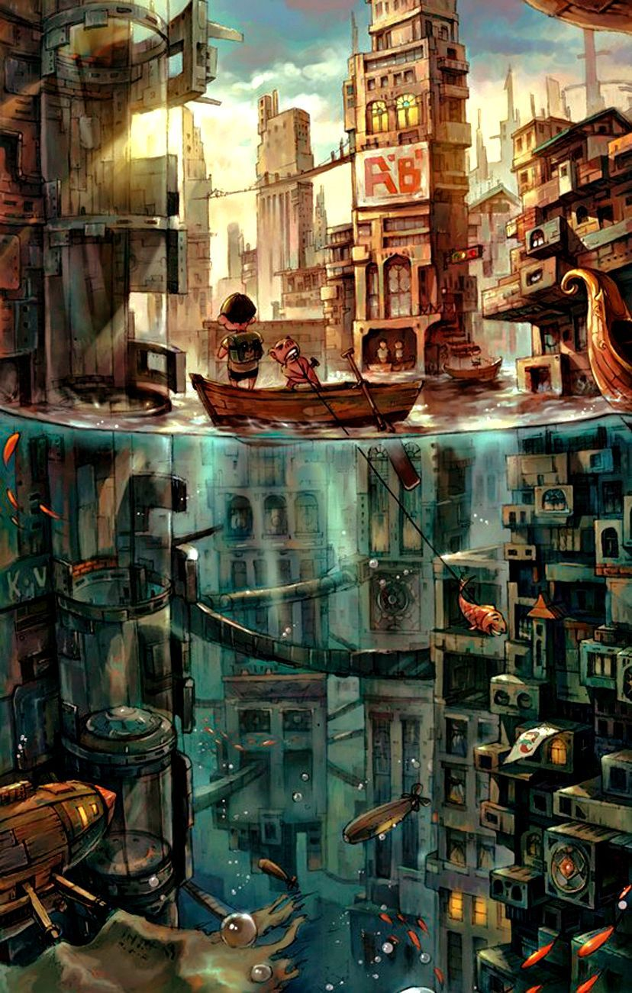
Atlantis after sinking

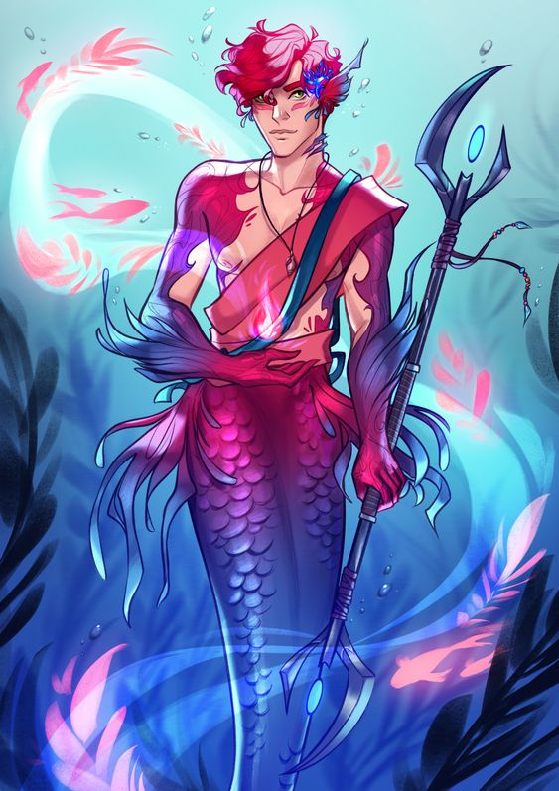
UNI-man (Achilles)

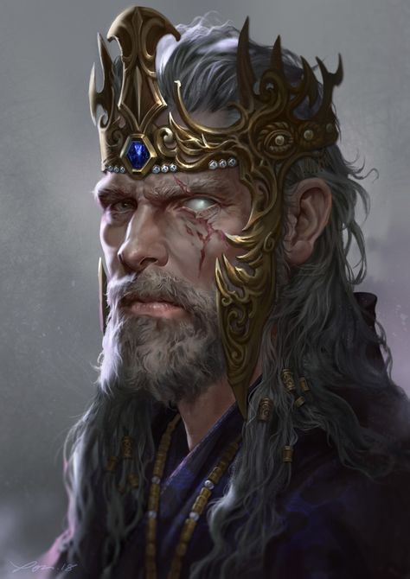
King basil

