Links to WGSB website articles and social media

Erasmus+ Project
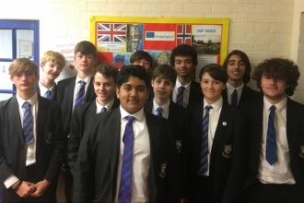
Posted: 10/10/2018
http://www.wirralgrammarboys.com/news/318

Netherlands Visit With Erasmus+
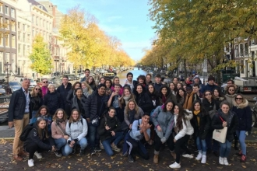
Posted: 04/03/2019
http://www.wirralgrammarboys.com/news/321

Try To Tell A Timeless Tale
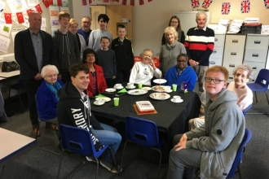
Posted: 05/06/2019
http://www.wirralgrammarboys.com/news/323

Erasmus+ Norway Trip
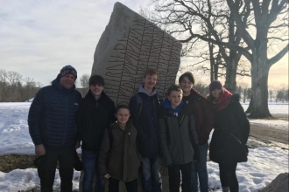
Posted: 20/06/2019
http://www.wirralgrammarboys.com/news/324

