NOVEMBER

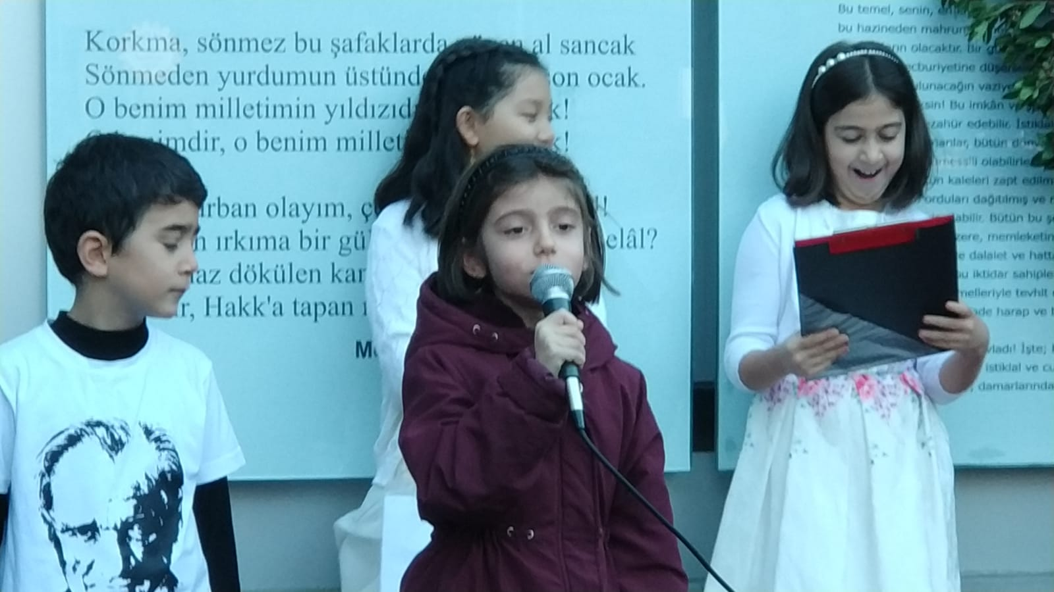
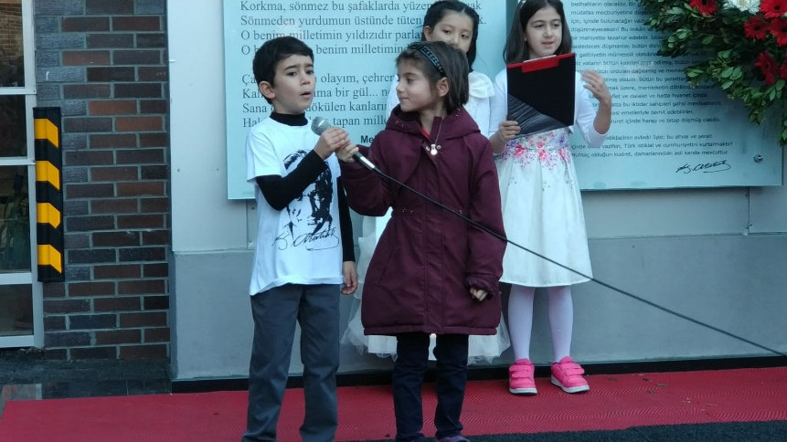

In our school, we commemorated the death of Ataturk on 10 th of November, 2018. 10 th November is the Rememberance Day of Ataturk and is a National mourning on which the death of the founder and the first president of Turkish Republic , Mustafa Kemal Ataturk, is commemorated. On that day, we had a ceremony at school as well as the whole country. The ceremony started at 9.05 which was the hour of Ataturk’s death, with one minute of silence and after sirens throughout the country. After that our students made speeches and read poems. At the end of the ceremony, school chorus sang songs which were about Ataturk’s love and appreciation of Turkish Nation.

