Unemployment in Slovakia

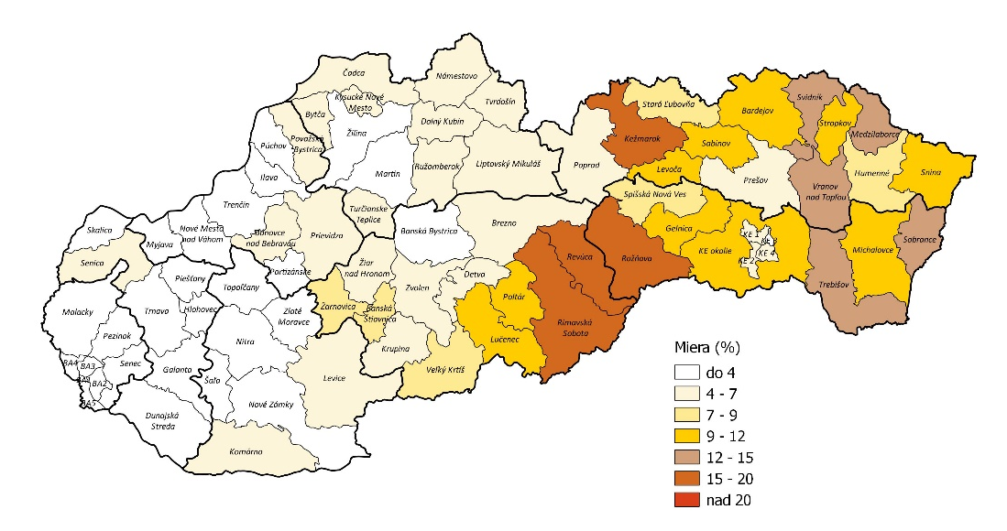
Over the past few years the unemployment rate in Slovakia has been gradually decreasing. Currently it is 4.98% on average, ranging from 2.68% to 8.29% in different parts of the country. We can observe that the lowest values are measured in the west, while the eastern regions are struggling the most. One of the main causes of the rate being so drastically different across Slovakia is its infrastructure. Most of the large and influential cities are located in the west and so are the highways. This helps local people easily find jobs. Compared to that, finding an ideal workplace in the east is much more difficult. Travelling from villages to cities is proven to be very challenging for many people. Other than that, there is education. It can be hard to get proper education for people living in the more remote areas and the same goes for work experience.
The rate of unemployment in Slovakia, 2018

Unemployment rate - women

There is a noticeable difference between the unemployment rate of men and women. The value for women is 5.88%. As previously stated, the rate differs across the country, but in this case it ranges from 3.20% all the way to 9.78%. When employing women, their age, marital status and in some cases even appearance are considered. It’s challenging for everyone to get work experience after graduation, but women even more so.

