May survey
Dear students
As you know, we have an Erasmus + KA229 project (TAB - Together Against Bullying ) and we made a survey in the beginning of our project and got its results. We are in the end of the first project year and want to learn about your ideas about bullying.Here are some questions :
* Gerekli
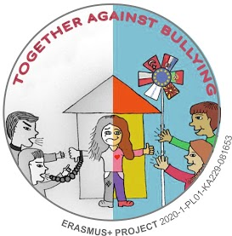
please select your gender *
male
female
Diğer:
Do you know what bullying is ? *
yes
no
I don't know
Diğer:
Do you think bullying is *
ımposing domination over others by force or threat
refuse a present/ invitation or etc
being kind
not to get on well with friends
Diğer:
What can be done to prevent bullying? *
to warn the bullies around us
to give informative lessons, with someone's help
To react the same
Inform a trusted person
Diğer:
Have you ever been bullied? *
yes
No
I am not sure
Diğer:
How often have you been bullied at school in recent months?
I have never been bullied
I have been bullied more than once
I have been bullied more than three times
I have been bullied at least ten times
Diğer:
Have you ever been given derogatory names, ridiculed, or hurtfully taunted?
yes
No
Diğer:
Have you ever bullied someone? *
yes
No
I m not sure
Diğer:
How much do you like school? *
I like school
I don't like school
I don't know whether I like it or not
Diğer:
If you were bullied by peers on the internet or mobile phone, how was it done?* *
by mobile phone
by only internet
both of them
Diğer:
Please point to whomever you told the following people when you were bullied. *
1.sütun
one of your teachers at school
one of your family members
one of your classmates
one of your close friends
one of your teachers at school
one of your family members
one of your classmates
one of your close friends
How did they react to your bullying problem ? *
concerned but not helpful
helpful and concerned
careless
only worried
Diğer:
Gönder

