„Don’t be a bully, be my buddy” MAGDALENA GÓRALCZYK, POLAND

Don’t be a bully, be my buddy.
I’ll always help you, when you help me too. ( x2)

When someone hurts you.
Don’t be silent, report the bully.

I’ll always be your friend.
For good and for bad.
You know it well.

Don’t be a bully, be my buddy.
I’ll always help you, when you help me too. ( x2)

PAWEŁ DROZD, POLAND
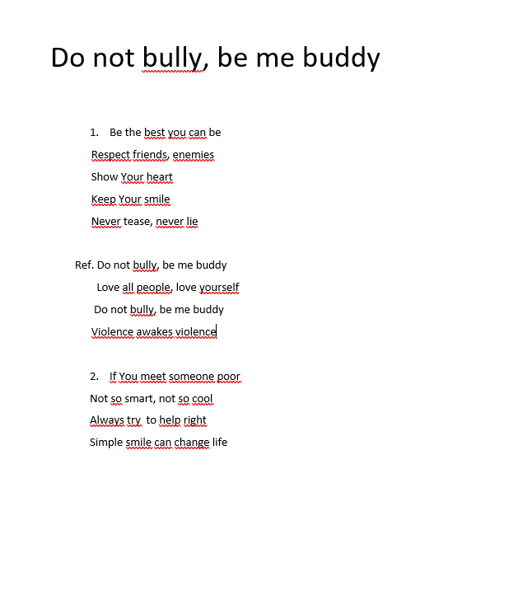

FRANCISZEK WROŃSKI, POLAND

Yo, I'm MC Frank
It's not a prank,
It's serious stuff,
Nobody's laugh, yo...
Together against bullying you say,
Together against bullying yes man,
How can we do that in this crazy time I'm asking
When meeting each other is almost illegal and nasty
We spent a year in loneliness and silence
But it didn't protect us from virus or violence
There is a jungle in network my friend, belive me, I don't lie,
They can hunt you, catch u you, make you think you wanna die,
Together against bullying all my fellas
Together against bullying let's open care umbrellas
Together against bullying with love and kindness
Together against bullying stop being blindness
Network is full of people like a crowdy place
But u can feel it's empty like you are alone in space
One picture, one movie bang! It's on Facebook!
That one with messy hair, that one not looking good
Just a few likes, rest is a bullying
You are ugly
You look stupid
What the hell are you doing!
Next day you can't find not even a one good word you need
Nobody cares your heart just started to bleed
Today it's me, tomorrow it can be you
In cyber world doesn't really matter what you not or you do
What if we all say
Together against bullying all my fellas
Together against bullying let's open care umbrellas
Together against bullying with love and kindness
Together against bullying stop being blindness

