Worksheet for group 4: The architecture experts of the Marzahn high-rise buildings

Your objects of research: buildings in the Berlin quarter of Marzahn in the 1970s and today
Tasks:
1. Please read the papers provided by the teachers.
2. Make notes on a) the historical aspect of the area and b) its architecture in the 1970s and today.
3. Make a poster with your results.

Help for tasks
- historical aspect of the area: Answer the following questions
(1) What is Marzahn?
(2) When and why were the present high-rise buildings erected?
(3) What was there before?
(4) What is the architectural idea behind these new high-rise buidlings?
(4) Name the main architect of the Marzahn quarter buildings.
(5) What is typical for the architecture of these Marzahnhigh-rise buidling at their time of building in the 1960s
(6) Which changes were made in the 1990s onwards – and what is typical for those high-rise buidlings today?
(7) Find examples of sustainability in Marzahn – use the information on “your examples“!

- sustainability: Sustainable architecture is architecture that seeks to minimize the negative environmental impact of buildings by efficiency and moderation in the use of materials, energy, and development space and the ecosystem at large. Sustainable architecture uses a conscious approach to energy and ecological conservation in the design of the built environment

- Help for the poster
(1)aims of the poster: The poster should give you a quick overview of your topic and of your answers to the task questions. The poster is to be used for a short presentation to your partners and for a gallery walk!
(2) Your poster should have thesis (such as:“high-rise buildings– cheap accomodation for masses of people“)
(3) Use the oval cards provided by your teacher. Write key words or phrases (which answer the task questions!) on them.
(4) Stick the oval cards into the appropriate boxes of your poster.

Clauß, Gymnasium Tiergarten, Berlin Germany, 2018
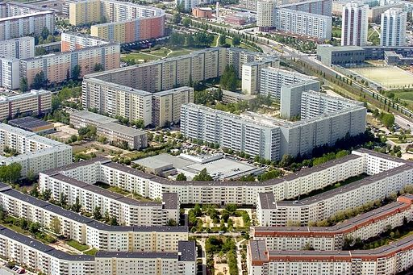
Topic: The architecture of the high-rise buildings in the Berlin quarter of Marzahn
Marzahn Plattenbau modernized in 2010
https://www.pinterest.de/pin/145874475405992435/220118;11:12
suggested thesis: “high-rise buildings– cheap accomodation for masses of people“
(find your own one!)

The history of the Marzahn
The name “Marzahn” was borrowed from a nearby medieval village. But for most of history, the area was mainly open fields on the outskirts of Berlin. Before the Olympic Games of 1936, the Nazis rounded up Berlin’s population of Roma and Sinti people at this remote location to keep them out of view from visitors to the games. Later, most of them would be deported and murdered at Auschwitz. After the war, Berlin was occupied by the four Allies against Nazi Germany: France, Britain, USA and Russia. But soon the co-operation changed into rivalry because of different political ideas. As a result of this conflict of two ideologies (democracy against communist dictatorship - the so-called Cold War) Berlin was divided into a Western and Eastern part. Marzahn was now in the communist eastern zone of Berlin. There the first concrete slab was laid on July 8, 1977, 40 years ago. Marzahn is in fact Europe’s largest development of this kind, and thus of historical importance. In the 1970s onwards some 400,000 people lived there.
The new construction settlement of Marzahn
The Soviet dictator Nikita Khrushchev’s, rise to power in the Soviet Union opened the way for a large, loosely associated group of architects, designers, and city planners to implement their philosophy of a rational, ahistorical, and mass-produced city-space, home-space, and material culture. The Marzahn plan was soon after approved and set in motion by the Politbüro (the East German communist government) on March 27, 1973. The new buildings were proclaimed the central pillar in the SED’s pledge to completely solve the housing shortage in the GDR. And the new district was a key component of the communist leaders' promise to deliver “Real Existing Socialism.”
Between 1977 and 1990, the sparsely populated townships of Marzahn, Hohenschönhausen, Biesdorf, Hellersdorf, Kaulsdorf, and Ahrensfeld were transformed from open croplands, meadows, forests, and swamps into a new city district with hundreds of perfectly symmetrical, monolithic, and almost identical concrete slab buildings known as Plattenbau. A “Platte“ is a large, prefabricated concrete slab used to construct the sort of housing blocks considered to be the example of communist architecture in the 1970s. By 1970 the most advanced mass-production system for concrete slabs—the “WBS 70” (Wohnungsbauserie 1970)—had been developed, resulting in a more cost-effective system.
The transformation was rapid and complete: multiple construction teams, called Taktstrassen, working parallel to each other and on three shifts, were able to finish a new Plattenbau living block with as many as 120 apartments, or “living units” (Wohneinheiten), in 90-120 days. By 1984, most of it was finished, and additional developments in Hellersdorf, Ahrensfeld, and Hohenschönhausen began, further expanding the scope of the Neubausiedlung. Over 650 hectares worth of land was dug up, displacing almost seven million cubic meters of soil to make room for nearly 1300 building foundations. Forty-five combination Kindergärten/Kinderkrippen and 51 polytechnical high schools were built, each with a construction time frame of about 150 days. Sixteen shopping centers, fifteen local restaurants and pubs, nine senior homes, five hospitals, eight general service centers, fifty indoor sports arenas, two indoor community swimming pools (with saunas), and nine youth clubs were built in direct coordination with each Plattenbau.
At the time it was the architectural future, meant to liberate East Berliners from shabby homes, coal stoves and multiple-family shared toilets. The most common high-rise design was 11 floors high; these were interspersed with double-height high-rise of 21 floors.
The local river, the Wuhle, which cuts a gentle swale between the old villages of Marzahn and Hellersdorf, eventually flowing into the Spree to the south, was redirected to form an artificial lake that was never completed. The lake was to be at the foot of what would become an artificial “mountain,” the “Kienberg,” a 100-meter, 31-hectare round high hill made of seven million m3 of construction debris, torn-down old homes, left over war rubble, and displaced earth.
Together, the Kienberg and the Wuhle were the center of a new and completely artificially landscaped recreation park, which included a bunny ski hill, an all-weather bobsled run, boat rental facilities and open spaces for picnicking, hiking, soccer, an open air stage, and more. Within five years, an entire metropolis in concrete had sprouted out of the nothingness.
For those people who moved to Marzahn and its surrounding Neubausiedlungen, the experience was one of profound change, change bound up very closely in ways seen and unseen with the power of SED state. This change was more than just a new address, or a new view, or new neighbors: it was a total transformation of their material environment. Whether they came from the crumbling Altbau buildings of East Berlin districts such as Prenzlauerberg or Friedrichshain, or from small country houses, the move to a Plattenbau apartment in Marzahn meant new dimensions of rooms, new materials in the walls and floors and windows which required new methods of maintenance, repair, cleaning, and decorating, and it meant new ways of getting to work, to school, to recreation. Often, it meant new kinds of schools, new kinds of playgrounds, new kinds of transportation. It meant new kinds of shopping, and new foods. The symmetric, block buildings created new ways of encountering neighbors and strangers, and meant new sights leaving and coming home from work; they meant new ways of caring for children, and new ways of children’s play, and thus, new childhoods. It meant new trees, new grasses, new smells in the air, new sounds, new weather patterns, new kinds of soil.

The Apartments of the high-rise slabs
Most of the new apartments, in contrast, while they ranged from one to five rooms, were typically three or four rooms because the entire project was intended for young families with children.
Industrial designers and the technocrats of the planned economy had long been at work designing and massproducing modern, Bauhaus-influenced amenities, including furniture, kitchens and appliances, and even flooring, for the Neubauwohnungen. The Schrankwand, a floor-to-ceiling shelf unit designed to hold books, stereos, vases, photos, knick-knacks and other common living room furnishings, became increasingly popular in the GDR and in other socialist countries for precisely this reason. The “Intecta” series, developed by the Hellerau Werkstätte, was the most popular “system” of furniture, combining a few different types of shelf units with beds and sofas to provide complete “rooms” for East German consumers. Modern kitchens were also touted as must-have amenities for the new apartments, such as the “Ratioküche”—a rationalized, streamlined built-in kitchen that could be found in most Plattenbau apartments. Throughout the new apartments, plastics were central: the Intecta shelf unit was laminated in polyester resin, and the Ratioküche kitchens were coated in “Sprelacart”—a kind of plastic surfacing. Even the floors, made of polyvinyl chloride (PVC), were a product of numerous studies by designers and engineers on how to make the modern apartment more efficient and easier to maintain.

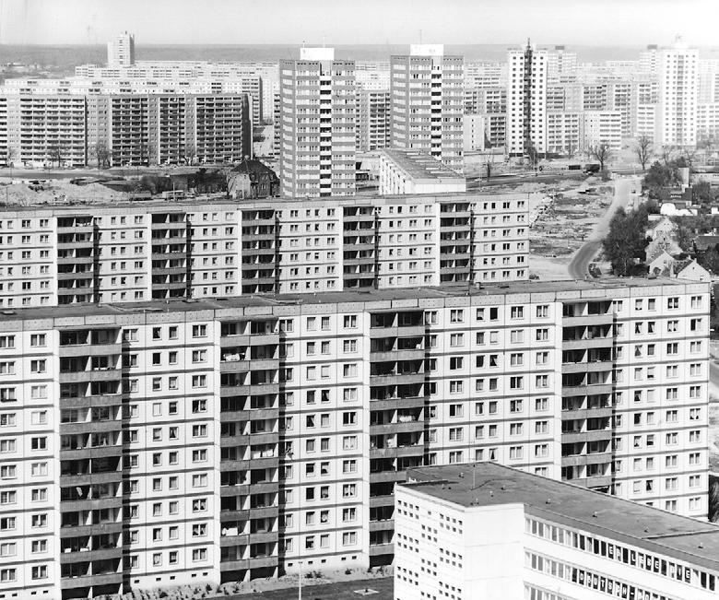
The architecture of Marzahn
Marzahn in 1984. Courtesy of the Bezirksmuseum Marzahn-Hellersdorf.
The new Berlin district and its high-rise slabs were planned out in advance by the German Architectural Academy (Deutsche Bauakademie, DBA), the main organ of architecture and city planning in East Germany, as well as the city planning office of the Magistrate of (East)Berlin.
The first tower blocks were completed just six months after work began.
One of the most influential architectural concepts was the Bauhaus. The planners, designers and architects had either been in the Bauhaus or had studied under disciples of this architectural style. So the strict geometry and strong, right-angled forms of the Bauhaus design of influenced the architecture of Marzahn – but the idea of the high-rise building in high numbers on a comparably small area was new. A large number of high-rise buildings of 11 to 21 floors at in one quarter are contrary to the Bauhaus idea. East German architects developed this idea during their exile in Moscew and took on ideas from French and West German architects as well.
One of the most important architects of Marzahn high-rise slabs was Gerhard Kosel, who replaced the Stalinist Kurt Liebknecht as the head of the DBA. Liebknecht, along with East German First Secretary and dictator of the GDR, Walter Ulbricht, had previously ridiculed modern, mass-produced housing projects in West Berlin such as the Hansaviertel as un-German, cosmopolitan, and American. Gerhard Kosel had spent almost twenty years experimenting with Plattenbau technology in the Soviet Union; indeed, he had helped develop Soviet Plattenbau methods. So when Khrushchev called for “cheaper, better, quicker” housing construction, and personally chose Plattenbau as the best, most efficient, and feasible method, Kosel was well positioned to begin widely implementing his vision of a Plattenbau future in socialist East Germany, including the Marzahn development. He was able to promote a number of his friends and close colleagues, all of whom were experienced in Plattenbau construction and the all-encompassing Neubausiedlungen Kosel had experimented with in the vast steppes of Russia. These included Heinz Graff under, the architect responsible for overseeing the Marzahn plan (as well as the architect of the Palace of the Republic in East Berlin and one of the most influential architects of the GDR), Roland Korn, Berlin’s chief architect who created the original Marzahn plan, and Günter Peters, the head of Berlin urban planning.

Bauhaus style house
Founded originally as a private school prior to World War II, the Bauhaus school of design in Germany sought to combine a wide range of design disciplines together, such as architecture, art and industrial design. Evident in both residential and commercial buildings is principle of geometry. Using curves and shapes that allowed for space wastage or poor spatial layout were frowned upon. Where possible, it was also encouraged to make the building as unobtrusive as possible to the landscape it was situated upon. The first and most important teaching by the Bauhaus school was to reject the ornamentation. Bauhaus design is practical and functional, and every aspect designed must have a use, or at least, a perceived one. Bauhaus teachings suggested that both the colour and material palette be of one colour only, with the only acceptable pop of colour coming from the primary tones—blue, yellow and red. Prevalent in most architecture during the Bauhaus period was of course strict geometry and strong, right-angled forms. While some people may perceive this as boxy, the reasons for such a design feature were clear. Both the internal and external layout of a house could be open and well laid out, making best use of the available space.
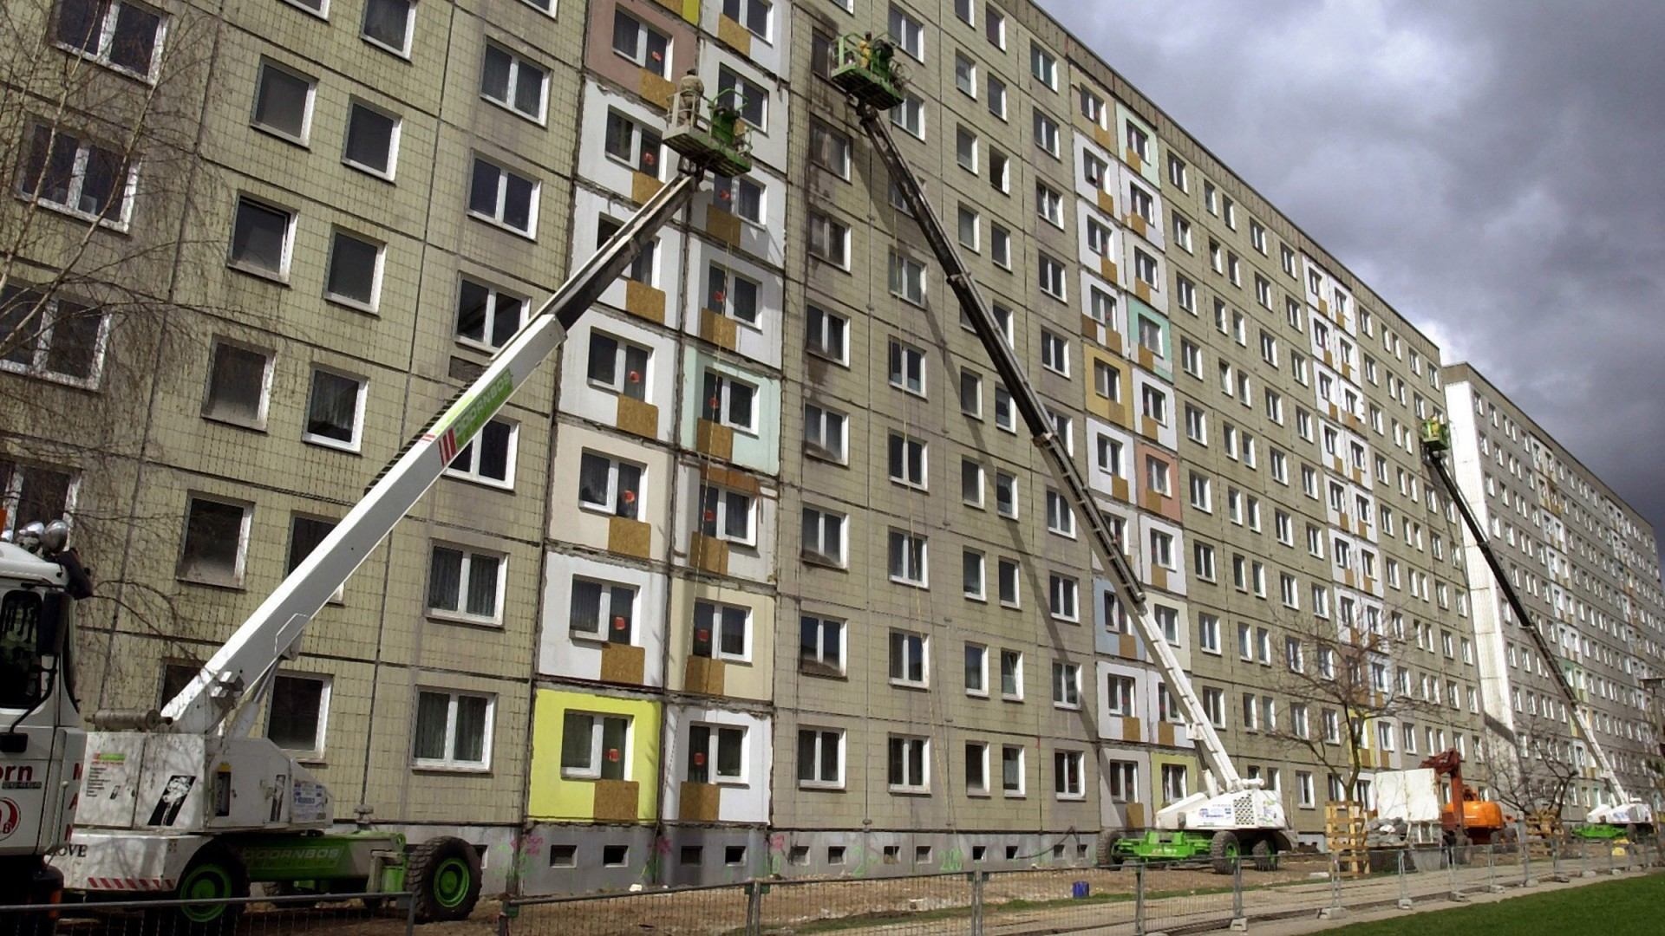
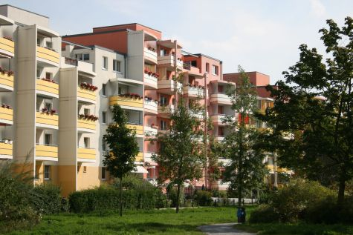
Marzahn - a redevelopment area after 1989 and Marzahn today - sustainability
Plattenbau Sanierung in der Märkischen Allee; https://www.bz-berlin.de/liveticker/afd-in-marzahn-hellersdorf-bei-zweitstimmen-vorn; 20.01.18
Ahrensfelder Terassen 2002; http://www.staedtebaufoerderung.info/StBauF/DE/Programm/Stadtumbau/StadtumbauOst/Praxis/Massnahmen/Marzahn/Marzahn_node.html; 200118; 11:20
When the Wall fell in 1989 and Germany was re-united in 1990, it left Marzahn in an existential crisis. During the GDR, Marzahn was a place of the future, designed to erase all links to the past so that a new, self-referential future, based only on itself, could become real. After 1989-90, it became a place with no past, as Westerners quickly recognized. Once the old neighborhoods of East Berlin—Prenzlauerberg, Friedrichshain, Mitte, etc.—were opened up to the mechanisms of a private real estate market and the kinds of investment capital able to renovate old apartments, suddenly having a past was the new future. Altbau trumped Neubau. Far from the socialist dream, Marzahn became a byword for desolate concrete landscapes, unemployment and vacant, derelict apartments. The Plattenbausiedlung was suddenly seen as old-fashioned and far from comfortable housing. People moved out of the quarter in the years to come – and left empty high-rise buildings.
A new architectural concept and housing plan of the early 2000s changed this trend: the high-rise buildings were cut down to three to four floors only. The buildings were modernized, the façades and heating pipes were insulated and the windows replaced by energy-saving ones. Some became energy-saving houses with cheap rent. So once again the quarter has become attractive for residents of the city looking for cheap rent and a quiet place to life. The population of Marzahn- Hellersdorf has started to grow again. Profiting from Berlin’s citywide boom — and the accompanying housing shortage — the district is the focus for an array of new building projects. In an area now considerably greener than it once was, the concrete tower blocks still house 190,000 people.

