There were two deportations from Latvia.
First one was in 1941 14th of June, when 15 000 people were deported.
Second biggest one was in 1949 25th of March – 42 000 people were deported.
We all - deported persons had one sorrow, but each one has different story. And this will be one of mine stories, what I remember and what was told by my parents.
Me, Rasa Ābola-Klasone, was in that list together with my little brother, mother, father and grandmother, who in that scary night suffered from repression. At that time I was 4 years old and my brother 2,5 years old.
In night of 25th of March into our house broke armed Russian soldiers with village Cheka person. Within one hour we had to get ready, but in this fuss we could not understand what to take with us, because nobody told where they are going to take us. My aunt, who lived with us, threw into the blanket some clothes, tied into bundle and threw in chariot. I also had older sister, she was 12, and older brother, he was 9, who were not at home that night, because they studied in city and they has not been deported that night. Parents grieved for elder children, because they did not knew what is going to happen with them and where they are going to live.
Arrests continued also on the next day, when people were caught on the road, in the streets, children who were supposed to be deported were taken out from schools.
And thus we, hundreds and thousands of people were tracked down into train cattle wagons, where on the floor was straws and some benches where sat mothers with infants and little children. On the floor slept old and sick people. I remember it very well how I and my parents slept on the floor on the straw. It was very cold in those wagons, because it was just March, April. In the middle of wagon there was a hole in which we all took our natural needs. And in wagon also was cast iron stove that gave a bit of warmth time to time. A lot of people did not survive and died, because there were a lot of old and sick people. Dead people by armed soldiers was thrown out from wagons into the forests and fields so wild animals can tear them apart. Hunger, disease, nescience was raging. We spent on our way 2 weeks, until we arrived far beyond Ural Mountains, far away Siberia – district of Omsk. There we were greeted and assigned to different villages. My family was placed to some Russian family. Also there we slept on the screed floor on straw together with cattle. In Siberia during winter time a lot of people lived together with cattle, because winters there are very cold.
We were tortured by hunger and diseases; we also as little children did not understand a lot of happening, just were asking bread to our mother, because we wanted to eat.
I also got seriously ill with diphtheria. Miraculously I survived. During the nights we were bitten by bed bugs that sucked out our blood, and our heads were full of lice.
After a while, I don’t remember how, but my family got to our own dug-out. It was built in the ground and made out of sod and clay. Also there we slept on straw that was compound on the birch logs. But we were happy about that, it was our home.
On the second day parents were sent to different works. Our grandmother looked after me and my brother; it was hard for her to walk. Each parent got 200 grams of black bread each day. After a while my father was arrested and deported even more far away to the east – to the coal mines. Then for us it went completely bad. My mother has to feed 4 mouths. It was very hard for us in April. In the summer we collected pigweed, nettle and our grandmother made out of it some kind of broth. We lived in with no big forests and waters, but wide dry steppe. There grew clumps of birch and bent. In summer children went to steppe and collected wild strawberries ravaged bird nests and ate their eggs. Cruelly! But hunger did its job. In spring when potatoes were sorted out, we, children ran and picked up frozen and half rotten potatoes and ate it as delicious meal. In spring we rend birch peel and ate its soft mid.
When I turned 7 years old I started to learn in Russian school. In the beginning it was hard, because there was nobody that could help. My mother did not know Russian language so she also had to fight for herself. Later in school I studied pretty well.
In 1953 when Stalin died, something in politics started to change. Deported people started to write requests to Moscow's Higher Council, to rehabilitate repressed people. Also my father was released from camp. That was about end of the 1955. Also my family wrote requests for our rehabilitation. Two times we received refuse, but in third time we got permission to come back to our homeland. And thus in July of 1956 we received the joyous news and immediately started to prepare to come back.
When I still was a little girl, then I remember that my parents were talking about homeland. And then once I asked my mother, what it is motherland and where it is? My mother answered: daughter, homeland is there where in the evening sun sets in the sea. I had a lot of unintelligible questions. Why in Siberia apples do not grow on birches but in Latvia does? That meant that we, children had not seen such things. There did not grow on the trees such fruits. This is just one memory story. To remember and tell everything, than it would be a book. But that is for the next time.
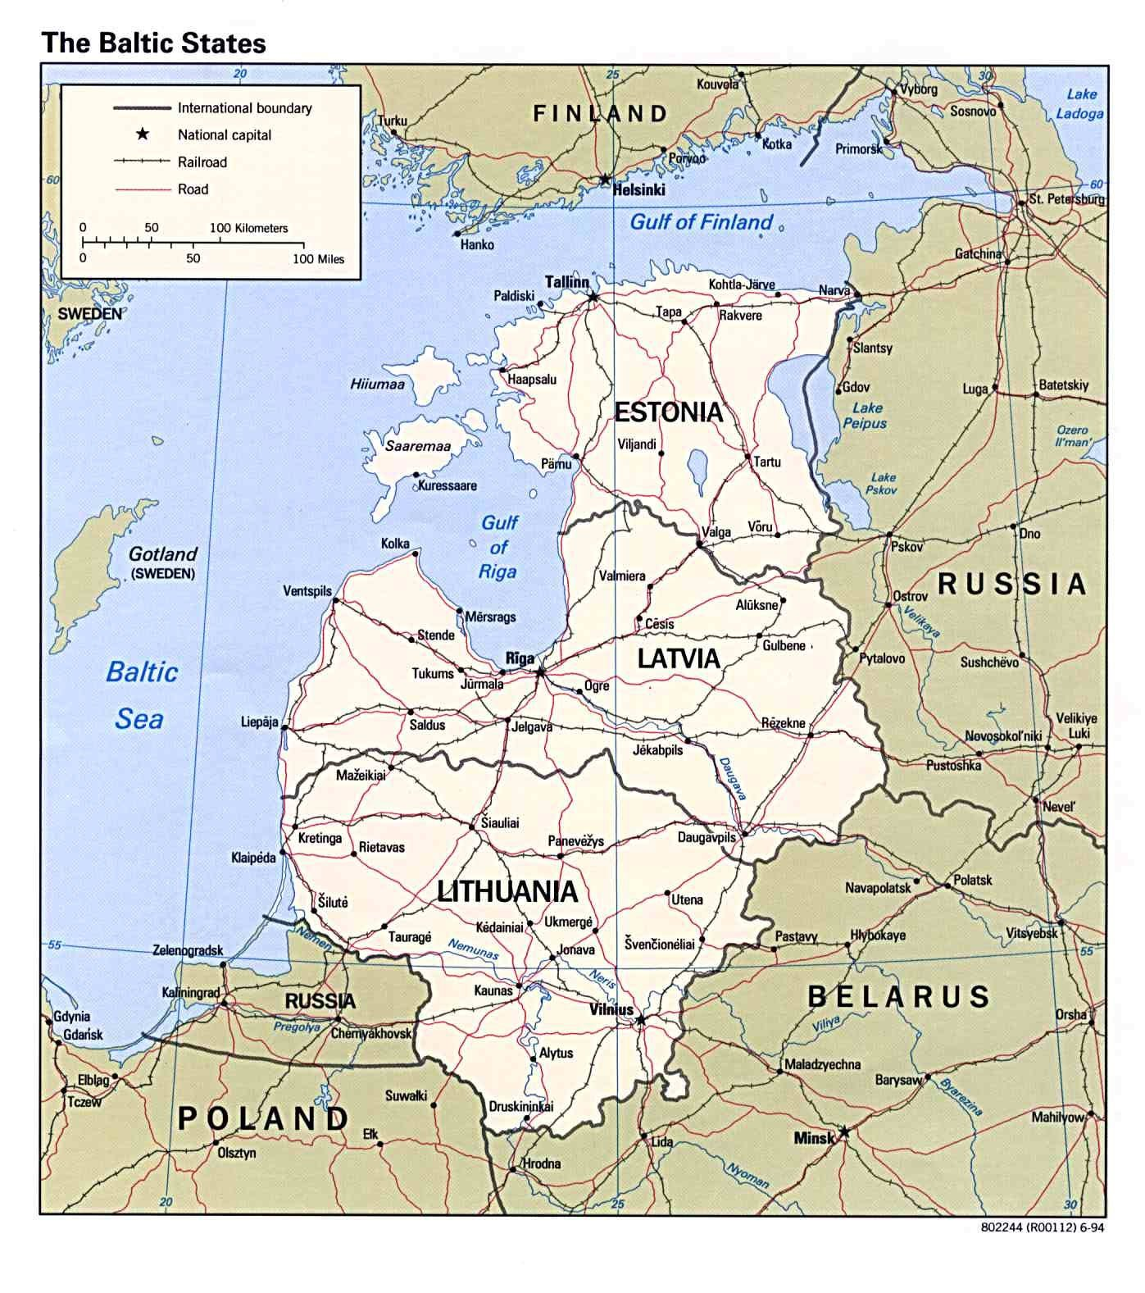

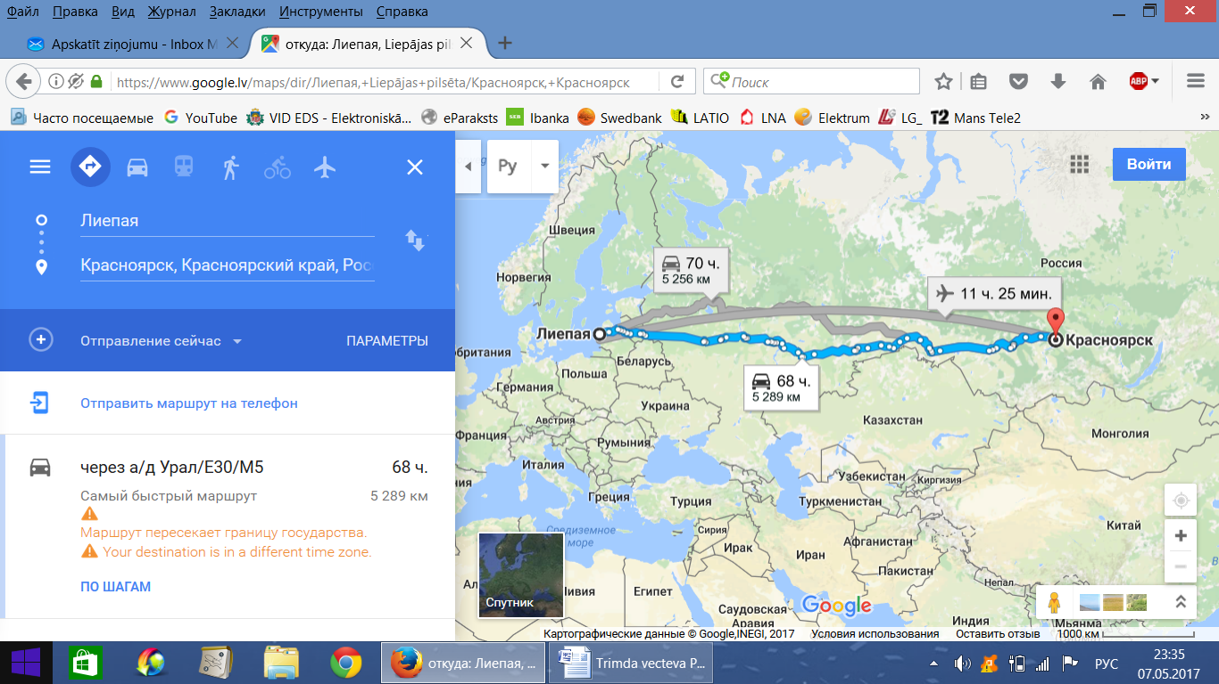

Georgijs Abdulajevs, 13 years

