My mother used to live really close to Vērgale. Her grandmother and grandfather also lived there. Her grandmother has already passed away, but grandfather doesn’t remember much about the deportation.
In 1942 he was 12 years old. He remembers only that day, when he found out about the family deportation, so he and his family hid in the nearest forest. They stayed there for the night.
We visited Vērgale’s museum to find out what families were deported. There wasn’t really much information about that. We found out that 5 families were deported. Nevertheless there were refugees from Vidzeme un Kurzeme districts who stayed in Vērgale. They were living in the local school which in was also an infirmary. Kids were educated in other buildings. The refugees were also being educated.
There was also an exhibit from those times – a chalkboard and a piece of chalk, which were used by the teachers, teaching the refugee kids. Refugees were living here for a few months, then they moved to Liepāja or Jūrkalne, where they tried to escape to Sweden with the small fisherman boats.

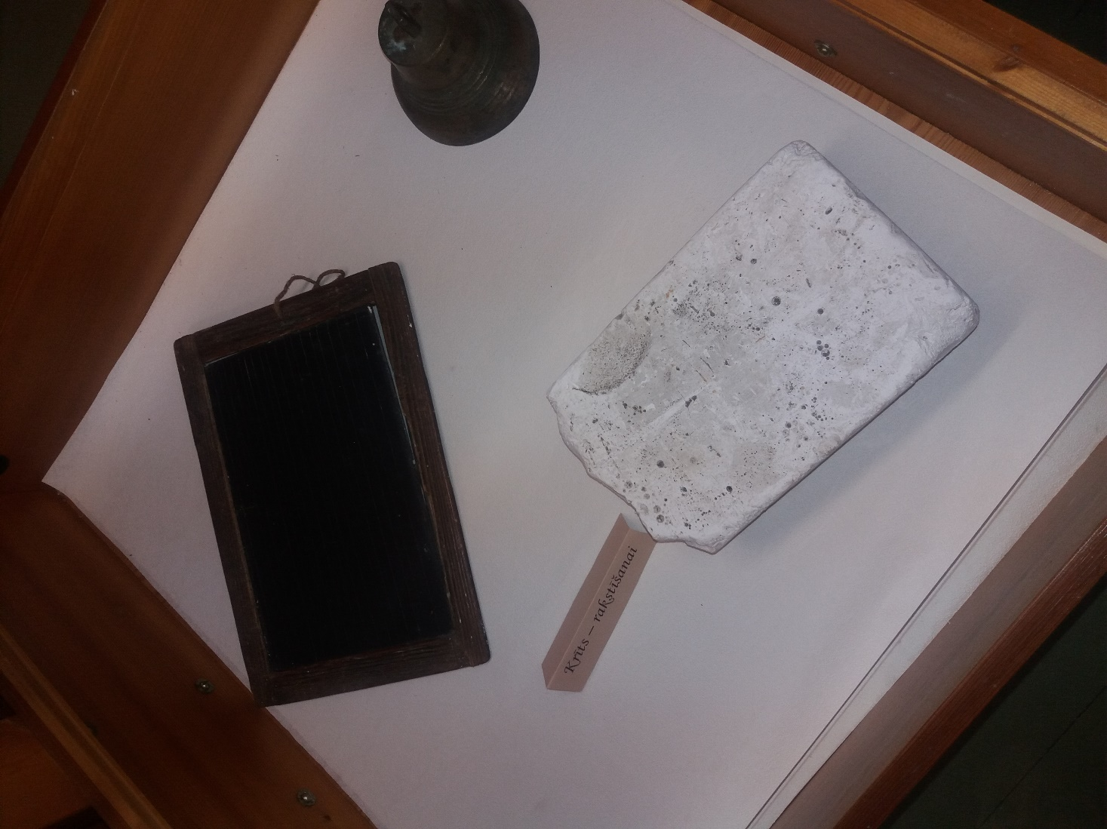
An exhibit from the museum. Chalkboard and a piece of chalk, which were used by the teachers, teaching the refugee kids.
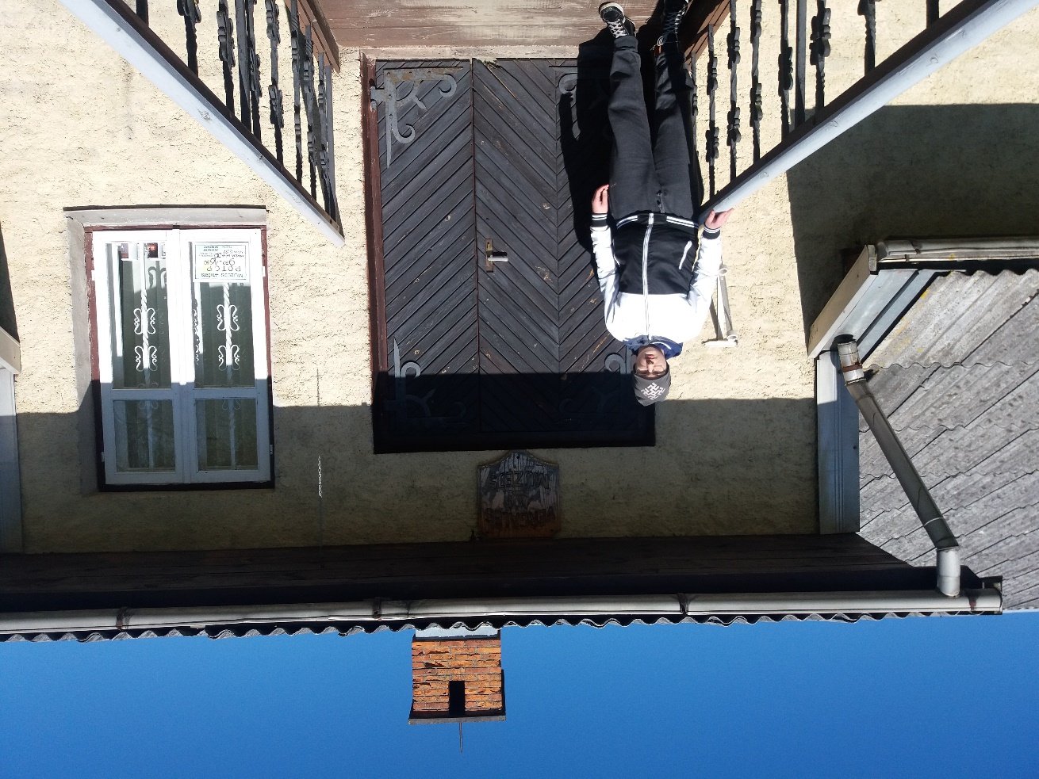

Next to Vērgale’s museum, where we found information about the refugees.

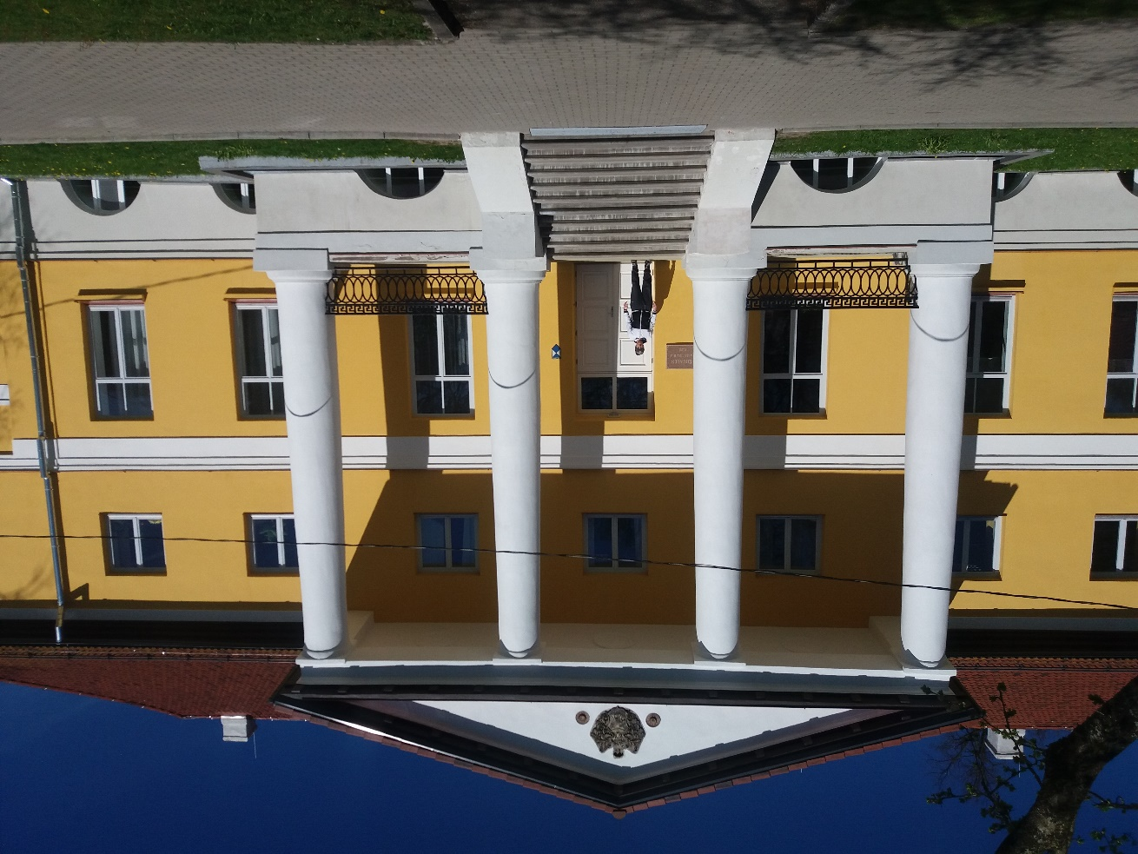
Vērgale’s school. That’s where the refugees stayed, educated and it was also an infirmary.

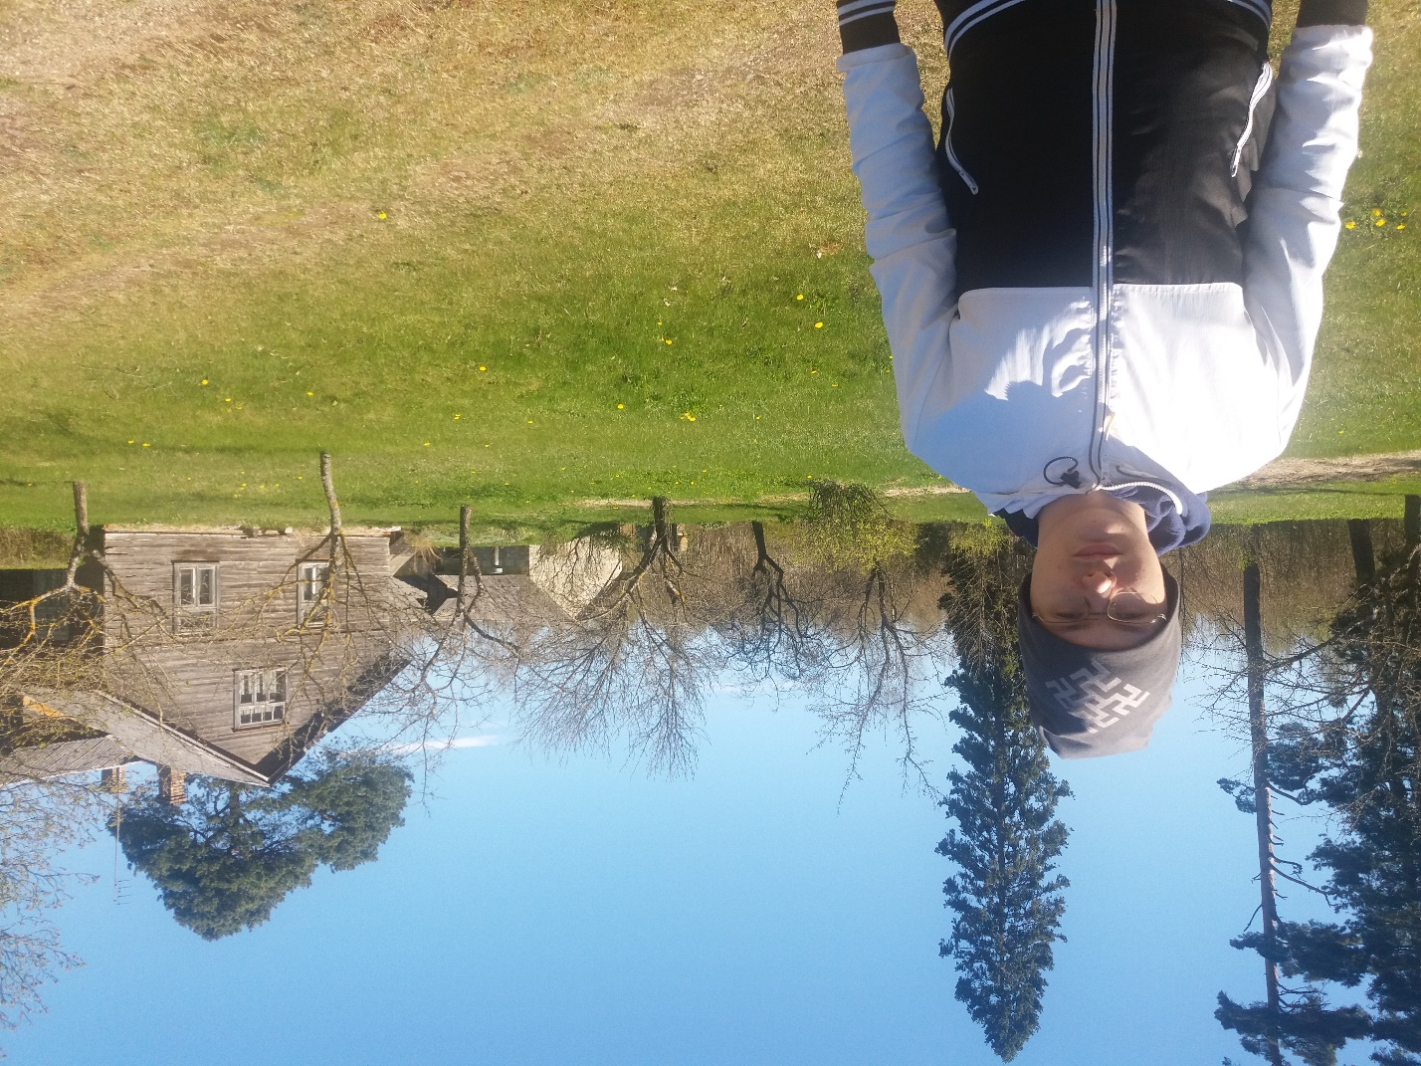
Mom’s grandfather’s old house where he lived in the 1940s.

