Deportation to Siberia

My dad’s grandfather’s sister and two of her children gut deported to Siberia on the 25th March of 1949. Her third child wasn’t deported because she wasn’t living with her mother at the time. In Siberia they were forced in to very small houses and forced to do hard work. They were released from Siberia on the 8th August of 1957.
While in Siberia they sent postcards to Latvia.
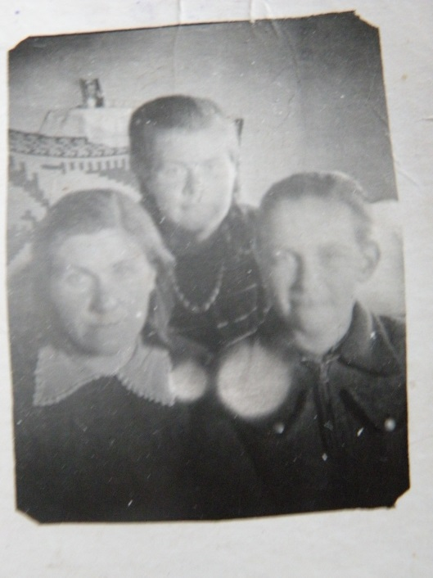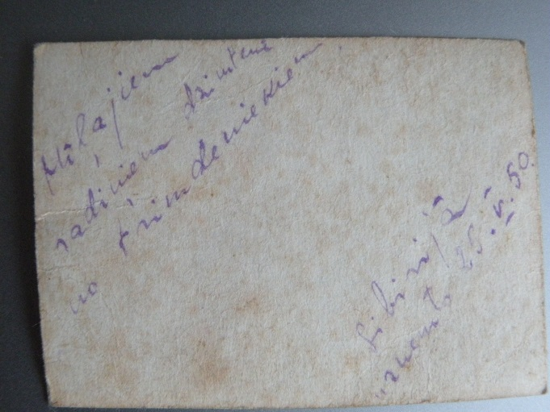
This picture was taken on the 29th of May in 1950. The text says “To the dear relatives in homeland from the exiles in Siberia”.

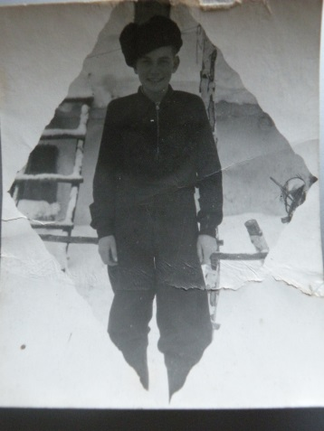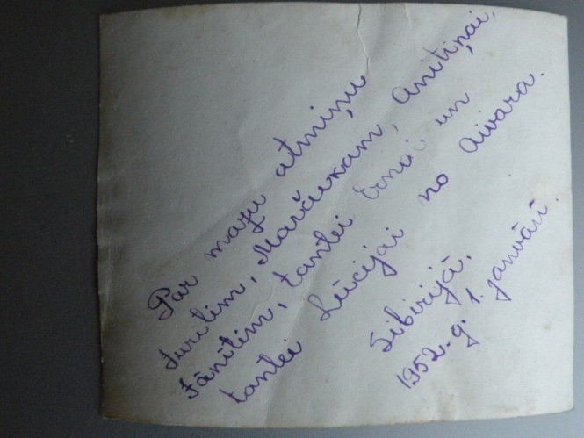
This picture was taken on the 1st of January in 1952. The picture was sent as a memory of him to his closest relatives.

