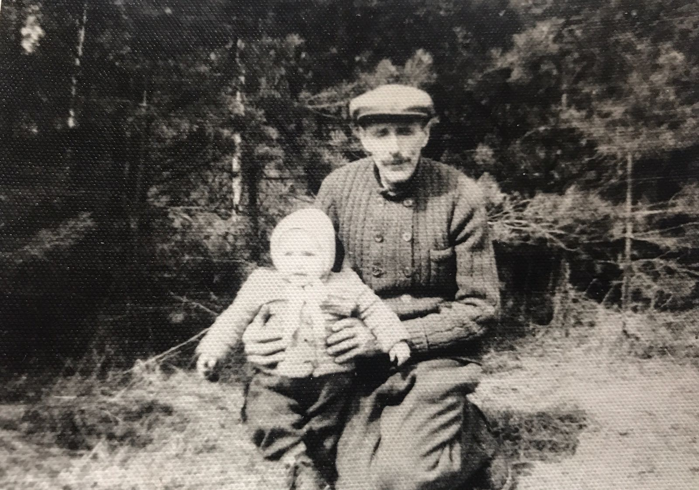

In the picture You can see my grand-grand-grandfather Jekabs Keire-Keiris. In 1920 he got awarded with the most prestige military order – The Lacplesis war order. In the picture You can see he’s granddaughter. In 1949 Jekabs got exiled to Omska, he came back to Latvia in 1955.

