TURKISH COFFEE
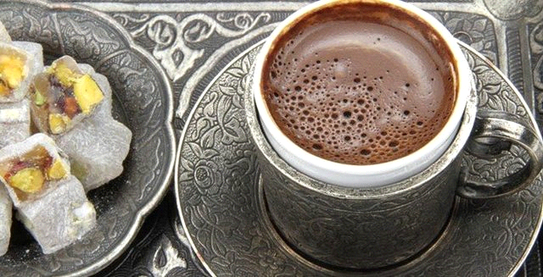
It's served in small cups,accompanied by a glass of water.It's regarded as a part of Turkish heritage.This tradition symbolizes hospitality and friendship.It has also an important role on engagement ceremonies.

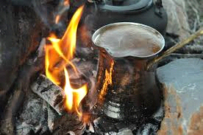
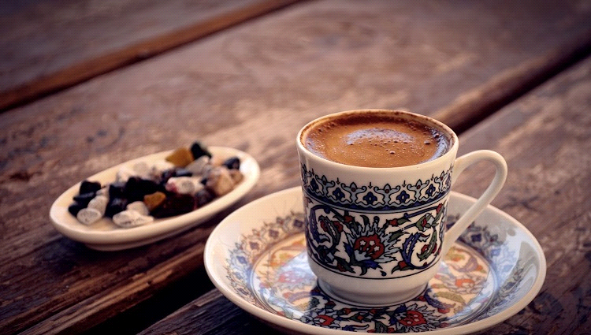
It is made in a cezve. First add water and coffee to the cezve then add sugar and , stir to blend it .When it's boiled , remove from heat immediately. It's similar to filtered coffee.

SEMANUR KOCAAYAN

