The feast of st Catherine of Langres

Is celebrated on November 25 of each year since the tenth century and commemorates the martyrdom of catherine of Alexendria. The festival is particularly popular in Estonia, where it marks the arrival of winter

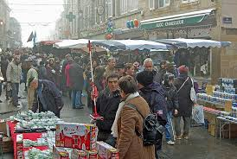

The lake of la liez in Langres

It is a lake with a course on the water , it also has pedalos .
It the summer there are a lot of people who go there for different activities .
There is also a nearty campsite .
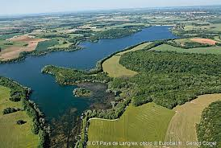
Great forgiveness

The Chaumontais and the inhabtants of the region have accompanied this religions festival with rejoicing ; jubilation and popular enfertainment streets and houses , flowers , garlands, foam patches and greenery.
It was recently celebrated on 24 June 2007 and attracted tens of thousands of visitors .
The last Grand Pardon of chaumont took place on 23 and 24 june 2012 .
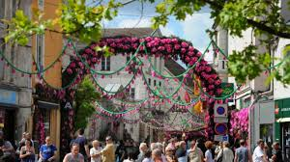

The medival feast of Chaumont

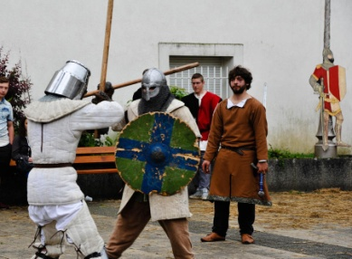
Relive the great hours of Chaumont at the time of the Counts of Champagne on june 11 and 12 , 2016 . To the sound of the troubadours , come to admire the knights fights , life in encampment , forge, weapons of hast, bow , cannon fire … Mon than 40 stalls and crafisman will welcome you troughtout the two days animations for all ages will be proposed . You can also feast on the sound of medieval music and snack at the tavern . A fire show will be offered on Saturday evening at the foot of the donjon .
