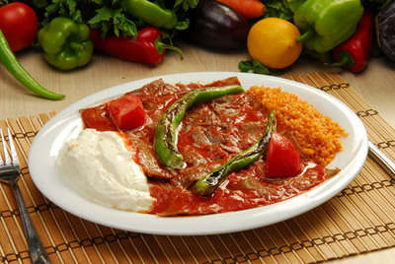
ISKENDER KEBAP
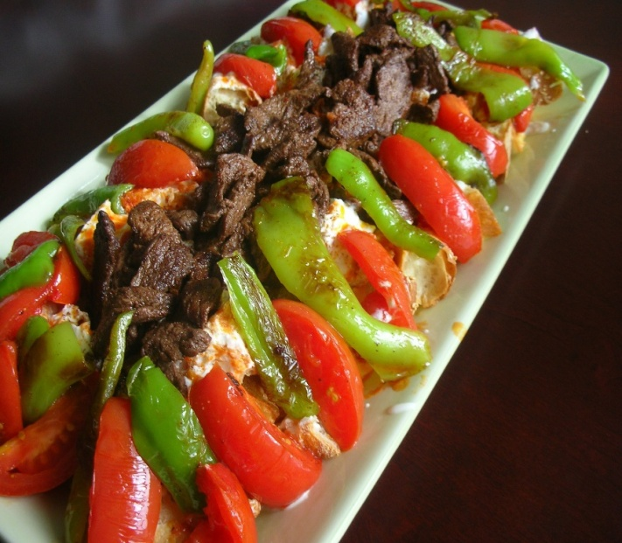
INGREDIENTS:
- 400g doner kebab slices,
- Cayenne pepper,
- 2 rounds of pide bread,
- 4 large chili peppers,
- 50g tomato puree,
- 2 large tomatoes,
- 500g yogurt,
- 4 large cloves of garlic,
- 50g butter,
- Salt to taste.

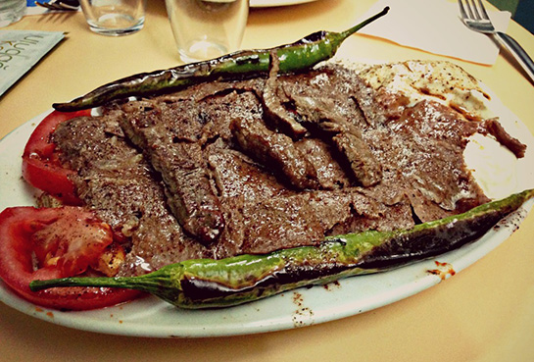

PREPARATION
- Warm the pide by placing on a barbecue grill and keep warm. When all other ingredients are prepared, slice the pide into 3 cm squares, divide into 4 portions and place as a layer on each plate.
- Crush the garlic and add to the yogurt, mix well adding a little salt to taste. Spoon onto the pide squares just before adding the doner kebab slices.
- Heat the doner kebab quickly taking care not to allow the strips to become too dry.
- Cut the tomatoes in half and grill slowly until hot, do not allow to overcook and become too soft.
- Grill the green chillies taking care not to burn, again do not allow to overcook and become too soft.
- Mix the tomato puree with the olive oil and cayenne pepper and heat in a small pan on the grill. Add salt to taste

İskender Kebap is one of the famous döner kebap of Bursa region.It takes its name from its inventor ,İskender Efendi, who lived in Bursa in the late 19th century.

YAPRAK SARMASI
(GRAPE LEAVES STUFFED WITH RICE)

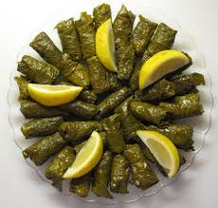

INGREDIENTS:
- 300 gr ground beef (mixed sheep and beef),
- 1,5 water glass rice,
- 1 large onion,
- Salt,
- Black pepper,
- Parsley,
- Dill,
- Enough butter,
- 2 tomato or tomato paste (1 tablespoon),
- Fresh or brine grape leaves

PREPARATION:
- Onion, tomato (peeled) or (tomato paste), dill,parsley ın small pieces. Into the ground beef, rice, salt, black pepper and 1/2 tea glass oil is put,mixed.
- The mixture was wrapped in grape leaves (thin and small).
- The saucepan placed under leafs rolls is spent water and butter is put, cook over medium heat for.
- Under garlic yogurt, deep fried sauce (tomato paste, red pepper) is poured and is served hot.
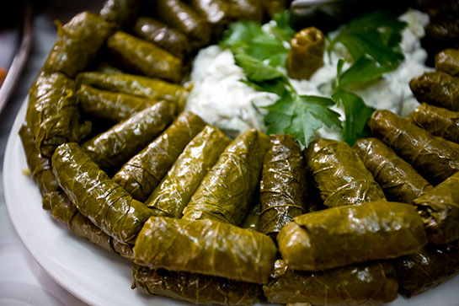

MERVE TAZE

