TURKISH DESSERTS

AŞURE
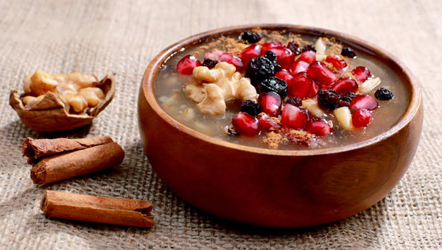
It's also called Noah’s Pudding because it was allegedly after Noah’s Ark came to rest on Mount Ararat in Eastern Turkey that it was first created, using up the supplies leftover on the ship. It symbolizes sharing, diversity, and friendship.
There are pomegranate particles, peanuts, raisins, almonds, rice, dried beans, chickpeas, orange fragments and currants.

BAKLAVA
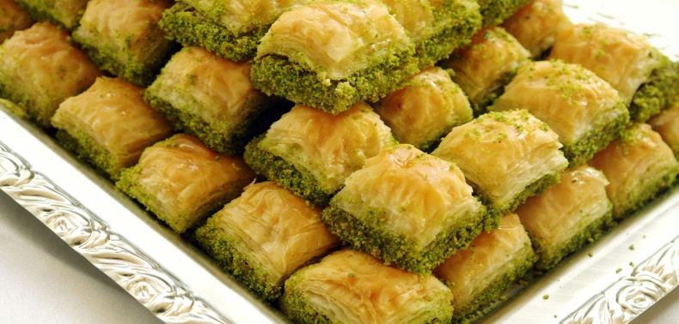

Baklava is a rich, sweet pastry featured in many cuisines of the former Ottoman countries.
The wafer is placed in layers and walnut and pistachio particles are placed between them. Then sherbet is poured on it. Baklava is a dessert of Gaziantep.

HÖŞMERİM
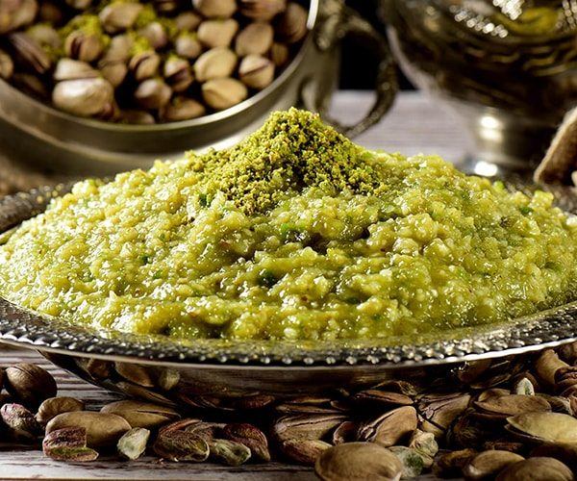
It is made with milk, semolina, sugar. It is the most famous dessert in Balıkesir. There are many varieties of höşmerim such as the one with mastic, chocolate, and pistachio.
SÜTLAÇ
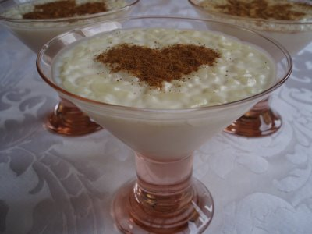
Rice puding or sütlaç is made from milk, sugar and rice.

KÜNEFE
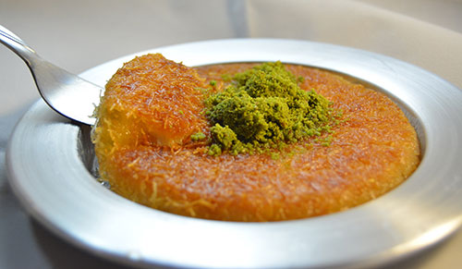
It is a sweet variety belonging to the Eastern Mediterranean region, made of kadayıf and cheese and served hot.

Nisa ORHAN

