TURKISH TEA
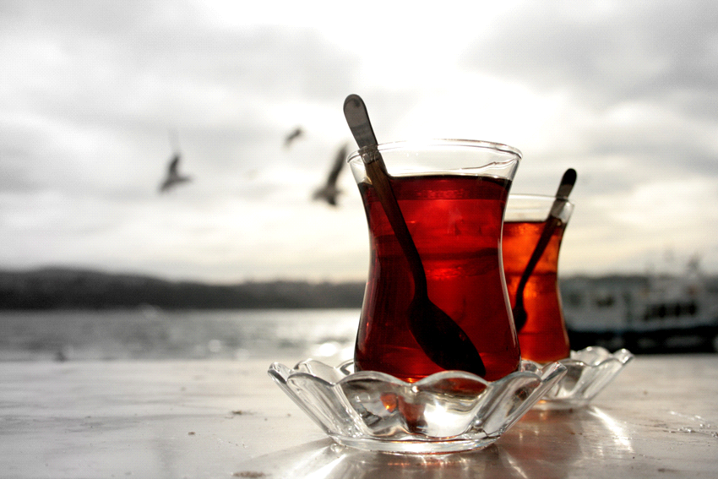
Turkish tea is one of the most popular drinks in Turkey.
Tea is indispensable for Turkish people .Turkısh tea is commonly grown in the black sea region.
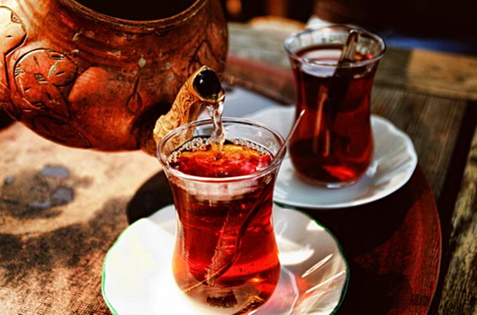
It's mostly offered in little tulip-shaped glasses. You can add sugar in it but no milk, and you can have it either lighter (weaker) or darker (stronger) depending on your taste.Turkish people always drink it in breakfast and also offer it to their guests .Cakes or cookies are usually served with it.
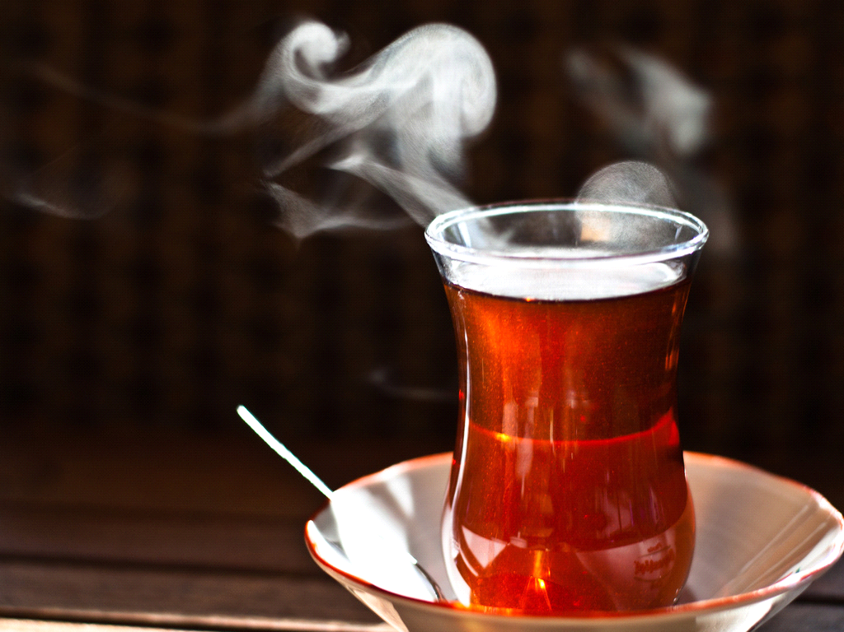

SEMANUR KOCAAYAN

