I get up at half past nine every weekend. I wash my face and hand.I make my bed. I clean my room.Then I have breakfast with my family. I do my homework and study .I text with my friends and listen to music. I spend a little time on computer. I prepare for going out. I meet with my friends. We sit at a cafe and talk .We take photos.We generally have tea together. We walk around and visit museums. Then everybody goes home .When I arrive home , I wash my hands and change my clothes. I have dinner. I watch TV and drink tea for an hour. Then, I read a book. When it is time to go bed, I drink a glass of milk. I brush my teeth. I set the alarm and turn off the lights. I sleep at eleven.
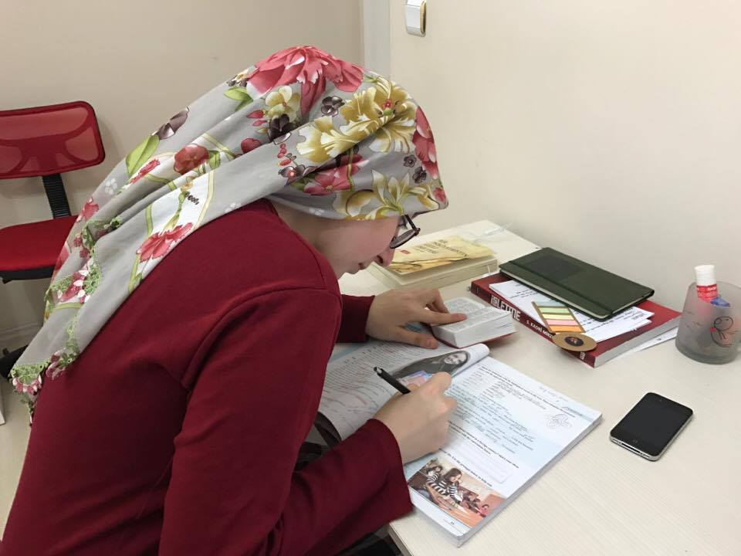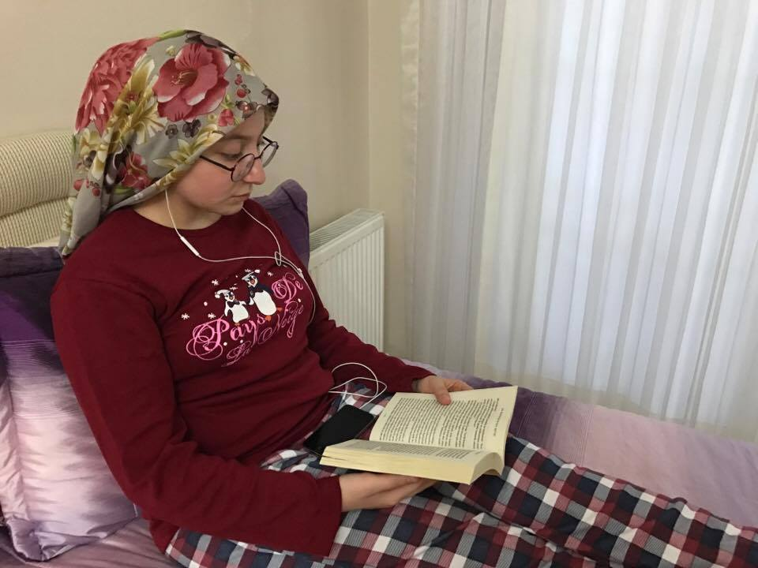
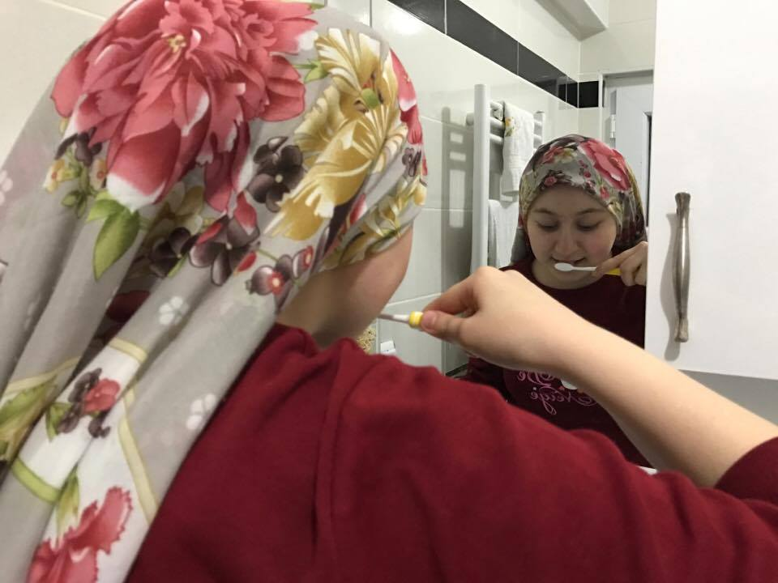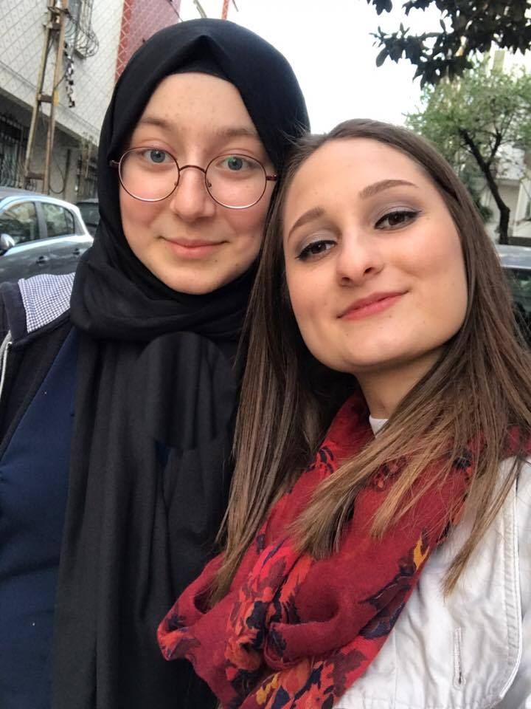

By Aslıhan Doğru

