TURKISH AYRAN

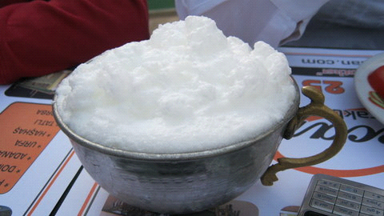
Turkish Ayran is a simple salty yoghurt-based drink served icy cold.
Cold AYRAN is mostly indispensable for summer days in our country .Ayran is usually preferred with grilled mea or rice .
SEMANUR KOCAAYAN

