CVB52 CLUB OF CHAUMONT
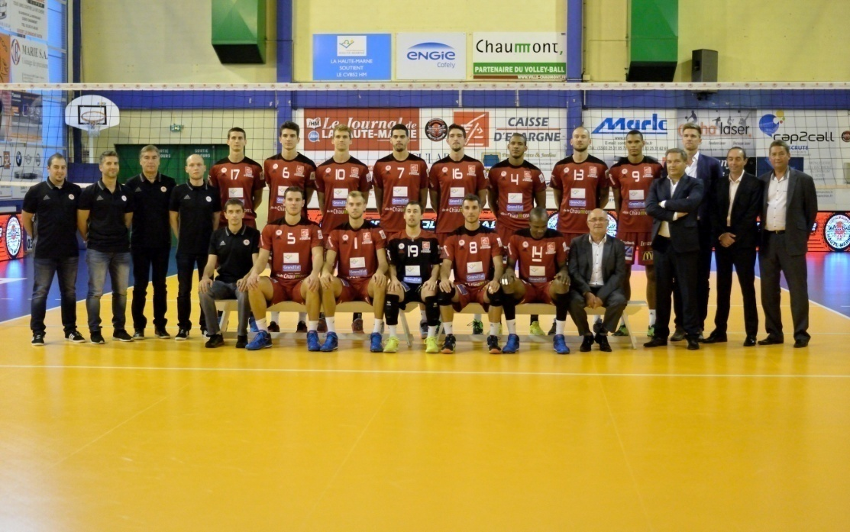

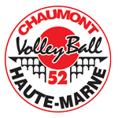

Employees 2016-2017

There is a volleyball club in Chaumont, In THE FIRST DIVISION

CHAUMONT-Ankara in the semi-finals of the European Cup.29/03/2017

Chaumont for 5 years made of the 8 first.

Other sports American football is phoenix.
