Capital of French

The capital of France is Paris. Paris is made up of 2,300,000 inhabitants with an area of 105.4 km2.
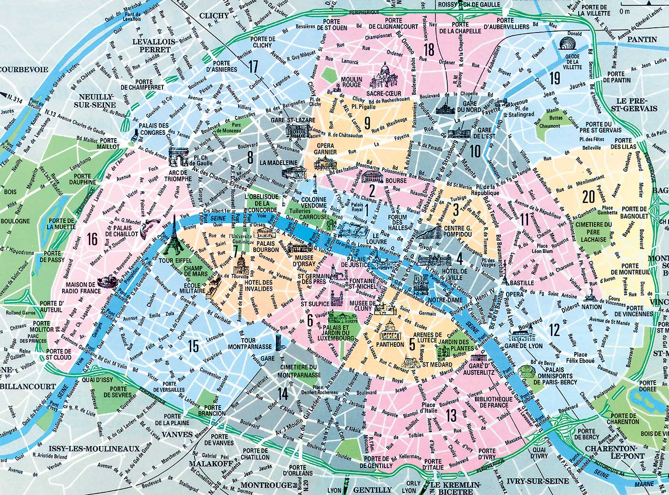

The name of Paris was given in the 1st century before it was called Lutetia.
The President of France is François Holland.
He lives in the Palais de l'Elysée.
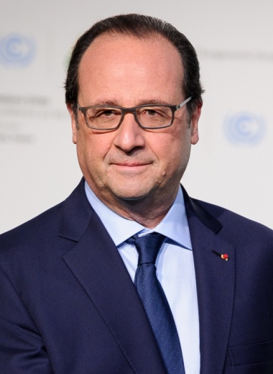
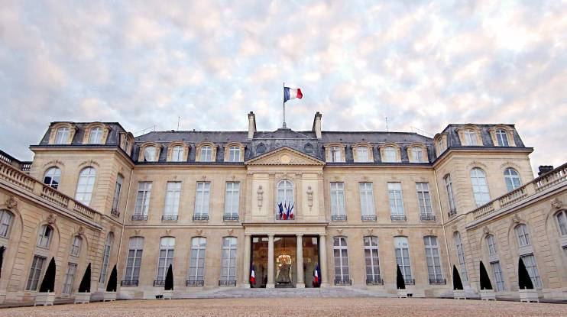

The Tour Eiffel is monument most known of France. The river that crosses Paris is the Seine.

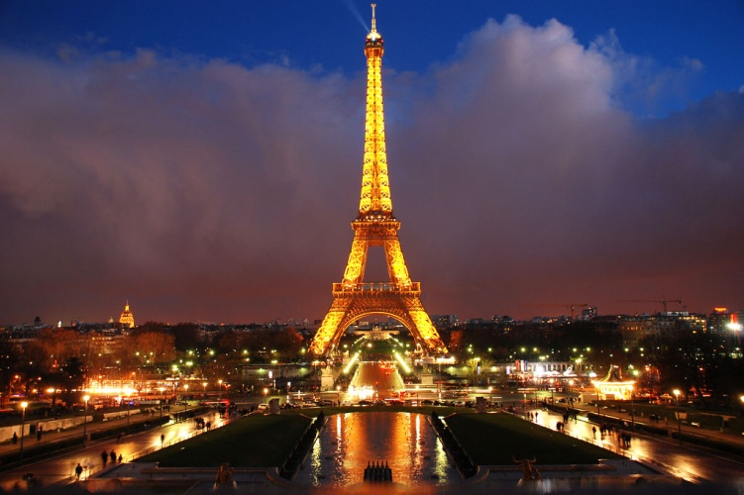
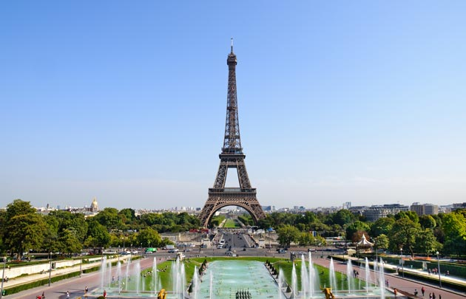

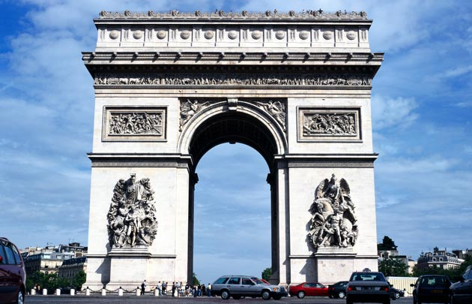
The other two main monuments of Paris are Arc de Triomphe and the Royal Palace.
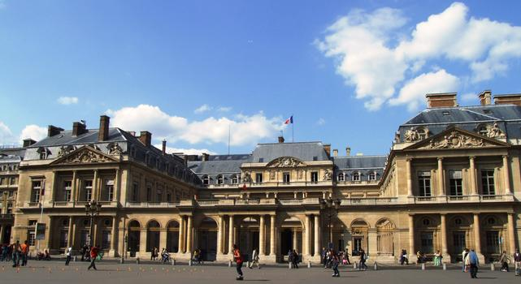

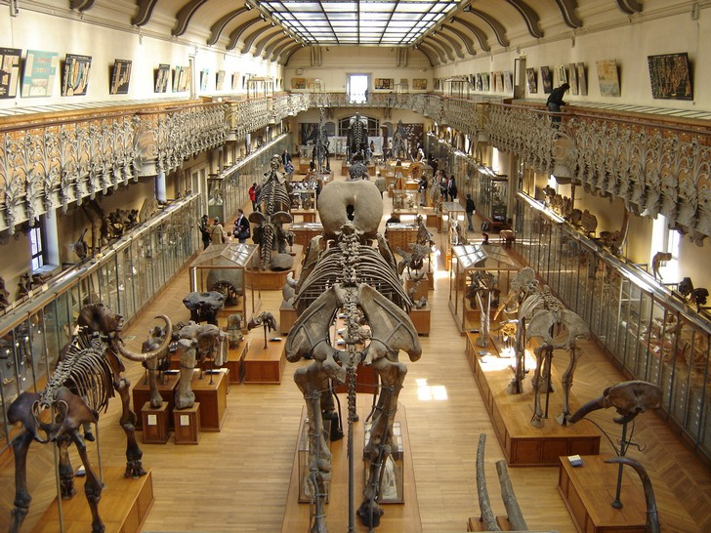
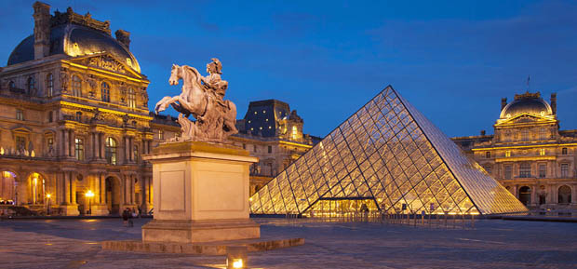
The most famous museums in Paris are the Louvre Museum and the National Museum of Natural History.
The largest market in Paris is Rungis International Market.

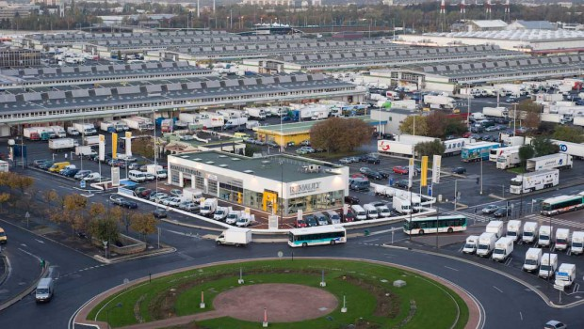

The largest gallery in Paris is the Galerie de Lafayettes
The amusement park which is close to Paris are Parc Astérix and Disneyland
