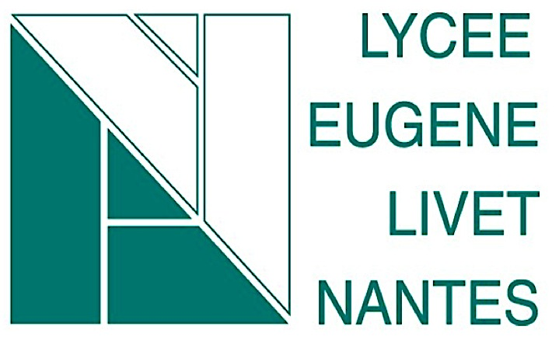

Tutorial : How to prepare your picture for your laser cutting
Open Inkscape

Drop your picture (QRCODE) to Inkscape.
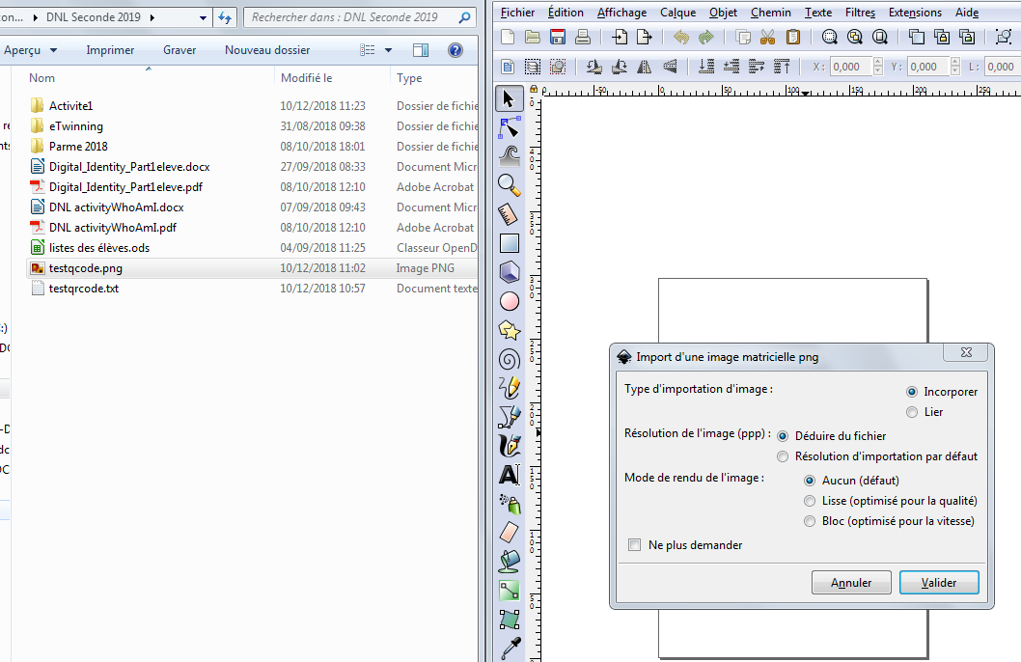

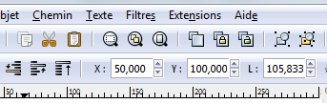
Change the position :

Change the width and the length
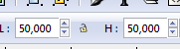

Currently your picture is converted into pixel. You have to convert your picture to vectorial object as so the laser cutting cuts. If you zoom, you will see the pixels and you can notice ; the picture is too blury. So you can imagine the laser cutting won’t be able to print it!

So, to convert your picture, firstly select your picture and
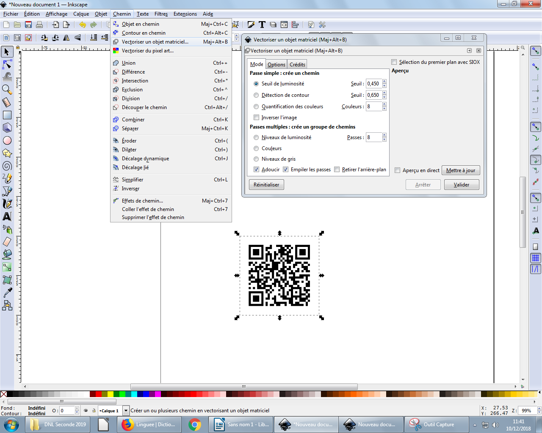
You can see you obtain an another object. Zoom and you remark now, your picture is net

Now you have to indicate the color to grave and to cut
To grave : Black
to cut : Red

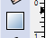
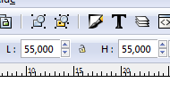
Create a edge to limit the cut size. We offer to obtain a wood sheet of 55mmx55mm

Choose these dimension
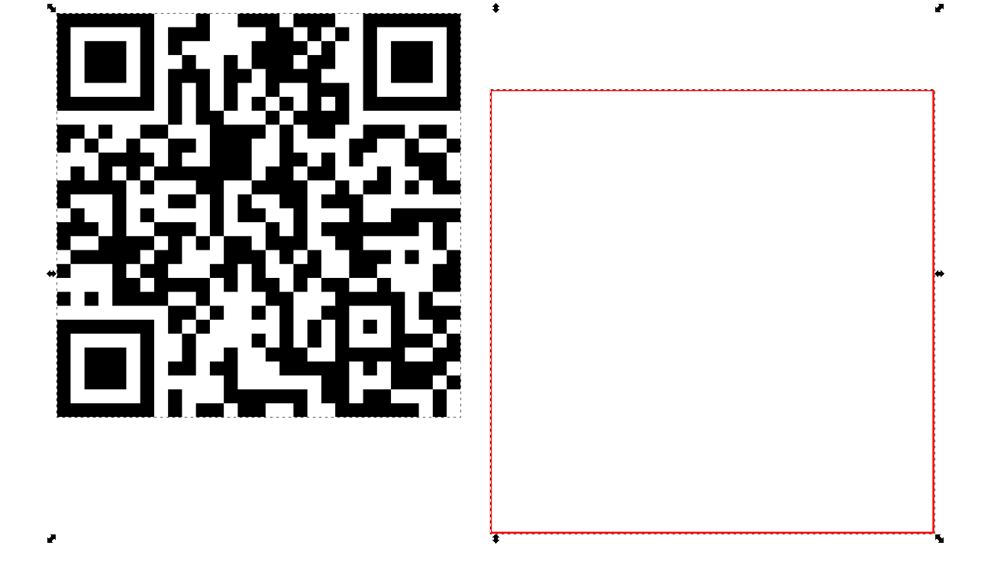
Select the 2 objects and center them by this mean thanks to the “Object” tab:

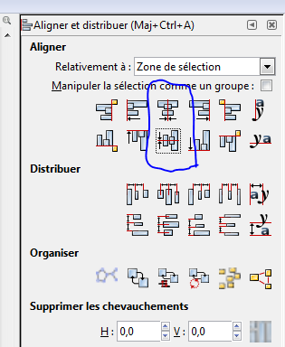

Normally you obtain this
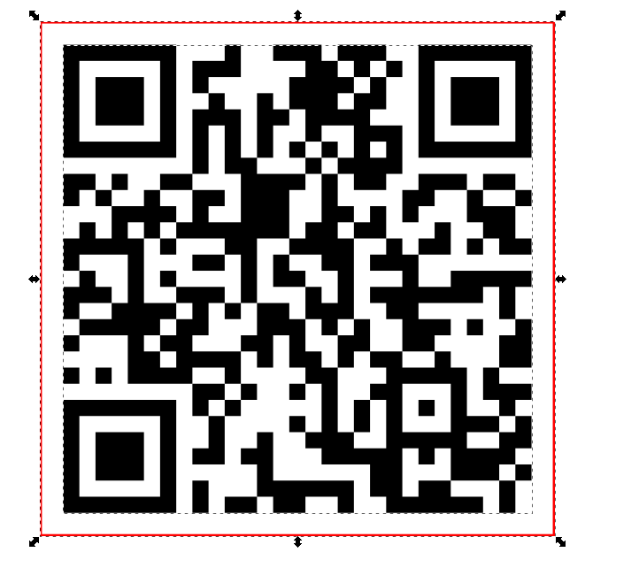

If the edge is black, don’t worry. Click right and choose ‘background ans edge”. Select Edge :

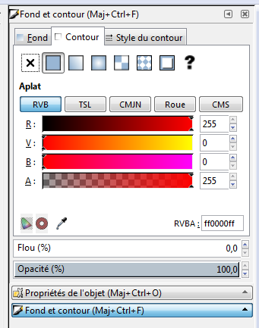
255,0,0 code corresponds to red colour

You have finished almost your job. Save it.

In order to print quickly, create a new file, where you copy your job and the job of 3 other students.

You must put its common file on Inkscape QR Code Files on Twinspace (my twinspace).

