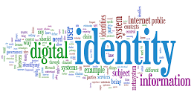
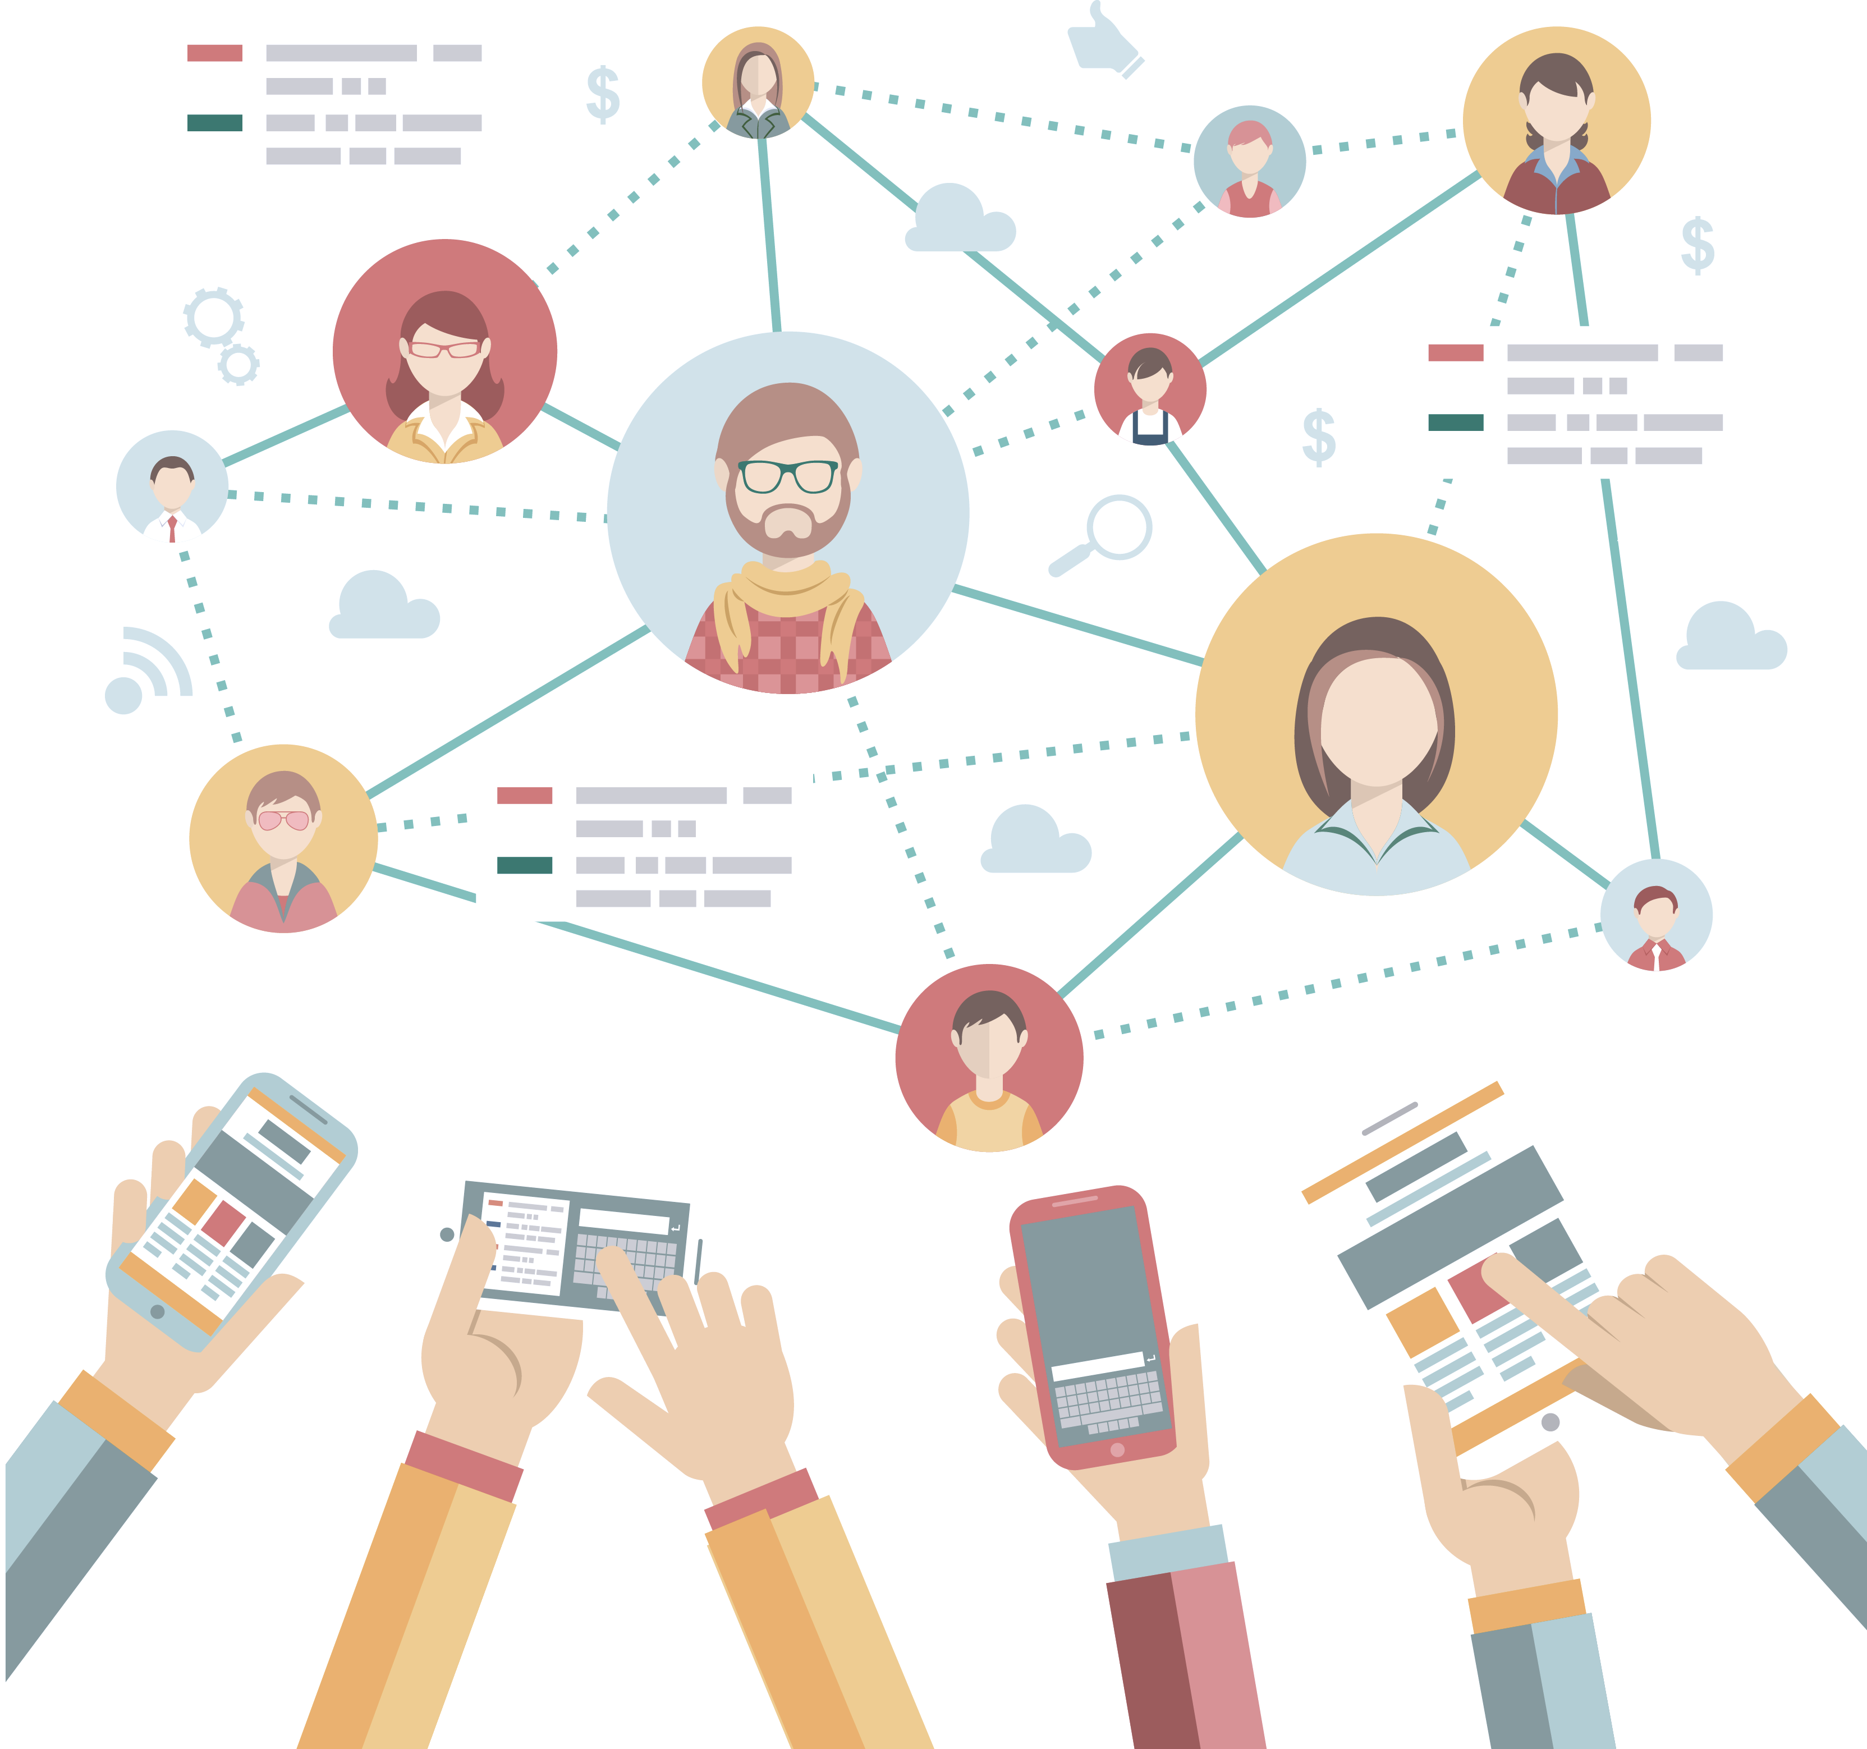
Digital identity QR scan Workshop

DNL 2018-2019

Workshop : QR code scanning application
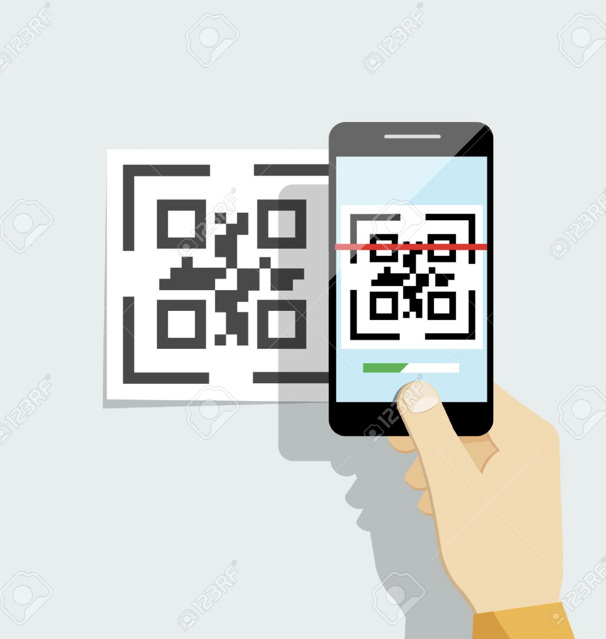

Androïd QR code scanning aplication.

Each code will contain :

- Your "url path" from your Digital_Identity_Form TWINSPACE's uploaded work.

Step 1 : QR code generation

Open the website : https://www.qr-code-generator.com/
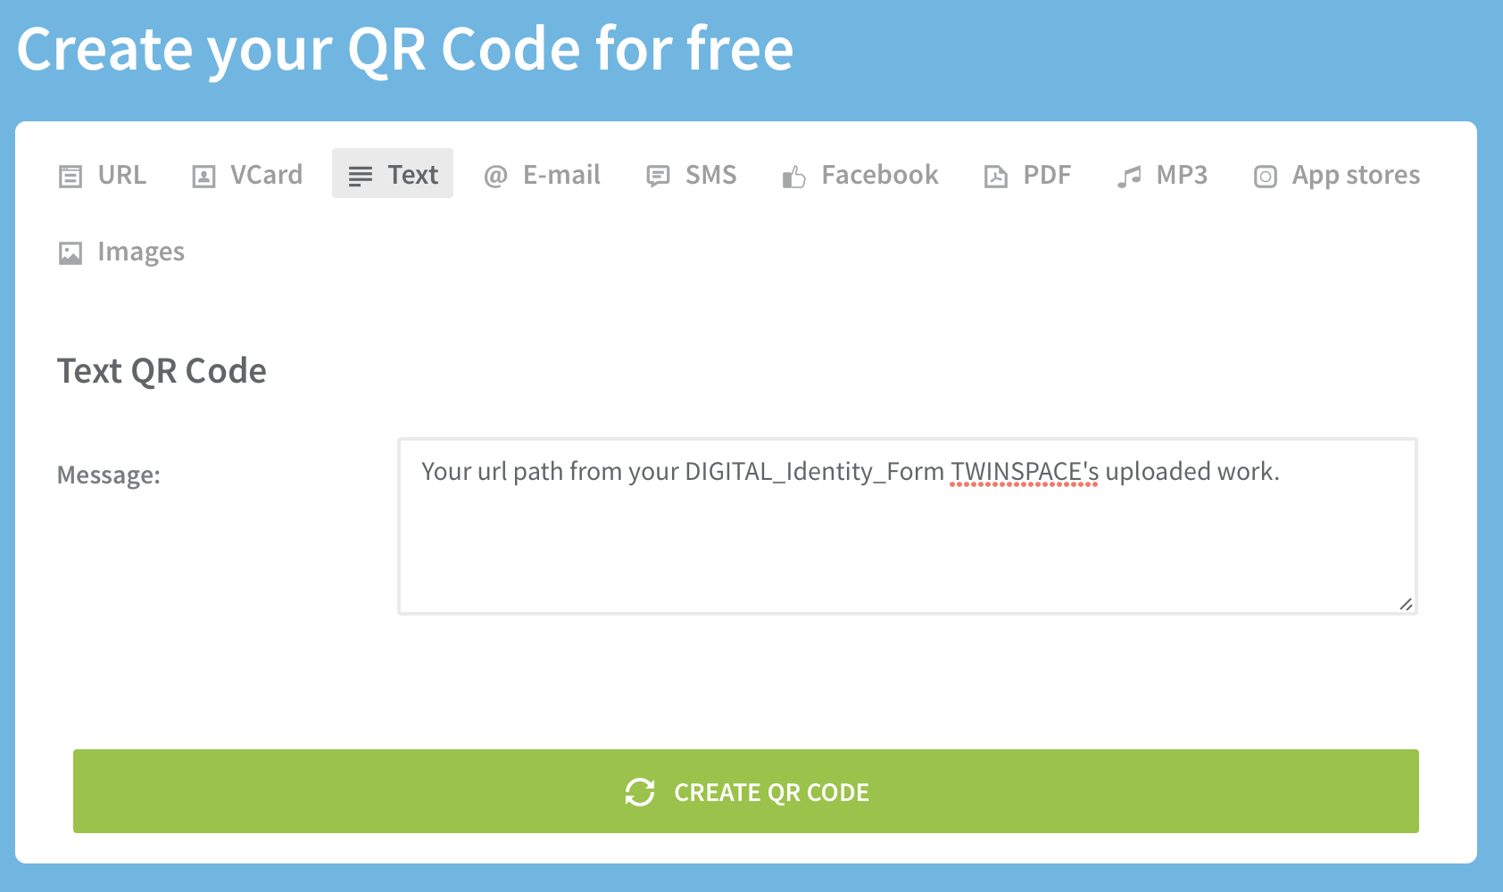

Select the Text mode
Create your own QR code
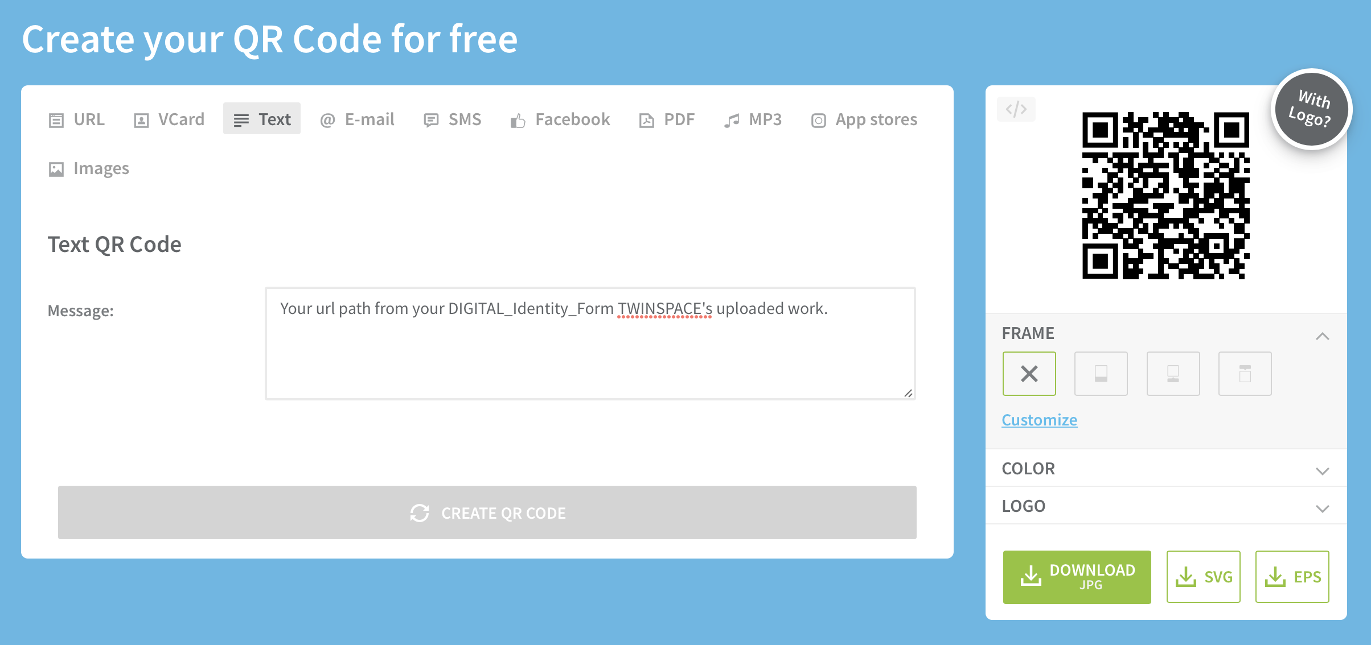
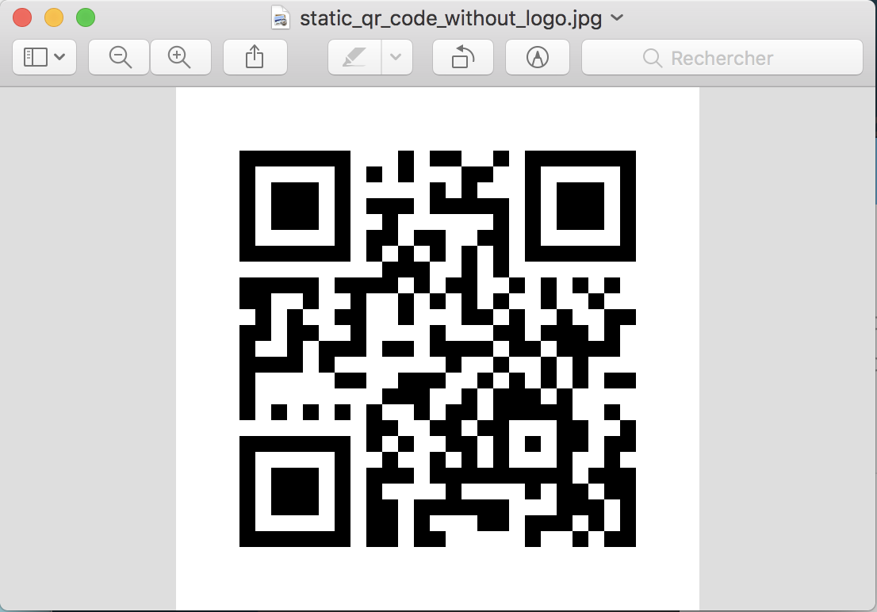
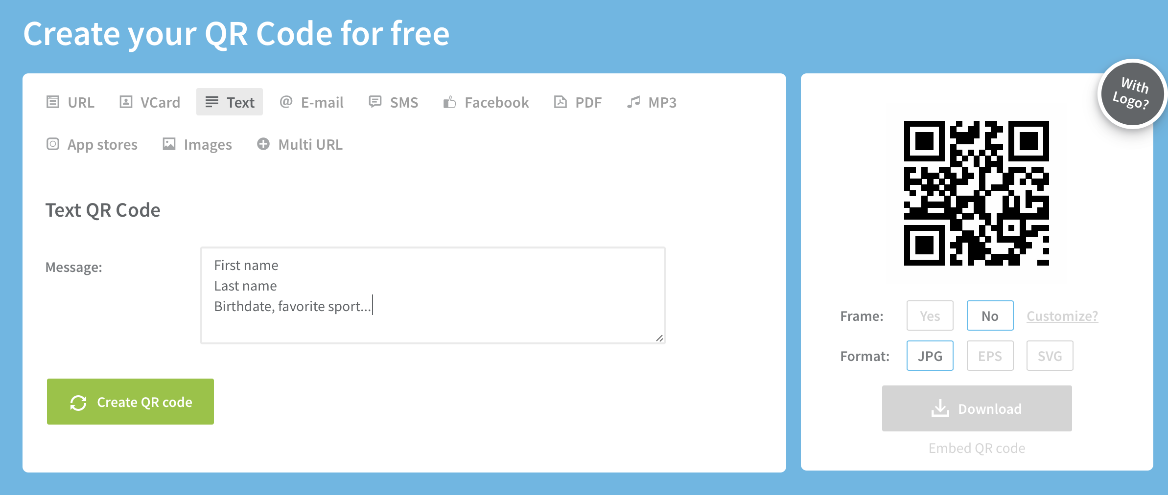
Download your QR code file

Step 2 : Create an Androïd application

Objectives
- To scan QR codes
- Display embedded informations

Open the website App Inventor : http://appinventor.mit.edu/explore/

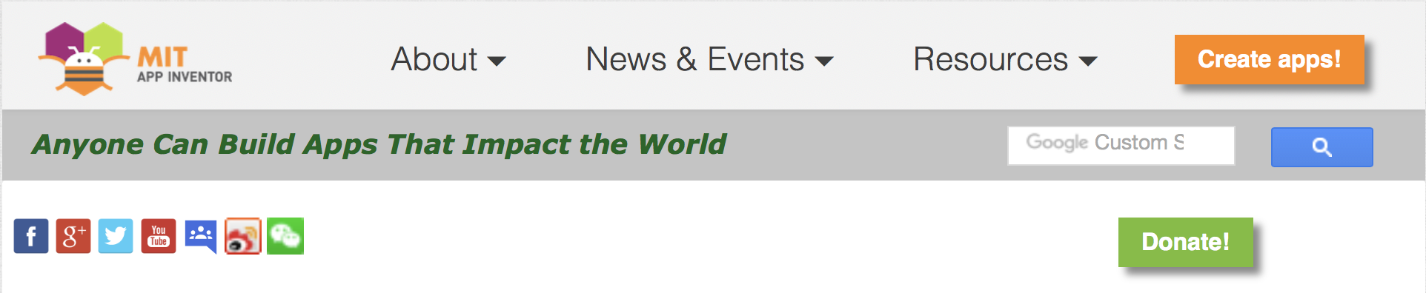
Select Create apps! icon

Connect the app from your "Google" account [so you're not longer anonymous …]

Begin a new project

Choose your project name

Have in mind to add your "login" to your project name.
Ex : QR_CodeLogin

Designer and Blocks Editor
If you need help : http://appinventor.mit.edu/explore/designer-blocks.html

Create the graphical view of your application

Insert a "sensor" type BareCodeScanner

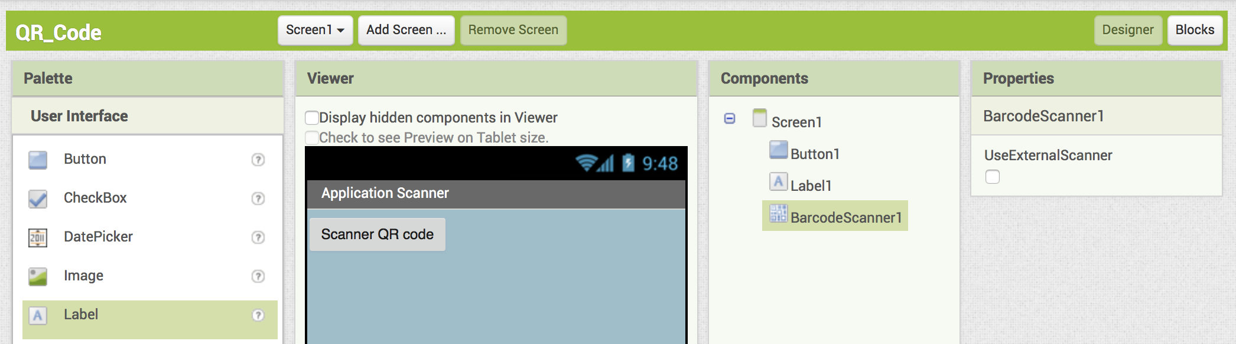
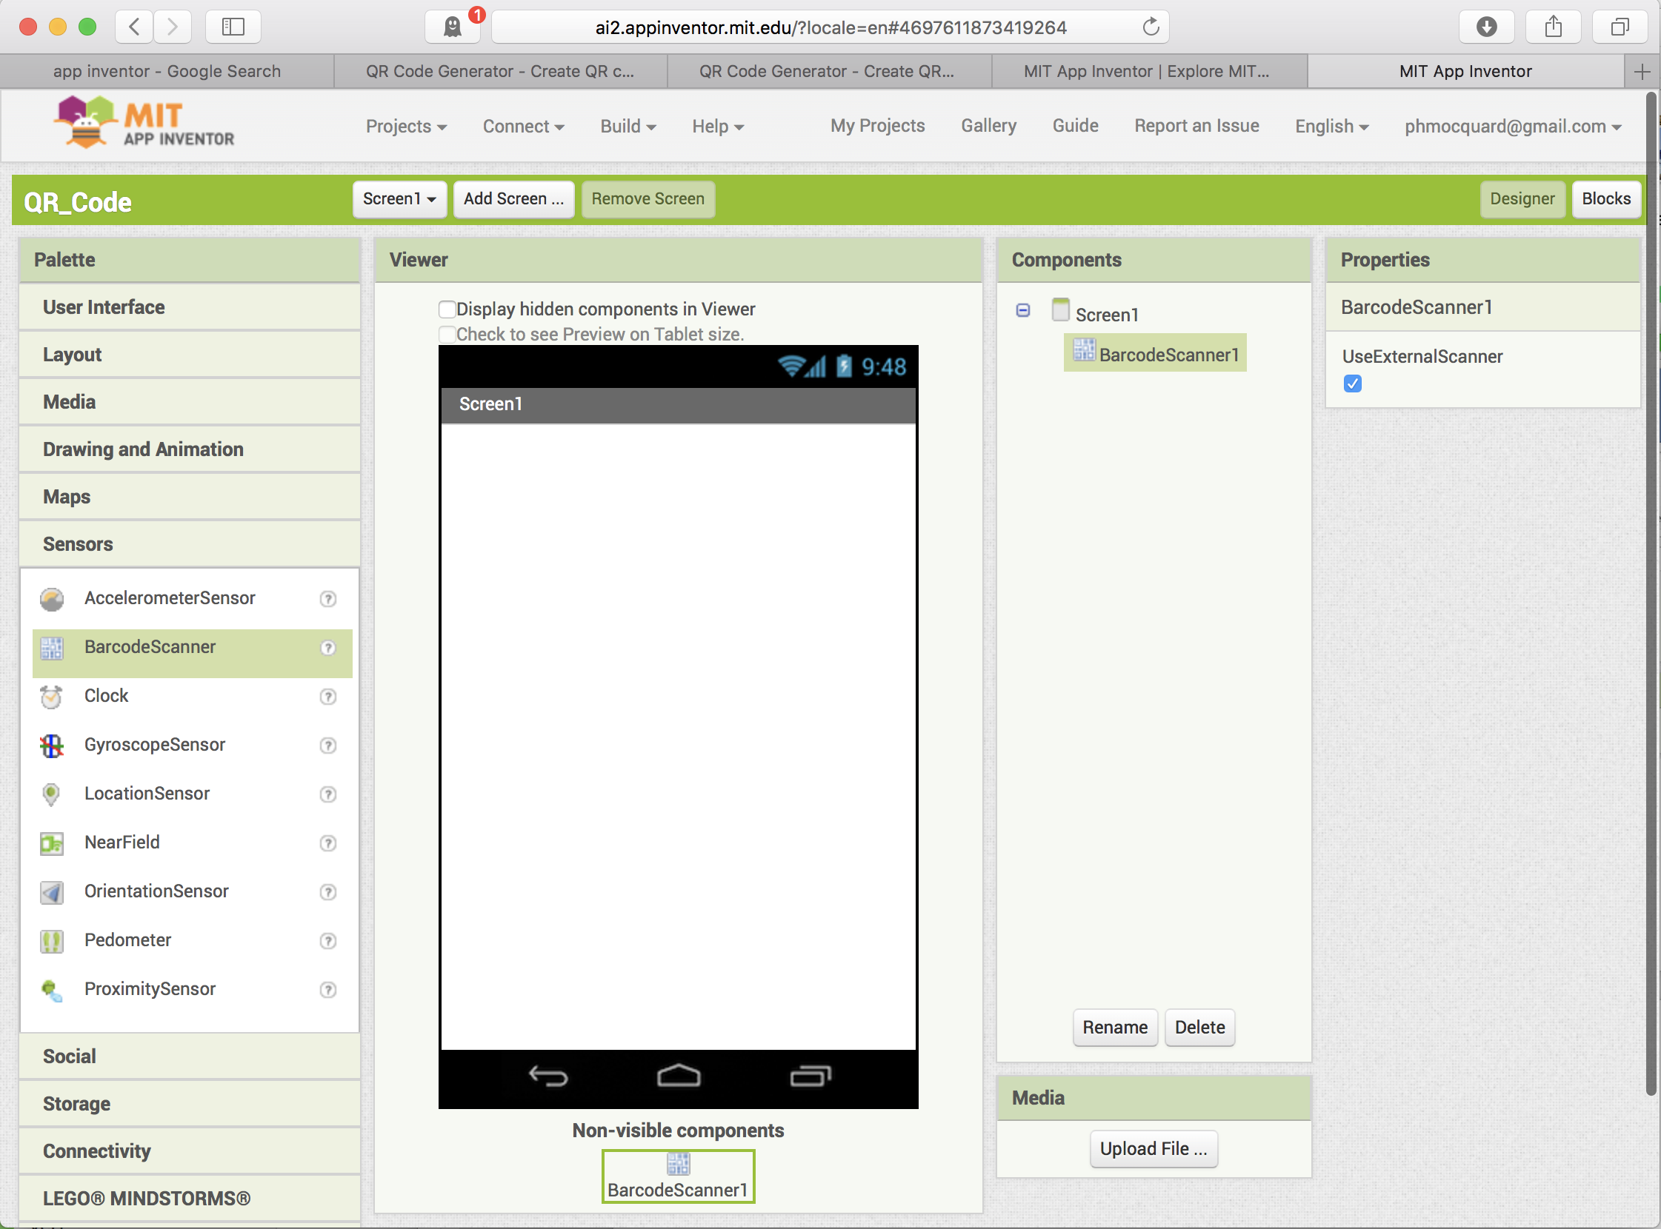
Drag and drop the object on the screen of the handset…[unselect UseExternalScanner]

Add a "Button" and a "Label" by the same way.

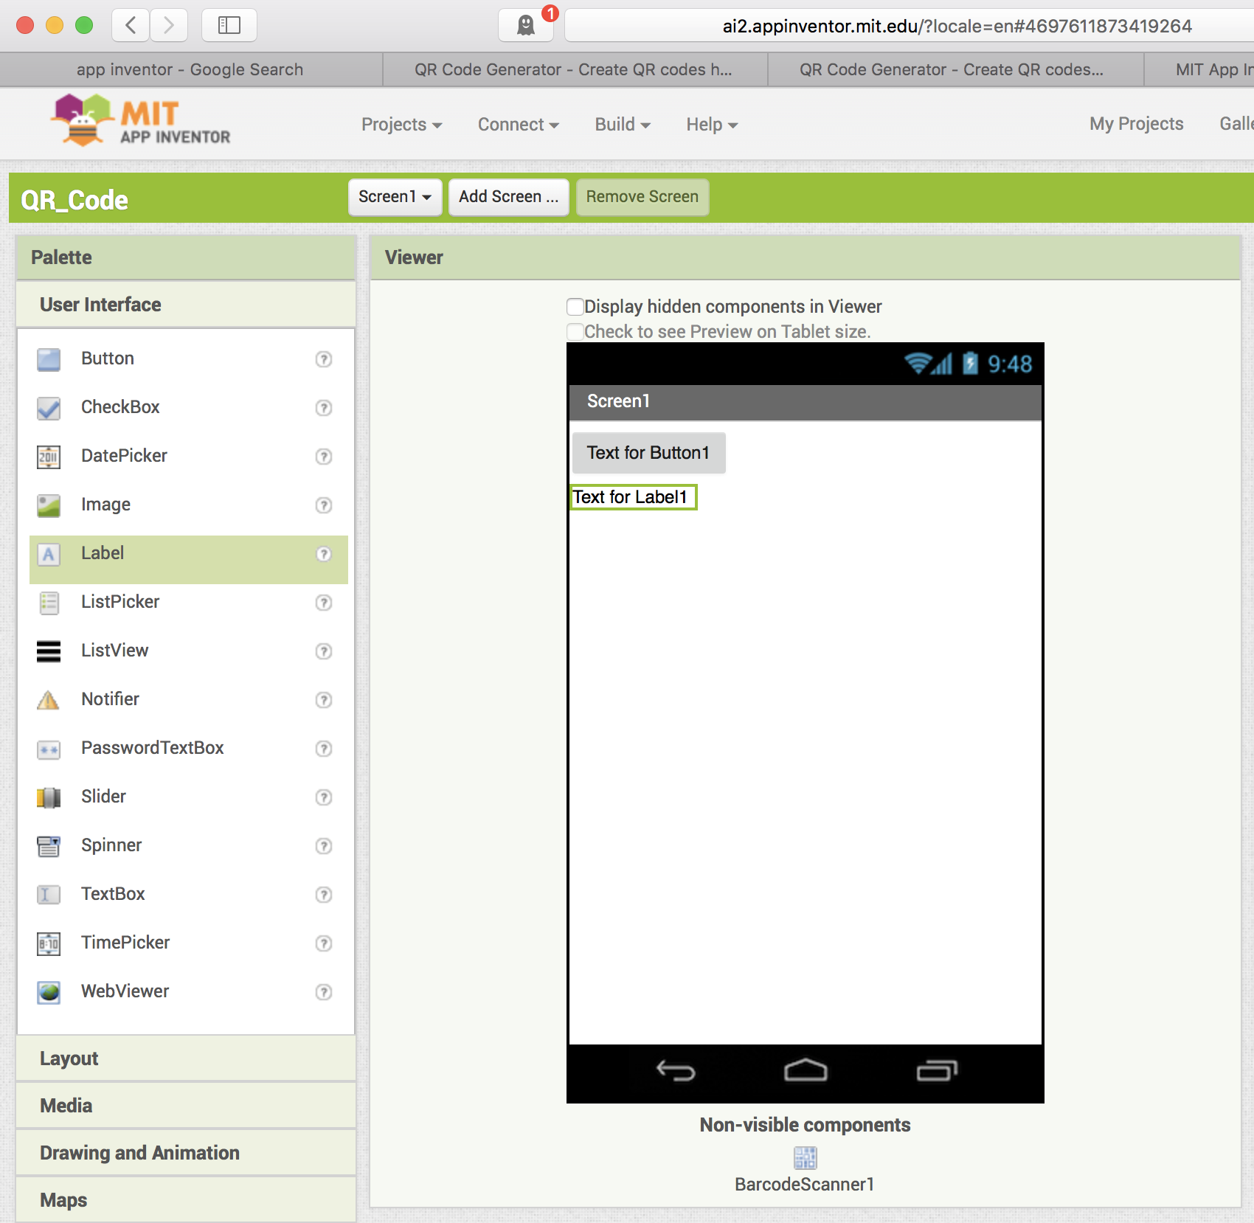
Customize the objects :

Property Title du Screen1

Property BackgroundColor du Screen1

Property Text du Button1

Property Text du Label1 => vide

Property Width du Label1 => Fill parent

Customize all the objects you can
Create the program of the application

Tooggle from the design mode to the Blocks mode [program]
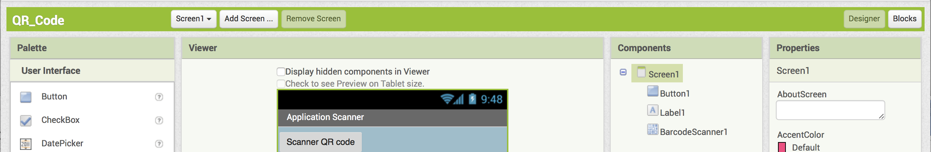

You can see all the available objects already presents in your project
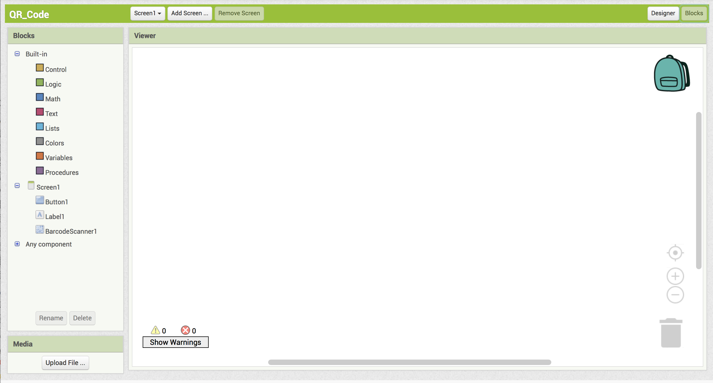

Select the Button1 object :
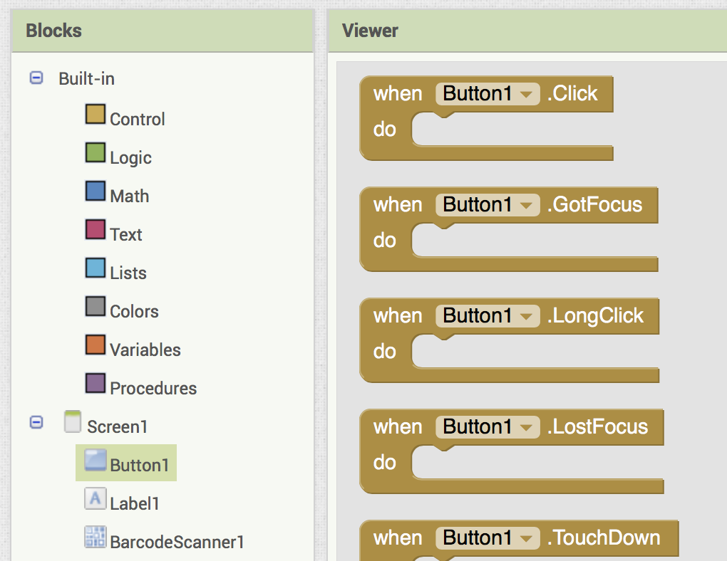
Drag and drop the algorithm block "When Button Click" in the sheet of the editor.
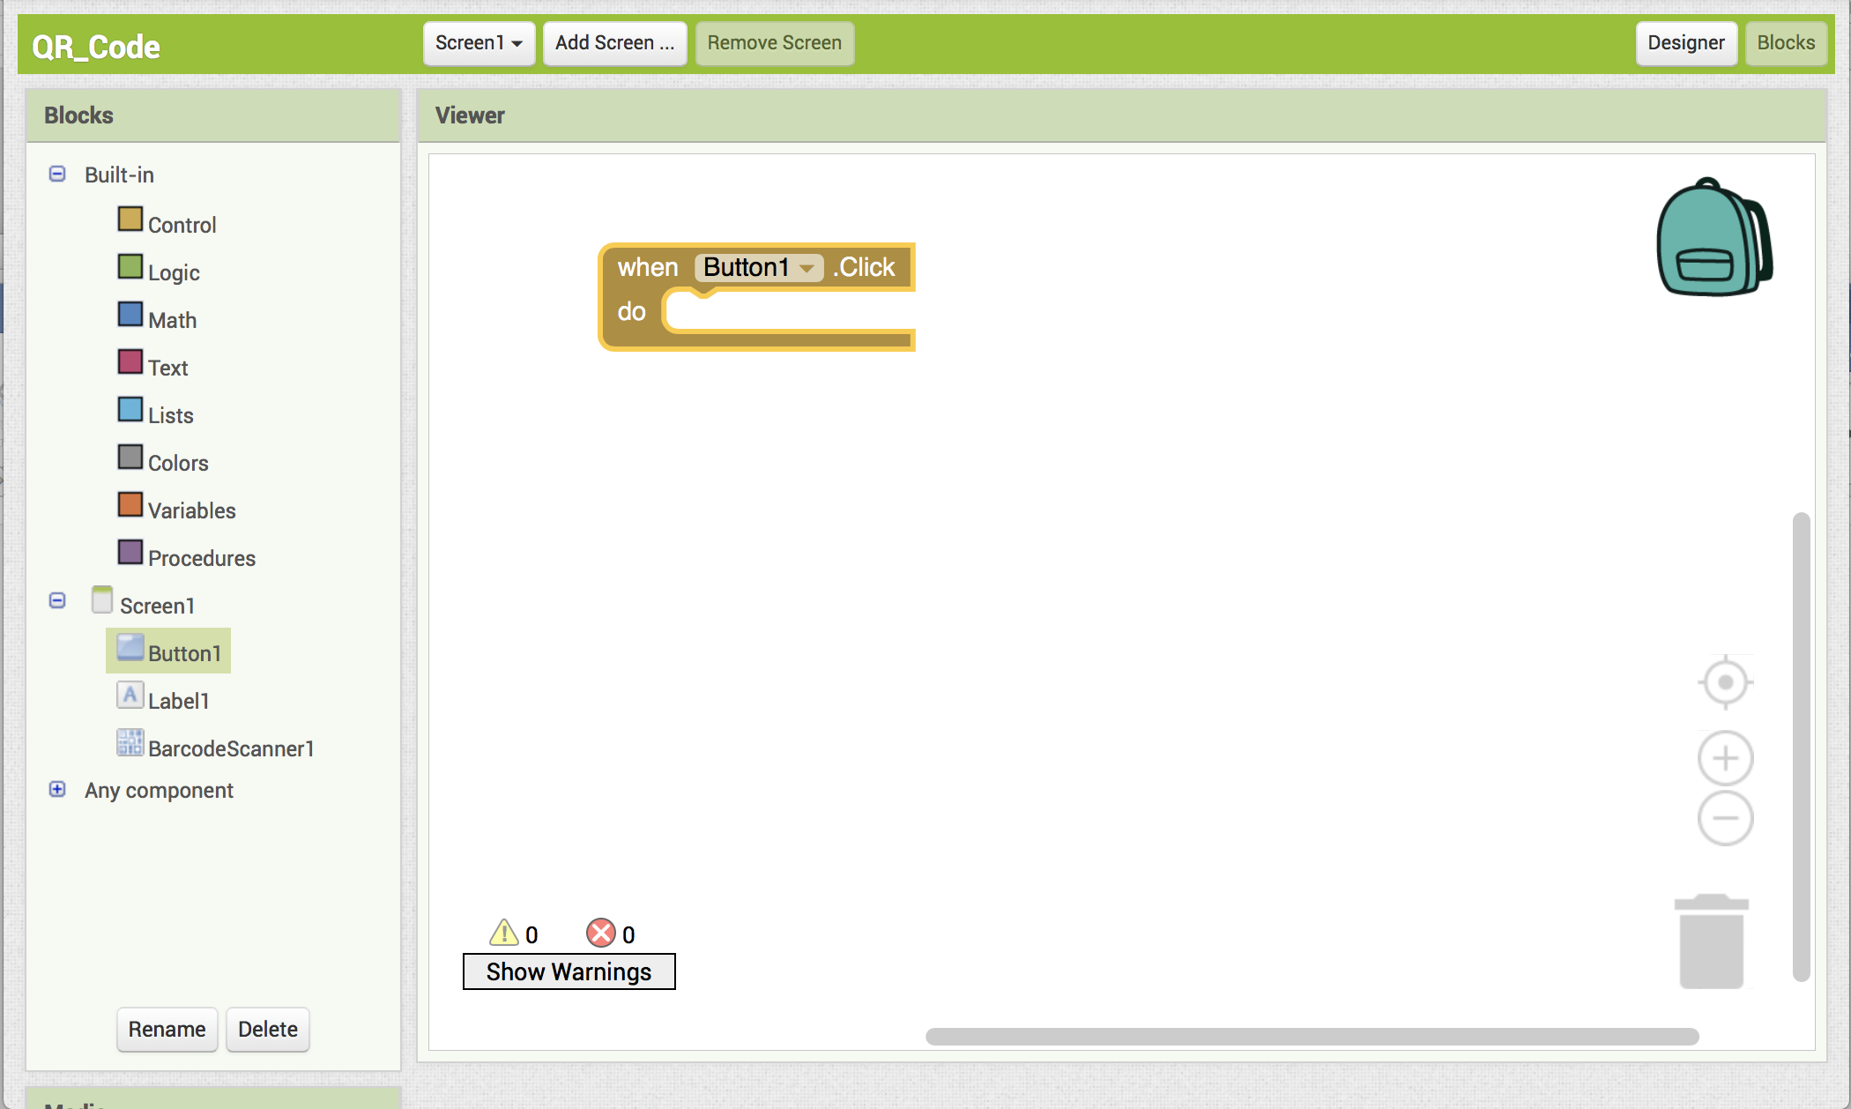

You need to embed the block "call BarcodeScanner1.DoScan" in the object "BarcodeScanner1" …

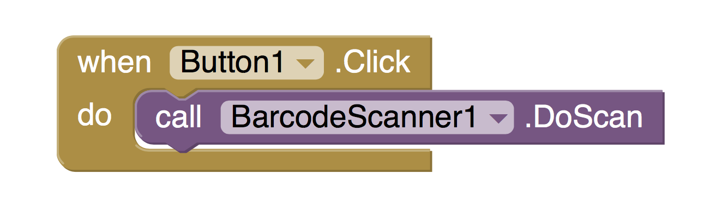

Add an action to copy the result of the scan in the value of the object label1 :

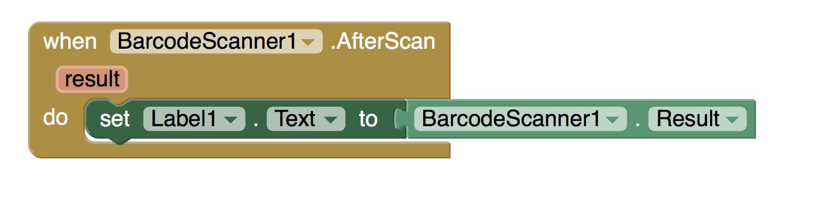

Build the file "apk" of your application

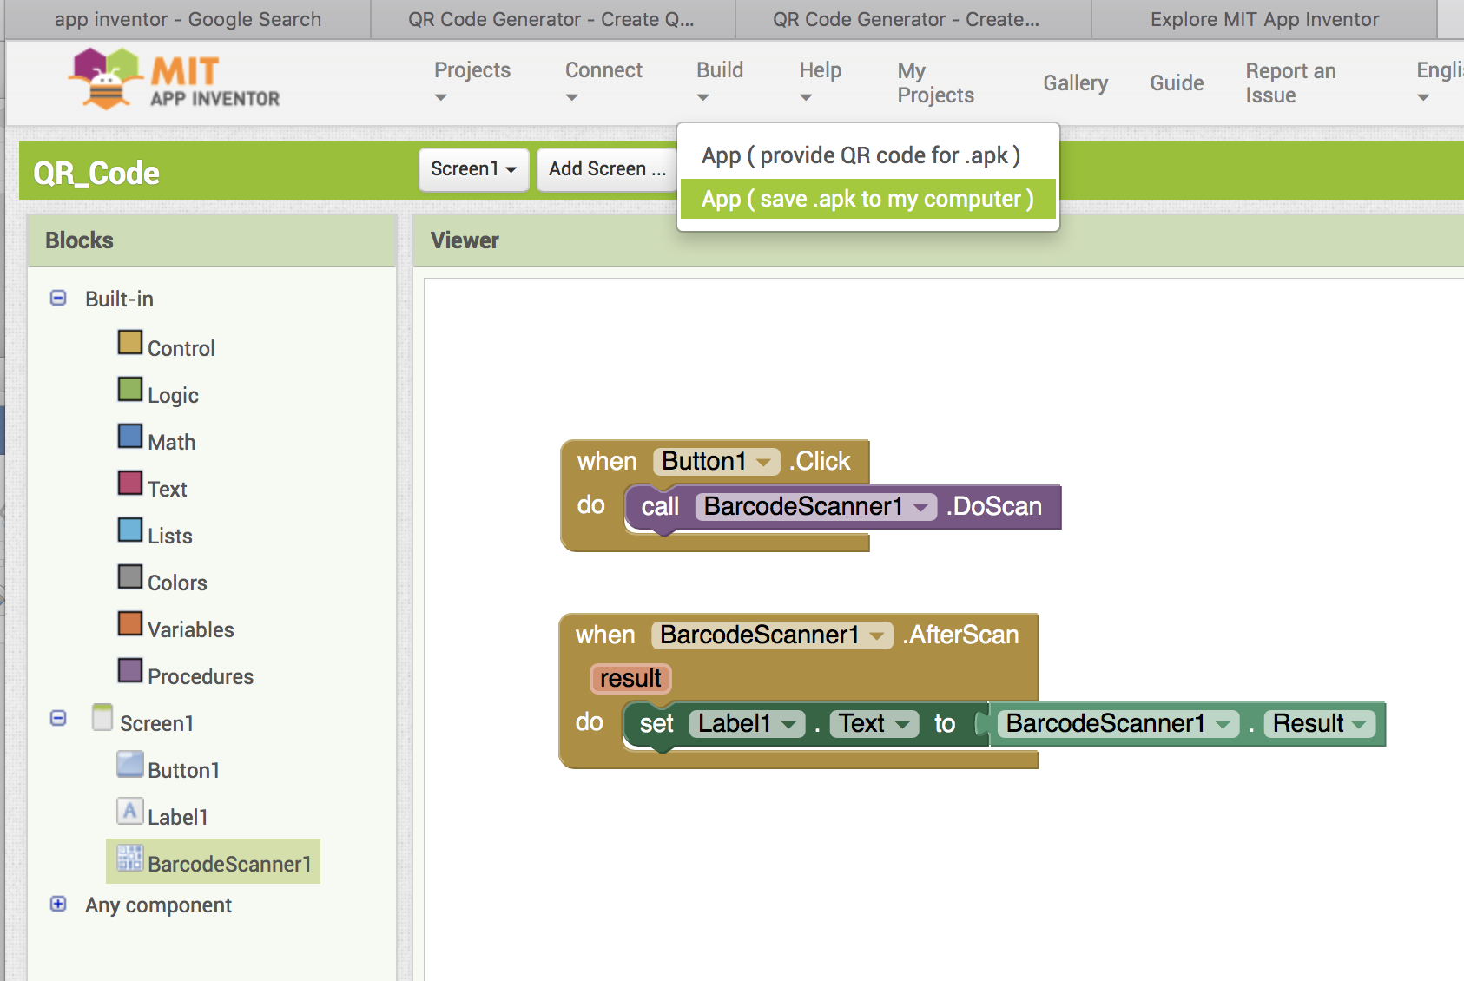

Download the file "apk" in your handset with an usb cord

You have to allow the unknew sources in the safety menu of your cellphone

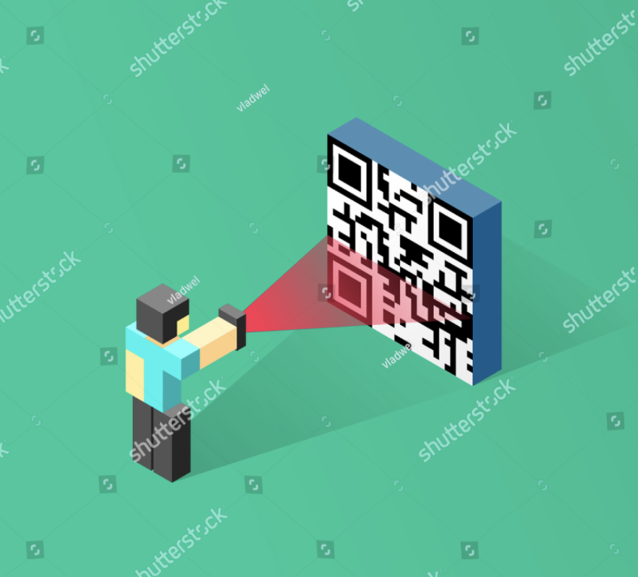
Install the program in your handset
Open your great application

Scan some digital printed identity QRcode

Make a report [pptx file format].
Embbed pictures, comments…
Explain to the Italian and Spanish students
Make a pptx kind of file
Add your names on the first page.

