Goal:
Through this lab-work, you are going to find out energetic digital signature of each household goods and how is it possible to know if you are at home or not
At the end of this job you will have to explain the energetic digital signature at your classmate.

Presentation

Diagram
Consospy allows the electricity customers to reduce the energy consumption.
Each time the good consumes 1WH, the switch is closed
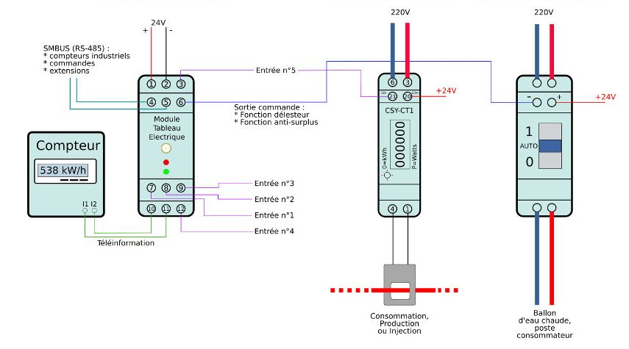
Hot water tank
Current transformer as so it measures current used by household goods as Heat pump
Light, heater ..
Inputs: they receive a high level (+24v) each time their relative counters measure 1Wh
Each time the good consumes 1WH, a high level is send to the input 3
Energymeter
Others energy meters

ERDF energy
meter

Energy Counter:
This device collects all the informations providing from energy meters en send by radio these information

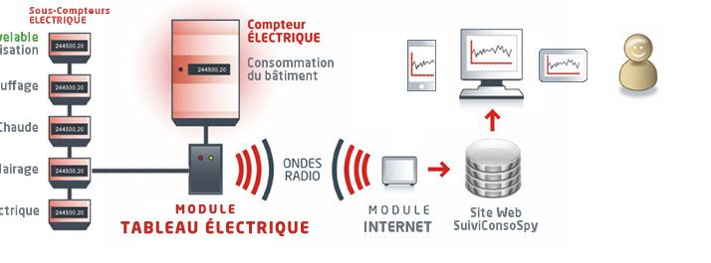
HAVC
Hot Heater tank
Light
Heater
Renewable energy
Electrical
energy meters
ERDF energy counter

Energy counter
Internet
Gateway
Web site consospy

Explanation
The electrical energy consumption is measured by energy counters. These counters measures intensity (current) flowing the different household goods as so the voltage. Thus, thanks to these 2 parameters, it calculates the electrical power and the electrical energy.

Electrical Power = Voltage x Intensity
P = U x I
Counter’s switch is closed each time it measures 1Wh (Watt hour) or (3600 Joules). This information is transited to the energy counter. This energy counter collects all the informations providing from all the energy meters. It counts each energetic impulsion. After, its send these data to Consospy in the first time by radio, then by internet thanks to the gateway.

Energy = Power x Time
Joules = Watt x seconde
WattHour = Watt x 1 hour so 1 WH = 3600 J

To resume, the electrical energy measurement are transmitted.
The Consospy Site allows user to see the energy consumption in real time.

Let’s go

Consospy site

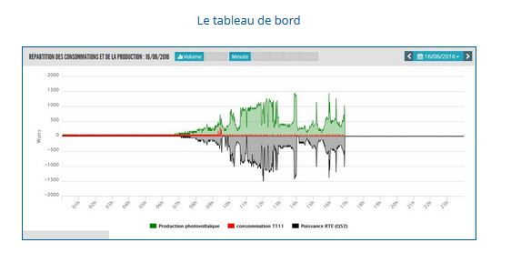
Firstly go to e-loco livet site.

And click on this picture.

You have access to this diagram
Electrical consumption
Of one circuit
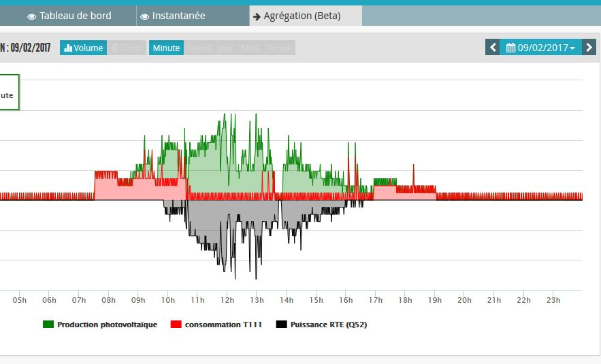
Solar energy

Date

Electrical Energy send to the grid

Time

Hours of the day

Thanks to the graph, we can identify the different devices when they work. The energy is also easy to see because energy is the produce of Power by Time so here, to know energy, you measure the area.

This graphs shows us the power produced by photovoltaic panel or consumed by 2 computers and a printer
Someone print a paper. In function of the longer of the peak, the printed file is more or less important
Someone switch on a computer

Power in Watt

Standby energy

Peak energy du to the work of the printer

It is your turn to play
Power
Set on Personnel computer
We give you some devices (heat pump, lamps, electrical motor, and you are going to plug them one by one in order to collect their own energetic digital signature. Ask to the teacher to give you an electrical counter in order to measure the electrical power. Thus you will compare the power transmitted by Consospy site and tour measure. Each time, time by recording the start time, the end time, and the period.

Be careful, each time you have plugged in, you have to wait because Consospy system needs few minutes to send data to the site.

Anyway, ask to your teacher where you have to connect devices and which devices you are going to analyst.

At the end, you have to prepare a sideshow which presents the different goods signatures.

Imagine if a third part site collects this kind of information and what may it do with ? Ask your classmate about this question.

