Goal:
Through this workshop, you are going to find out how your data are keeping. You are going to discovery where have you been there was long time ago, which video in you tuble you have been shown, well how google can know plenty of things about you.

Labwork

Connect to your google account
Go to Firefox web browser and connect to your google account
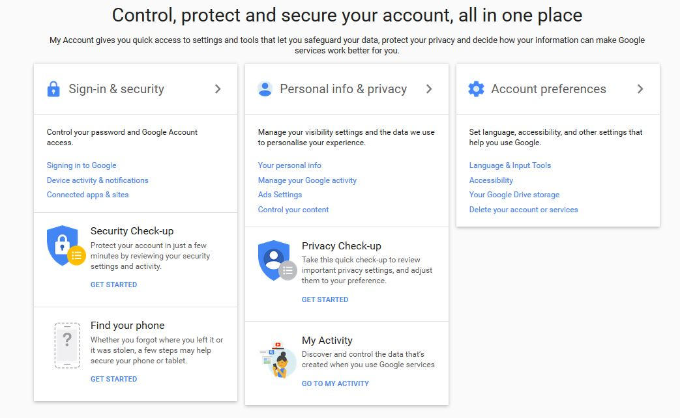

My activities
Click to “my Activity”

So you find out this screen.
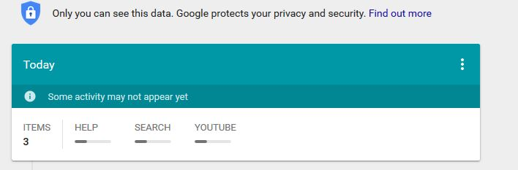
This panel allows you and mister “Google” to know where have you been today and since you have your account !!!!!

So anyway, as you are going to see, it is possible to delete one per one.

For example, I would like to delete this research:
Click here
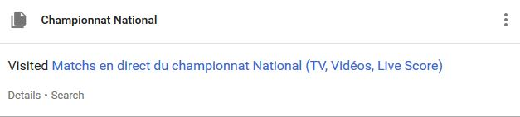
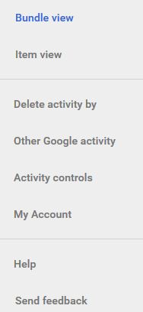
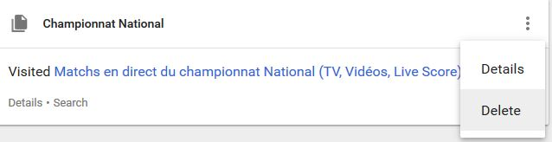
Delete and indicate you really want to destroy this research.

You can also delete all the data by this mean:

My geolocalisation
Now, do you know, since you have your smartphone, you are geolocalised.

So to discovery where I have you been during holiday, follow this tutorial.

Click to “Other Google activity”

This screen appears :
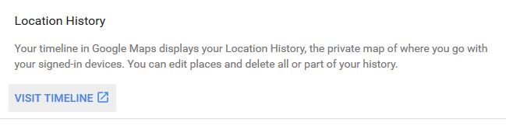
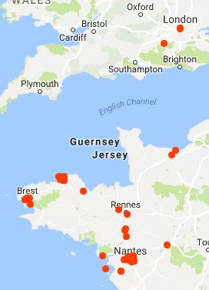
So visit Timeline
You will obtain where have you been during you have met your smarphone when the geo-tracking was activated.
It’s wonderful, isn’t it? (it’s a joke)

Click here and you are going to discovery how knows the spots you spend more time.
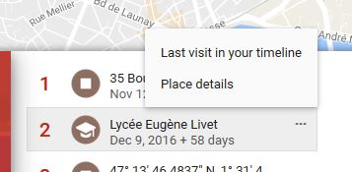

For example :
click “last visit or place details, let you discovery where you have been and ask you this question, why google keeps this kind of data (where have you been, how long, how..). Anyway , good browse.

What doest it know about you, how is your digital identity
a) Illuminus
Go to the site of Illuminus: https://illuminus.io/fr/
Watch the video to understand the goal of this site.

Make your prediction if you have Facebook Account or discovery witness account.

What doest it know about you, how is your digital identity

b) Apply magic Sauce

Go to the site of apply magic sauce : https://applymagicsauce.com/

Make your prediction if you have Twitter Account.

What doest it know about you, how is your digital identity.

c) amiunic
Go to Am I unique. https://amiunique.org/
Discovery your browser fingerprint
List all the informations which allow the spy sites to know who are you.
Go to “detail” to obtain more informations.
Go to Global Statistic

Your Job :
Create a mind view map about your fingerprint.
Complete your digital identity form and drop it on Twinspace.
Now you have to prepare a presentation to explain what have you got found out thanks to this workshop.

