Goal:
Through this labwork, you are going to find out how are you identify by your machine and which IP/Networking Commands you can be used to discovery how your data travel in the word.

Presentation

The differents parts of a network.
Computer networks are basically built from three components; End Devices, Networking Devices and Media. End Devices:
- End devices are used to access or transmit the data. Computer, laptop, data server and tablet are the example of end devices.
- Networking Devices: - Networking devices are used to control the data flow. Switchs, Routers, HUB, Bridges, firewalls and modems are the example of networking devices.
- Media: - Media is used to transmit the data. Copper cables, fiber cable and wireless signals are the example of media.
Following figure illustrate a simple computer network

Remark about IP Address and mac address
Every computer in network has a unique network address. This address represents its location in network. Computer address is built from two addresses IP address and MAC address.
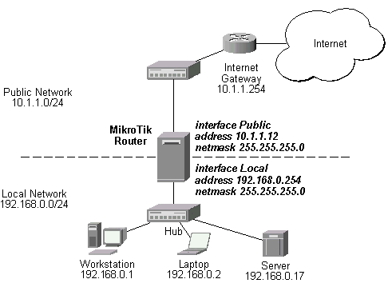
The router or gateway permits the messages to go out of your local personal network or to receive messages from outside

The switch allows the message to the good address:
For example, when you want to print a paper from a computer, the file is sended to the IP printer

This is a IP address. As you can see this 3 devices are almost similar.
The address of the network in 192.168.0.0
And the host are .1 for the workstation
.2 for the Laptop
.3 for the server.
Remark: at your home, normally you will have the same kind of address beginning by 192.168.0…..

IP Address: - IP address is a software address. We need to configure it on each PC.An IP address (Internet Protocol Address) is a label given to a device that is used to identify and locate other devices. These addresses allow devices to communicate on and between networks. To access the web configuration utility, you will need to find the IP address of the device you are using. Often, a local aera network have the IP address which begins by 192.168.0.n (n: number of the device)

MAC Address: - MAC address is a hardware address. It is assigned with Ethernet card from its manufacture company. Each device has its own MAC address.

Labwork

Go to command prompt
Navigate to the start menu and choose All Programs > Accessories > Command Prompt. The Command Prompt window opens:

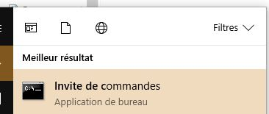

Remember when you type from the command prompt you can only write one command per line, and press Enter after each one to execute it.
For example, type color F0 and the screen becomes White.

How to Determine the IP Address of a Device
Type Ipconfig and then press Enter to display the applicable current TCP/IP configuration values.
You obtain this kind of screen
This is the ip address of your computer
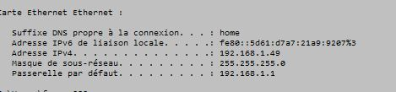

This is the ip address of your gateway (or your box)

The gateway allows your data to get out from your computer to the web or come to it.
Now you know your IP Adress, so you are going to see if your computer can communicate with the neighbourg computer.

Ping Command
A lot of IP devices are used in industry, home, tertiary sector like bank, supermarket. Some devices are sensors, human machine interface, processing unit, power devices. So, if there is troubleshooting for the accessibility of devices, you can use “PING” command to verify the communication. The ping command is a very common method.
The ping command first sends an echo request packet to an address, then waits for a reply. The ping is successful only if:
- the echo request gets to the destination, and
- the destination is able to get an echo reply back to the source within a predetermined time called a timeout. The default value of this timeout is two seconds on Cisco routers.
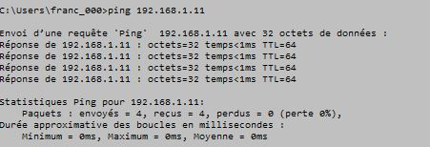
Time to Live :
Number of router the demand can pass through before to reach its target
This is the ip address of your computer

Ask to your neighbourg, his IP address and set ping command and verify your can communicate.
Now Ping www.google.fr and ping google. You can verify Google can send you too some message because the communication is done!

MAC Adress (Media Access Control),
To know the MAC address of your computer, use the “arp -a” command. You will discovery the physical and unique address of your board. Each network card contains a code built by 48 digits.
Indeed, the IP address can change but not your MAC Address.
The first part of the address is the name of the builder.
The protocol ARP allows to connect physical address and logic address of each station which are connected into the same local aera network.
Type arp -a . You will discovery the correspondence table between logical and physical address.

Traceroute commands
The tracert command is a Command Prompt command that's used to show several details about the path that a packet takes from the computer or device you're on to whatever destination you specify For example write this command: tracert “address of your neighbour” as this example.

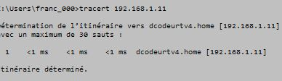
It takes less than 1ms to communicate to my TV Decoder
So know realise this command:

When I set this command, as you can see, my request went to Aubervillier, then Villeneuve Dascq at France Telecom firm, and at least to Lilles !
So let’s go to google.com or Facebook for example and see where your requests travel.
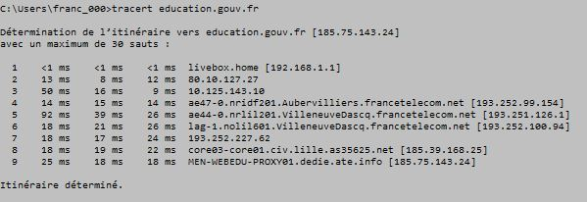
Look, certainly, this is IP adress of my internet provider from my district.
When IP adress starts by 10…., this is a large network!
When I set this command, as you can see, my request went to Aubervillier, then Villeneuve Dascq at France Telecom firm, and at least to Lilles !
So let’s go to google.com or Facebook for example and see where your requests travel.
So know realise this command:

Your Job :
