Goal:
Throught this labwork, you are going to find out how many third party sites are connected without your knowing. Where do they from, and their goals.
At the end of this job you will have to explain this Add-on module at your classmate.

Labwork

Set lightbeam Add on module

Go to Firefox web browser and choose “Modules” or go to Firefox browser and write ligthbeam
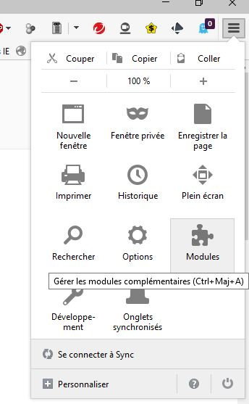

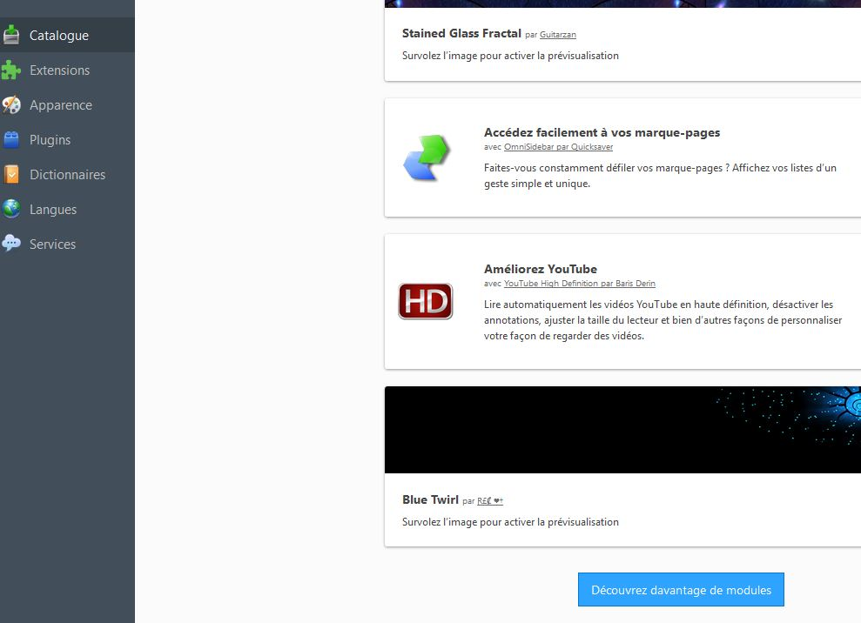

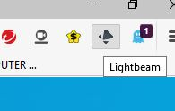
Resarch the “lightbeam” add-on module and set it.

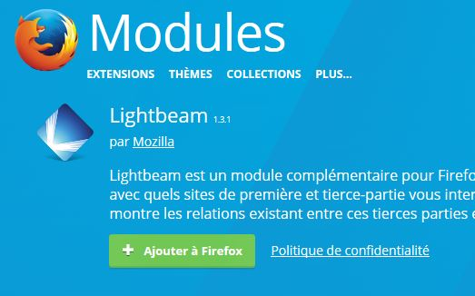

Discovery Lightbeam add-on module
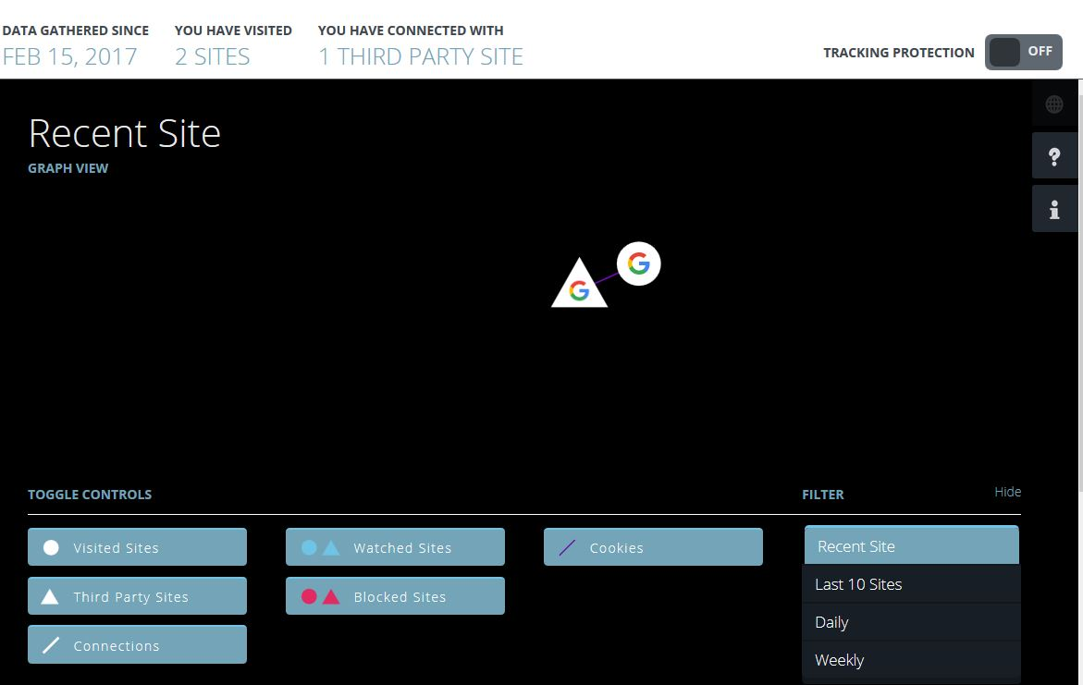
So you can launch lightbeam add-on module by this icon
You would obtain this kind of graph because you use only Firefox web browser

Find what the circular node and triangular node significate.

Click on the circular node and find which country hosts this web site.

Browse on these sites : Example French site but you can choose Spanish or Italian sites.
- https://www.lequipe.fr/
- http://www.lemonde.fr/
- http://www.lepoint.fr
- https://www.tf1.fr/
- https://www.6play.fr/m6
- http://www.sarenza.com/
- https://www.zalando.fr
- http://ww w.lefigaro.fr/
- https://www.nouvelobs.com/
- https://www.ouest-france.fr/

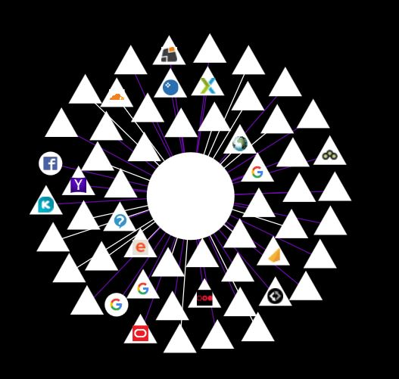
Brows on each site.

Come back to lightbeam Add-on Module.

Try to obtain 200 third sites
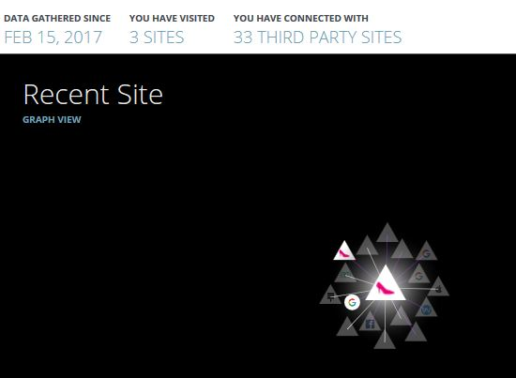
Answer at these questions :
- What does the triangle icon mean?
- How many third party sites are spying you?

Understanding the impact of the third-part site into the capacity of your computer
A What is my logical Address
When you are connected to internet by the means of your smartphone, computer, laptop, the local network identify your device by the mean of a logical address. This address is given automatically by your box or by a server, generally. When you make a request to browse on the net, your data have to past by a router. It has also a IP address. At home, it has often this following address 192.168.0.1. The router allows data to change network. When you are connected to the site you want, the site send data. Thus, some pictures appear on your screen for example. In this case, in the local aera network, the data go from the router to your device.
To resume
IP :192.168.1.1
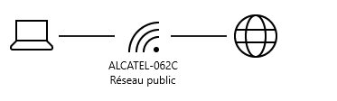
IP :176.180.85.134
Wide
Area
Network
Local
Area
Network
Router

IP :192.168.1.175

So go to the site http://www.mon-ip.com/
It will give you your local IP Address.

Which IP Address communicates with me, what is its name and where is it ?
Open Wire- Software [start Wire-shark software in administrator mode by the mean of right click ].
Choose network board "Connexion à un réseau local".
Go to capture tab if necessary

Start network analyse
Normally you will obtain this kind of “horrible” informations, anyway don’t be afraid!
The first line indicates the data go from my computer to the site I visit. The data transmitted are composed of 1301 packets.
The second line indicates the answer of the site to my computer. 54 packets are send.
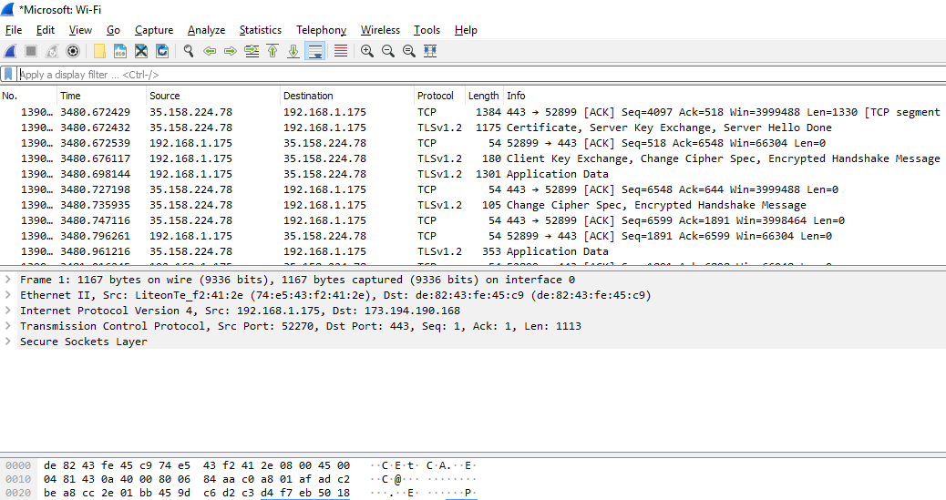

Now go to https://www.ultratools.com/tools/ipWhoisLookupResult
I enter this and I obtain plenty of informations ! So choose one address you have obtained by wireshark
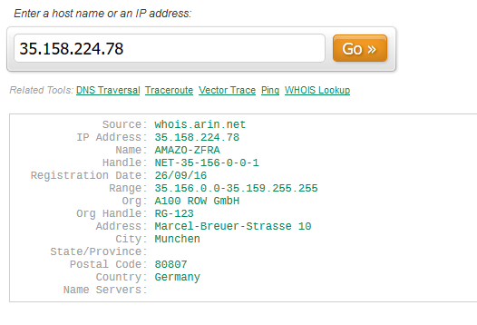
Now after copy this adress, go to IP Geo Location Lookup
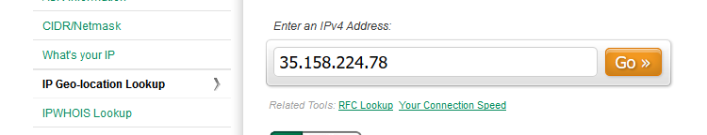
Then go to this site : https://www.coordonnees-gps.fr/
Enter the latitude and the longitude. It is really incredible. Now you have the skills to identify a IP address.

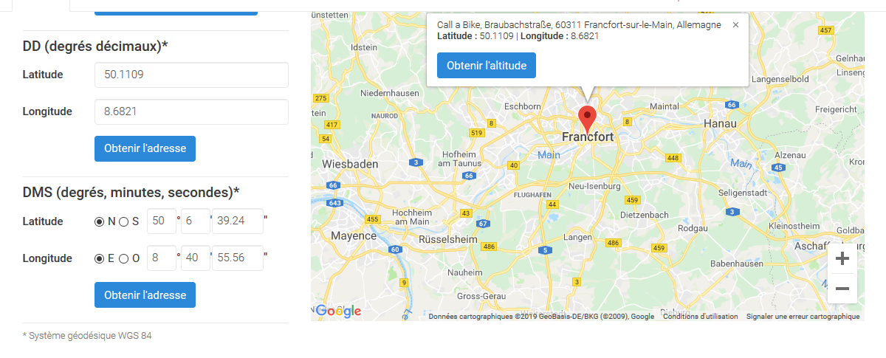

Track the tracker !
Go back to your browser and close all the internet pages or tab.
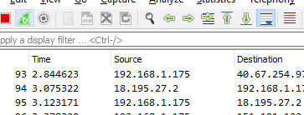
After go back to Lightbeam, reset data and choose only one site you like to go.
Wait few seconds to capture some third part sites.
Go to wireshark and restart current capture
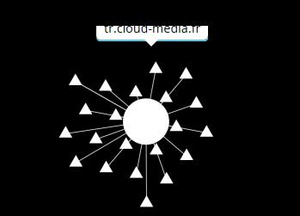
Choose one third part site

Go to whireshark and find it by writing just the beginning of the string.
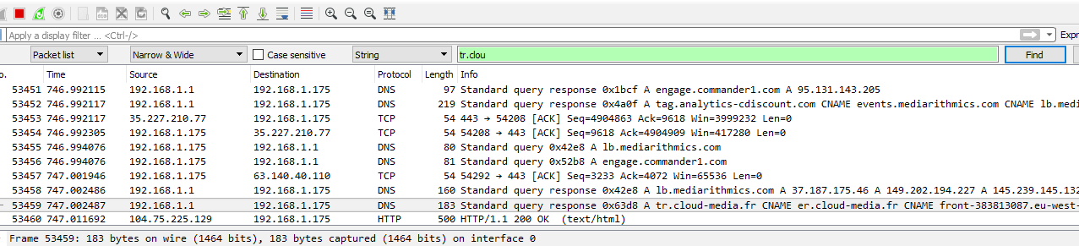

If you want, you can localisable where comes it from
You can see on this example this site uses some data. These data use the media ( the mean to transmit the information) by busying 1464 digits ( 8 digits x 183 bytes : one byte = 8 digits).
So the drawbacks are :
- energy consumption.
- speed decline.
- spying .

Who are the snitch and how to do to block third party sites
Now, you are going to discovery the different kinds of snitch and how to do to block them thanks to an another Firefox module. This module is called Goshtery.
So Set Gosthery module as you have done with lightbeam module.
List the 8 different types of snitch after you click on “parameter”.
Go now to extension management and disable this module for the moment
Go to Ligtbeam, reset and choose to browse one site you like to go.
Capture thanks to snipping tool for example the graph
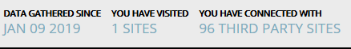
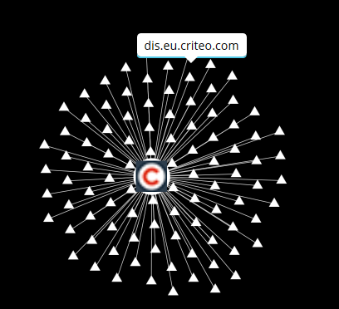
Enable Gohsthery, reset Lightbeam wait few minutes but don’t forget to browse on your site.
Capture an another picture.
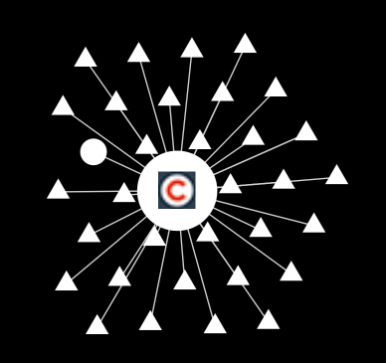

Your Job :
Now you have to prepare a presentation to explain what have you got found out thanks to this labworks.

