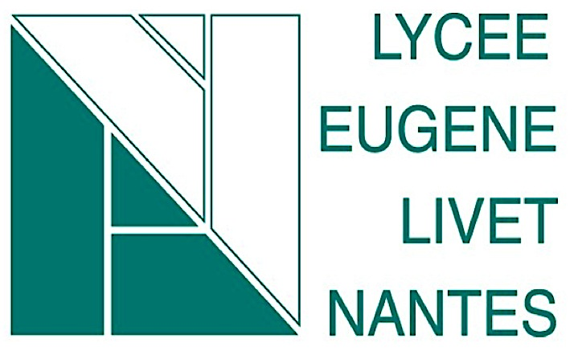

QRcode url link
Connect to your account on the website : https://twinspace.etwinning.net/about
Use your login account
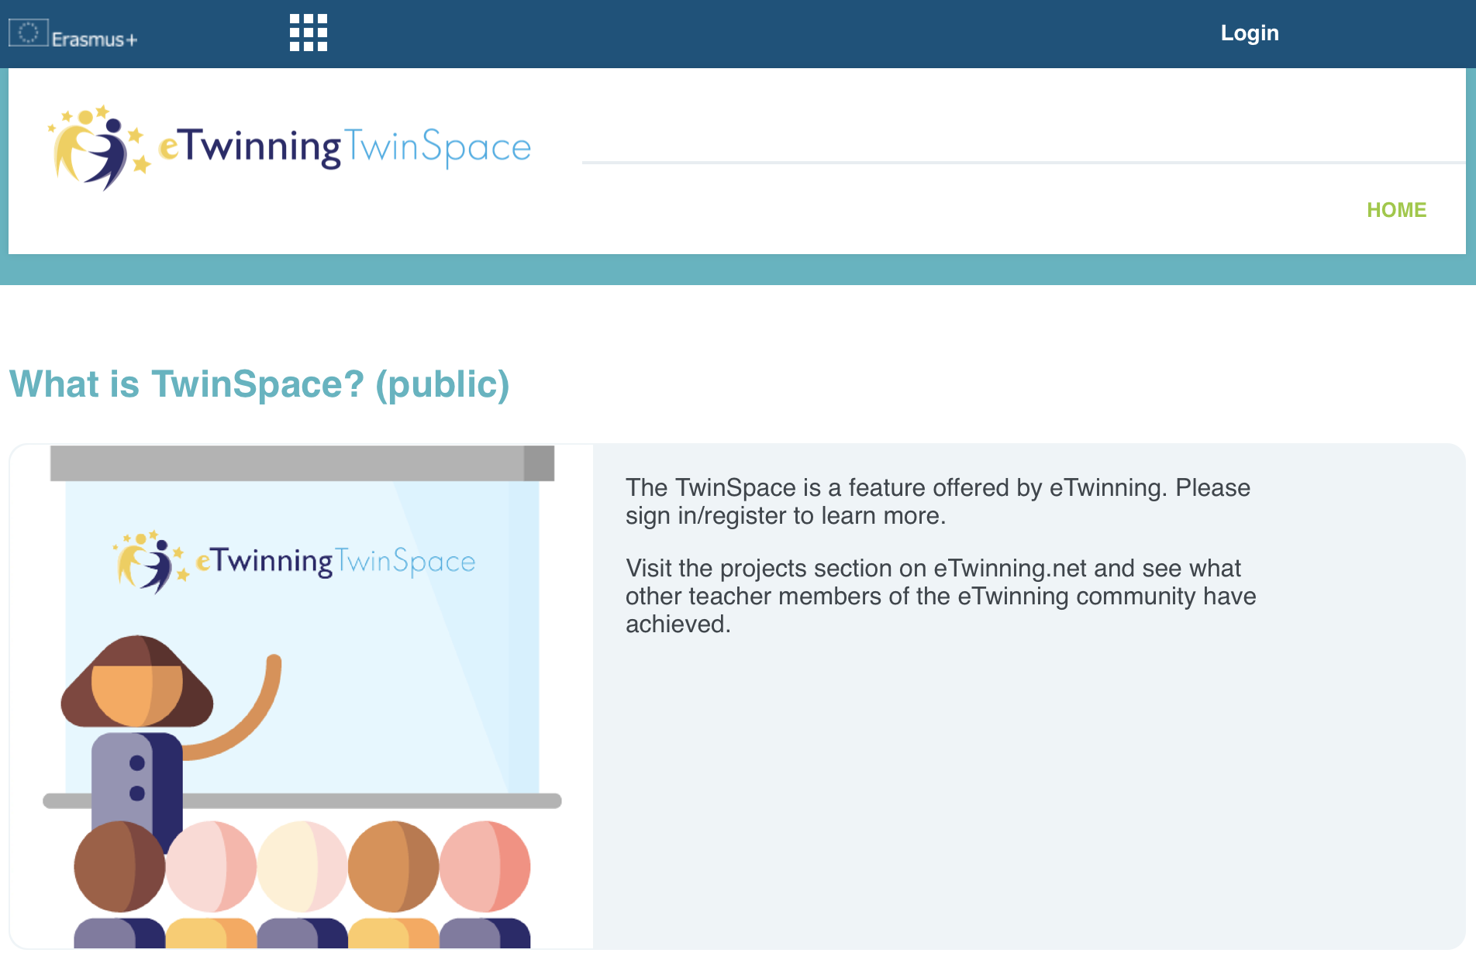

Select PAGES
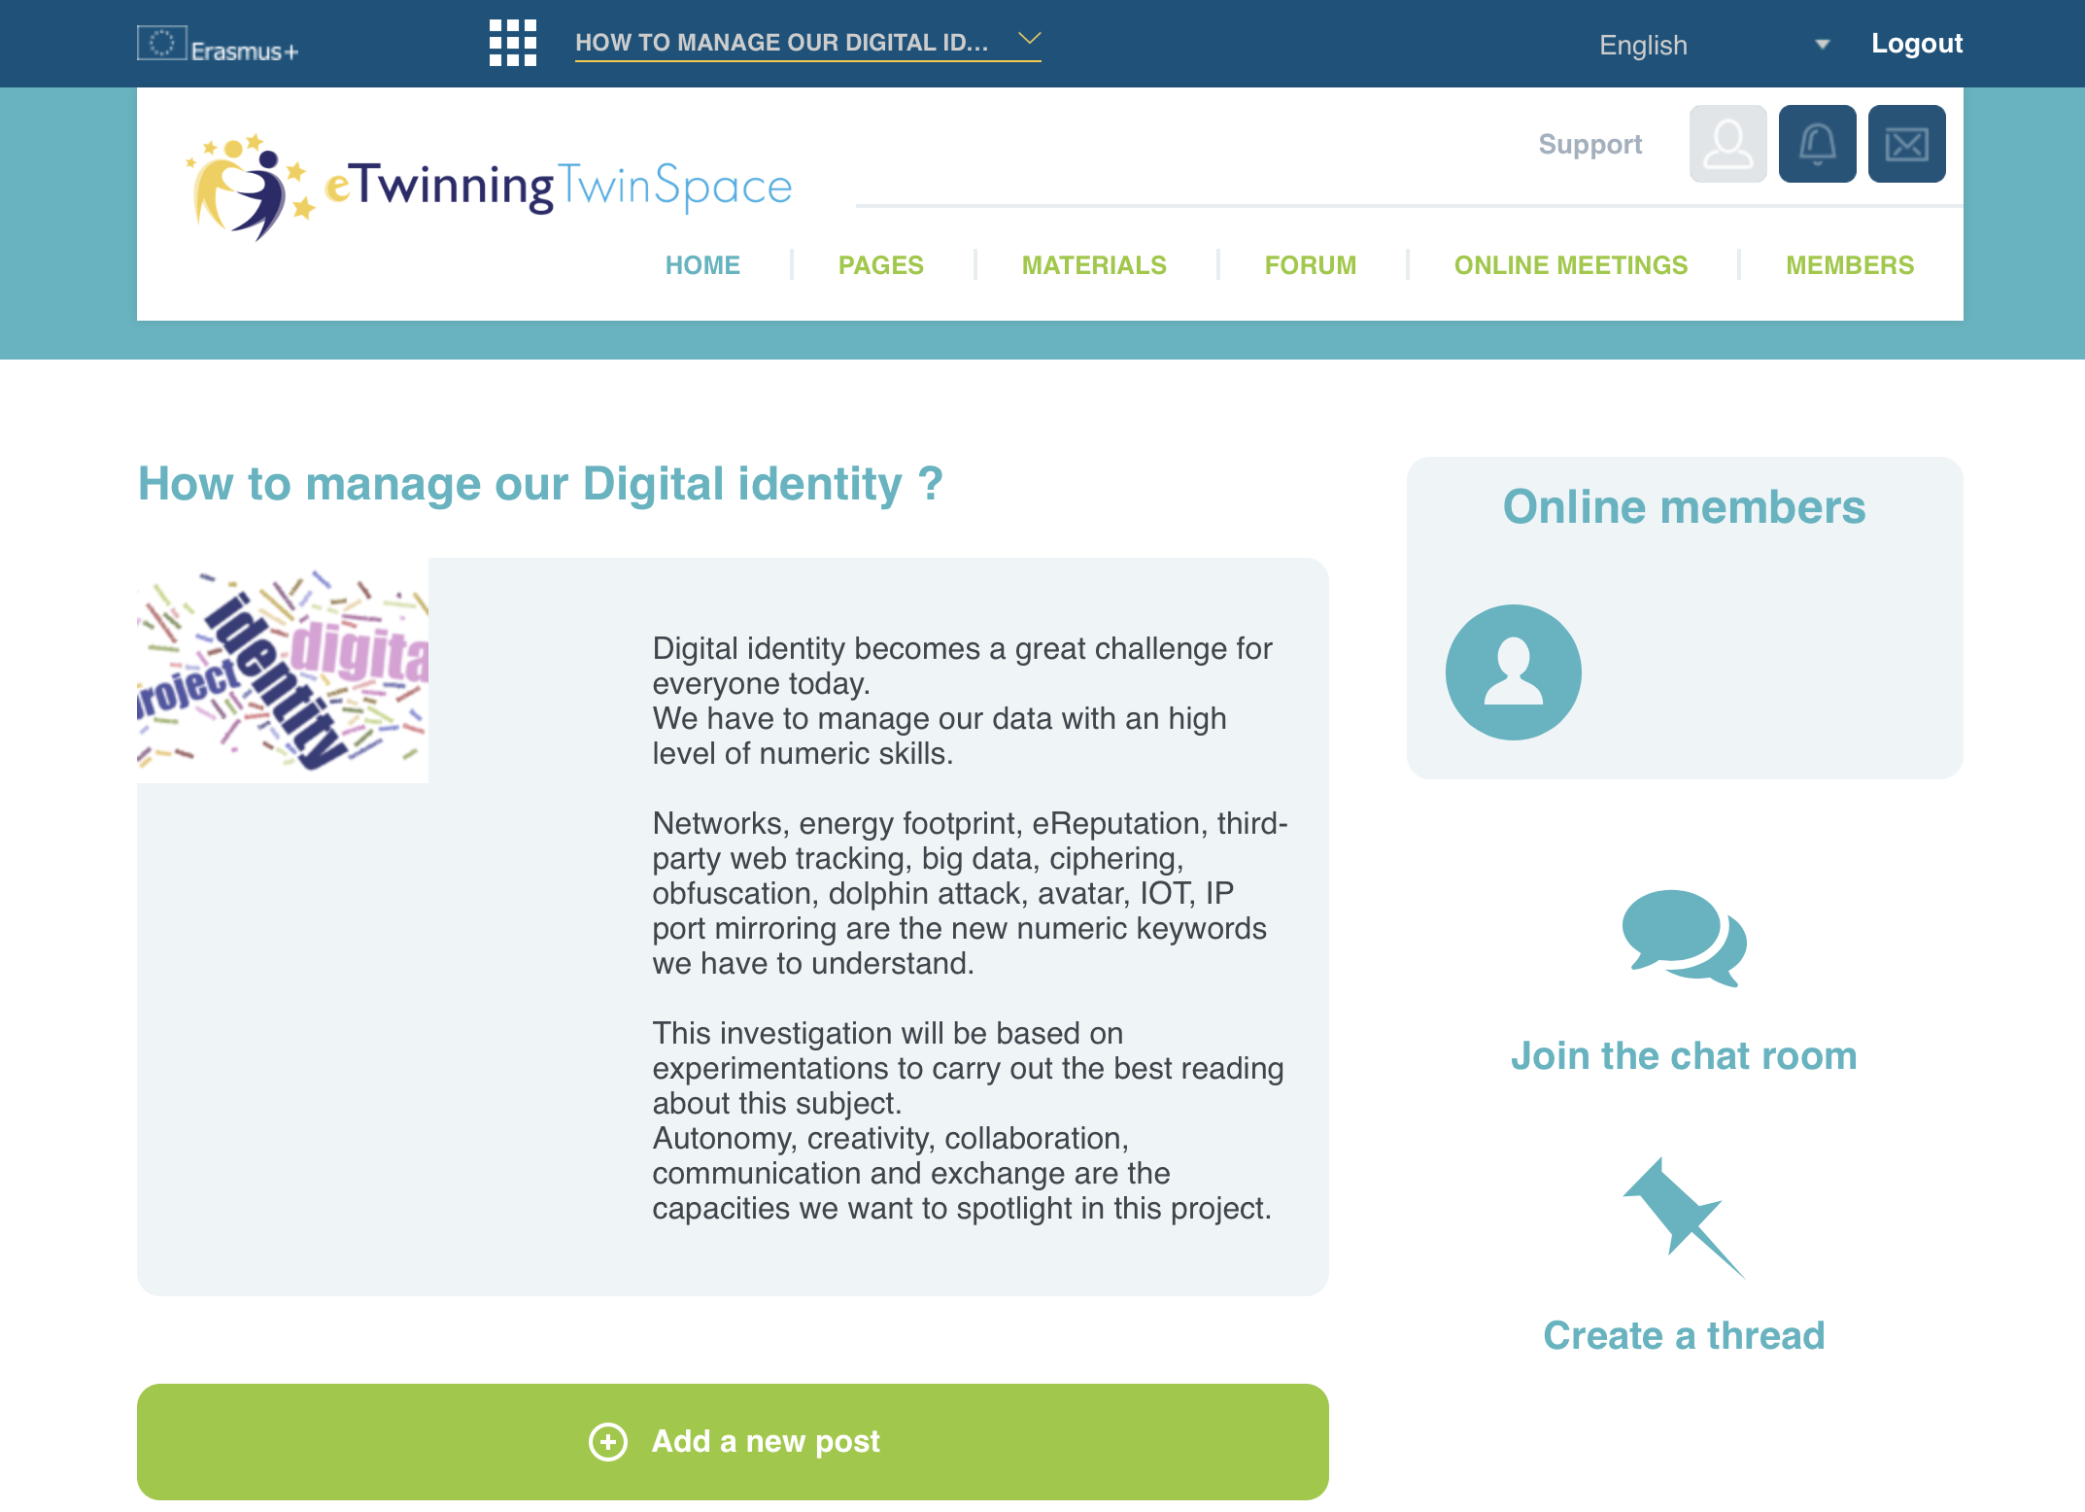
Select Livet-Digital_Identity_Form_Students link
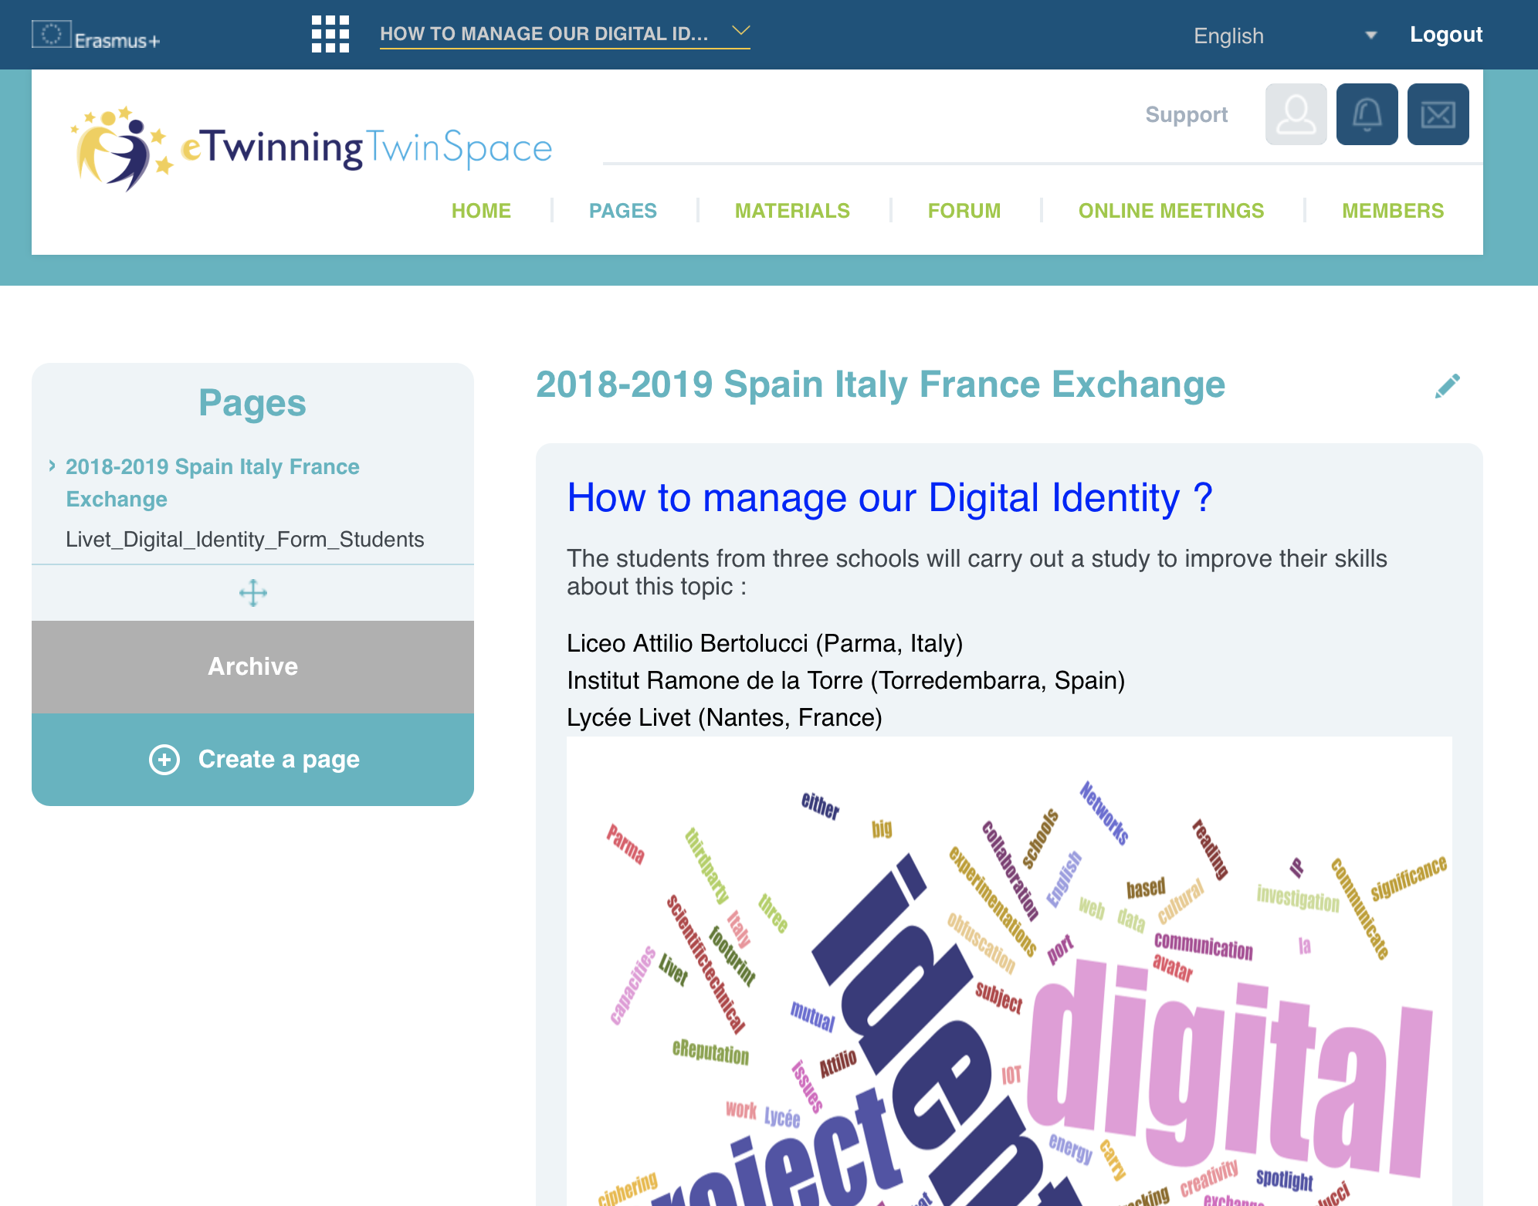
Each part will have its own url's page to embed in your QRcode message.
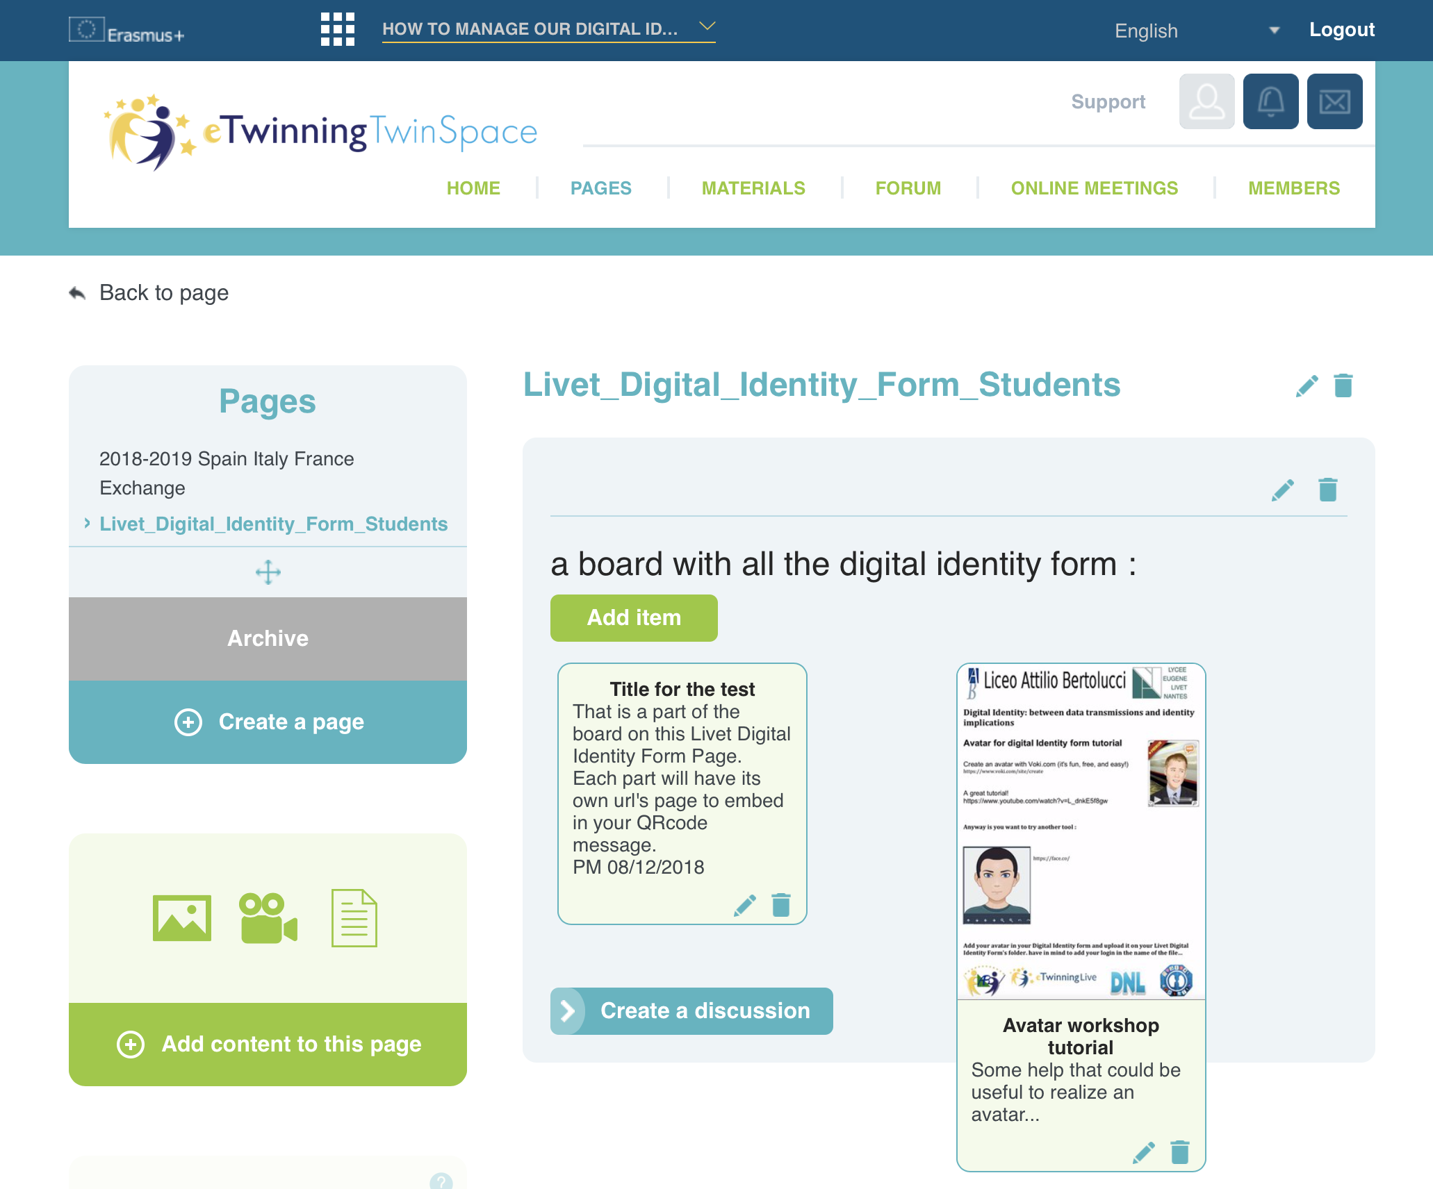
You have to add a new item from your Digital Identity Form activity. Convert your file in a picture could be a good way to succeed…
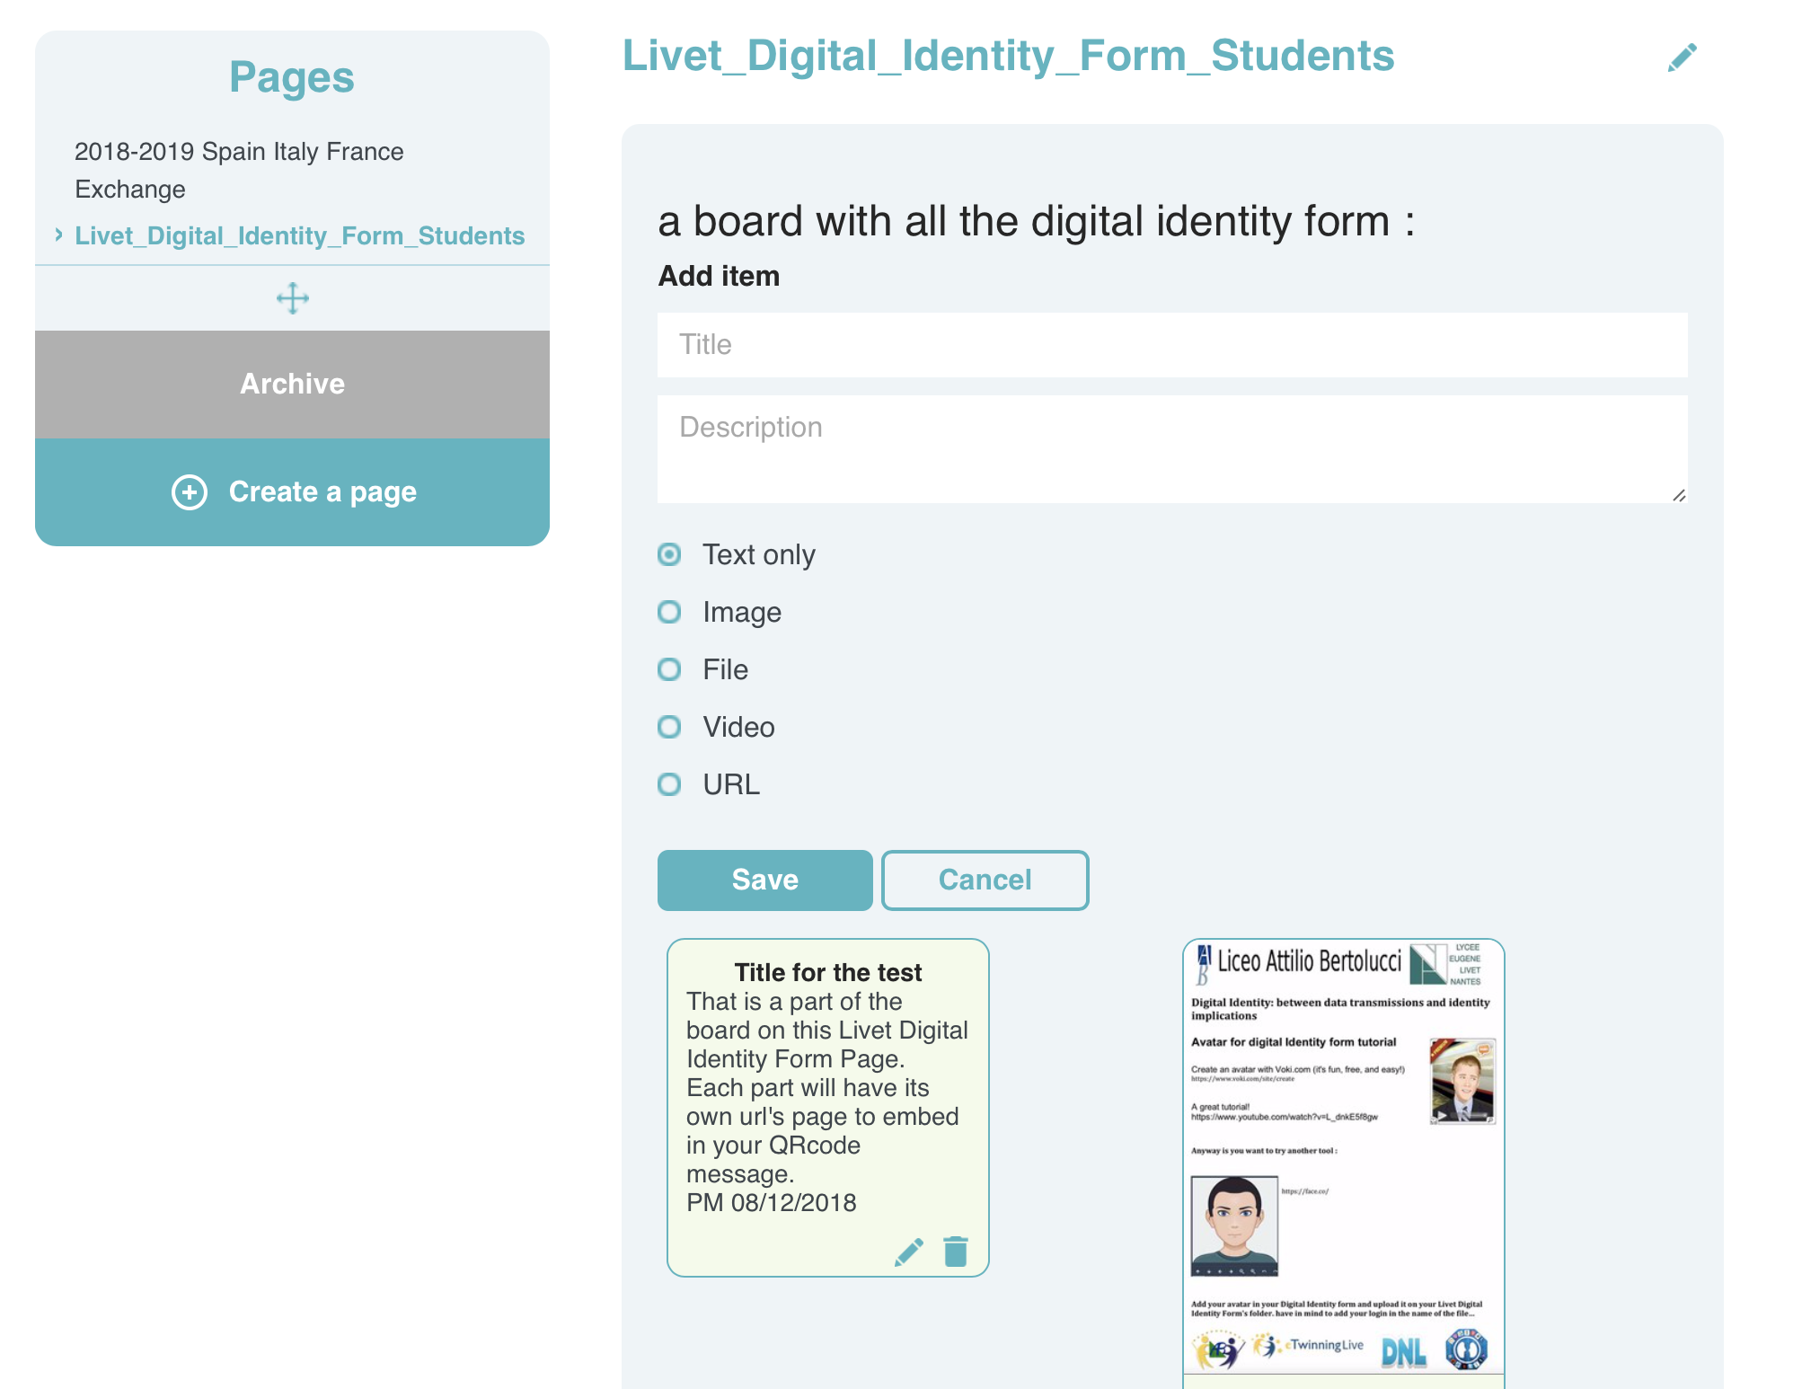
Firstname surname Digital Identity Form
Copy the url of your own page from your Digital Identity Form.
Embed it in your QRcode generator : https://www.qr-code-generator.com/

