Hello !

My name is Lilian, I'm a boy.I am thirteen and a half and I was born in two thousand and two. I'm French.

It's me.

I have one sister and I haven't got a brother. My parents are divorced, my dad lives in PROVENCHERES/FAVE with my sister and my mom lives with me in LA BROSSE-MONTCEAUX.

I love horse-riding and swimming, I swim once a week.I detest snakes and the spinach. I am sociable and generous but I am very talkative and I have lots of character.



My college is Elsa Triolet,it isn't very large. I love math and I love history but I do not love technology and I hate biology. I start every day at 8:20 and then I end a 5:00 p.m. except Wednesday or I end was 12:30.
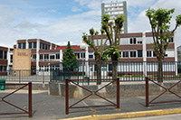
It's my college.

