National Anthem of Portugal
“A Portuguesa”

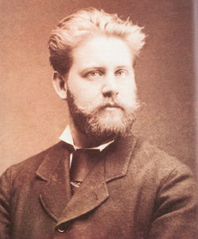
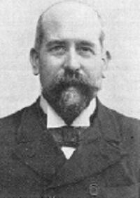
"A Portuguesa", was composed in 1890, with lyrics of Henrique Lopes de Mendonça and music by Alfredo Keil, and was used early on as a patriotic symbol and Republican. On July 16, 1957 the official version was approved of "A Portuguesa" by the government, coming later to be designated national symbol of Portugal in the 1976 Constitution consisting of Article 11, # 2: "2. The National Anthem is the Portuguese ". The poem consists of three parts, each with two blocks, followed by a chorus with 5 verses. In official ceremonies the first part is only sung. "A Portuguesa" is sung at official ceremonies, civil and military, which is paid tribute to the homeland, the flag and the President of the Republic.
Henrique Lopes de Mendonça
(1850/1931)
Alfredo Keil
(1850/1907)

