- Place for electronic solid waste.

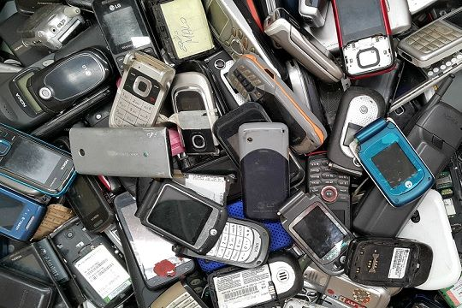
When we have to get rid of computer equipment (computers, cell phones, televisions, appliances) and batteries, most of us do not know what to do with them. For that reason, this idea is based on the creation of a place to deposit these wastes, where they will be properly disposed and can be used for recycling. There we will separate those that are in good condition from those that are not, and we will do useful things with those that still serve (ornaments, etc.) and we will recycle those that do not work.

