- Importer of third world products.

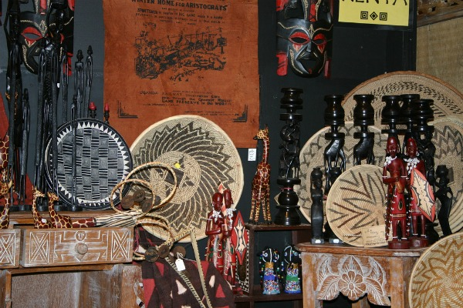
The idea is to help artisans from countries with economic difficulties when importing their products and selling them in other countries. Wholesale purchases of handicraft items can be made that can then be sold online, in a store or both. In addition, you can also become a distributor, selling products to stores.

