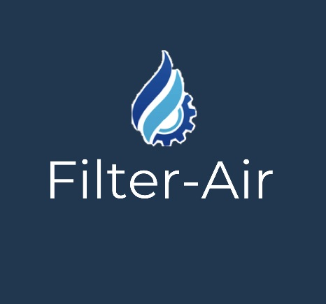

FILTER YOUR AIR, FILTER YOUR LIFE

FILTER-AIR
Our company tries to eliminate the polluting gases that are released into the atmosphere produced by the industries and thus reduce the bad consequences they cause. For example: diseases such as cancer or migraines; climate change; contamination in food ...
These filters are intended for industries that expel gases into the atmosphere. It is important to install these filters in order to avoid large amounts of pollution, diseases, global warming, etc.
One of the main causes that the poles melt and the animals that live in them die, are the industries that pollute and do not use these filters. Also one of the main affected are workers in these industries as they are more exposed to harmful gases and are the first to experience the serious consequences.
Some of these gases are Nitrogen Oxide (NO) and Carbon Monoxide (CO) which are the ones that harm us most in our health and in global warming since they cause a kind of greenhouse effect since these gases and some more they retain the energy that the earth emits when it has been heated by solar radiation.
Due to the pollution caused by industries to the environment we offer our customers through a physical medium our product, robotic filters that are capable of eliminating the most dangerous gases that leave these industries. For this we maintain our relationship with customers face to face, demonstrating the reliability of the product and interact with them about the improvements that this will cause in their industries for the welfare of their employees but also for the environment.
What differentiates us from the rest is the ventilation system perfectly studied and designed to eliminate the most harmful components of the gases and to be able to later expel a cleaner air. The mechanism it has works in the following way: once the polluting gases pass through the conduit that takes them to the atmosphere, they pass through the ventilation system that will eliminate these harmful components.
Our company to install these filters, do not pollute and do not cause, unlike other companies that do not have these filters, the damage already mentioned above.
With this we want to improve the health of the world population, prevent further global warming, prevent more animals and people from dying from these gases either through the air or through the food we eat.
In this sector as is the industry there are a lot of bidders wanting to leave their product above the others, with any company, but after knowing a bit about the filtering mechanisms of other companies I have observed that these filters are not so innovated , that is, they do not have that current touch. On the other hand, Filter-Air has the latest technology, the filters have external sensors that manage to detect the polluting gases and thus take them to the ventilation system where they are eliminated.
Economically it is not very high compared to the others, it is profitable taking into account the review every 2 months and maintenance in case of accident.
The most important part of our project is that we are going to reduce atmospheric pollution through robotic filters that have a mechanized ventilation system. With our contribution we will improve the quality of life of people and animals, we will not let more people die because of the polluting gases that the factories expel. Our main objective is to transmit to the world that we are capable of eliminating these toxic gases that damage our health so much.

