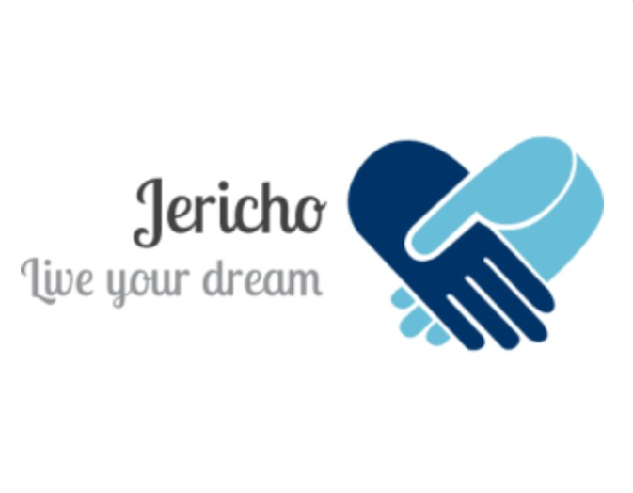
Nabch model
Mario Trujillo Durán
Nacho Rico Rodriguez.

Necessities:

our necessities are with clothes from other seasons , we are going to reduce them by up to 90%, and from actual seasons 50%, we need support for it.
recycle old clothes for fix them.

profits :

handmade manufacturing and machinery.

The profits are going to invent other clothes.

Approach:

to people of all age, we produce our products and spend them. And we don’t pollute producing our clothes.

The competition:

the spend of clothes to so that there is more fashion,

we want create news fashions.

Thanks machinery we can distribute more products.

Appeal:

we can appeal creating advert for tv, youtube …,

with this we encourage more partners and public.

Appropriateness:

the poor people can buy high quality clothes and good materials.

And oportunity for create a franchise , in all world.

Originality:

we haven’t shops, is online .

And we recycle old clothes and then spend them.

Economical sustainability:

because we will be adapted with the society and we will attract a lot of people.


