**Modelo de Negocio Canvas**

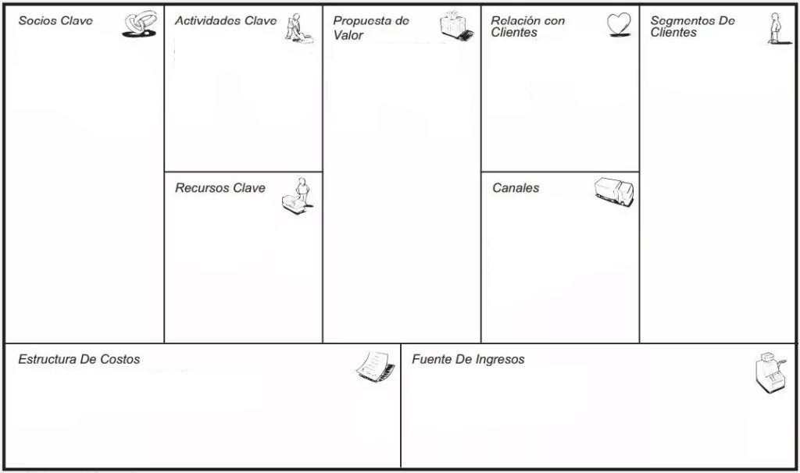

Through our multiple services, purchase of our app, tips. Being a variable income.

Gasoline, salary of employees, food, maintenance, production of electronic elements ...

Kennels, our app, advertisements, pet food companies ...

The client has the opportunity to customize the desired service through our easy-to-understand app adapted for all audiences, as well as being multi-platform.

Own premises, transport adapted for pets, app developed for the different options of our work...

Advertising, 24h services. adapted to each client, maintenance service ...

Digital marketing worker, architect, vet, workers, canine specialists, canine feeding…

Our company focuses on the care of domestic animals. We are characterized by: originality, availability, we have no competition ...

Because we are one of the few companies that give a good service, in exchange for an affordable price, to their pets while their owners are absent.