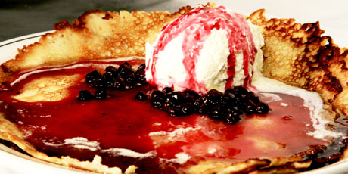

Directions for: Finnish Pancakes

INGREDIENTS
5 eggs
6 cup milk
2 tsp salt
4 Tbsp sugar
3 cup flour
½ tsp of butter or margarine

DIRECTIONS
1. Pre-heat griddle to 350 – 400 degrees Fahrenheit
2. Lightly whisk eggs and milk in bowl. Add salt and sugar. Slowly mix in flour.
3. Melt butter or margarine on griddle or pan.
4. Pour mixture in circles on the griddle or pan. Cook until golden brown flipping once.
5. Pancake can be enjoyed plain or with strawberries and whipped cream, or with fried eggs and bacon.

