Erasmus+ Finland Visit 11th-15th February 2019

Sunday

Nallikari winter village - walk on the frozen sea, some ice fishing, outdoor grilled sausages and marshmallows and some reindeer rides and igloo.

Monday - Svenska Privatskolan

Morning:

- Sampo Backman is the principal of the Swedish school and Anna Jordan is the vice principal. Welcome address by Anna Jordan of Svenska Privatskolan and Timo Kärkkäinen of Laanila High School.

- Video about Swedish Lucia (Lucia for Dummies). Celebrated 13th December brings light and hope in the darkness.

- Song by Svenska Lucia choir

- Oulu video

- Finnish-Swedish school system talk by students:

￼
￼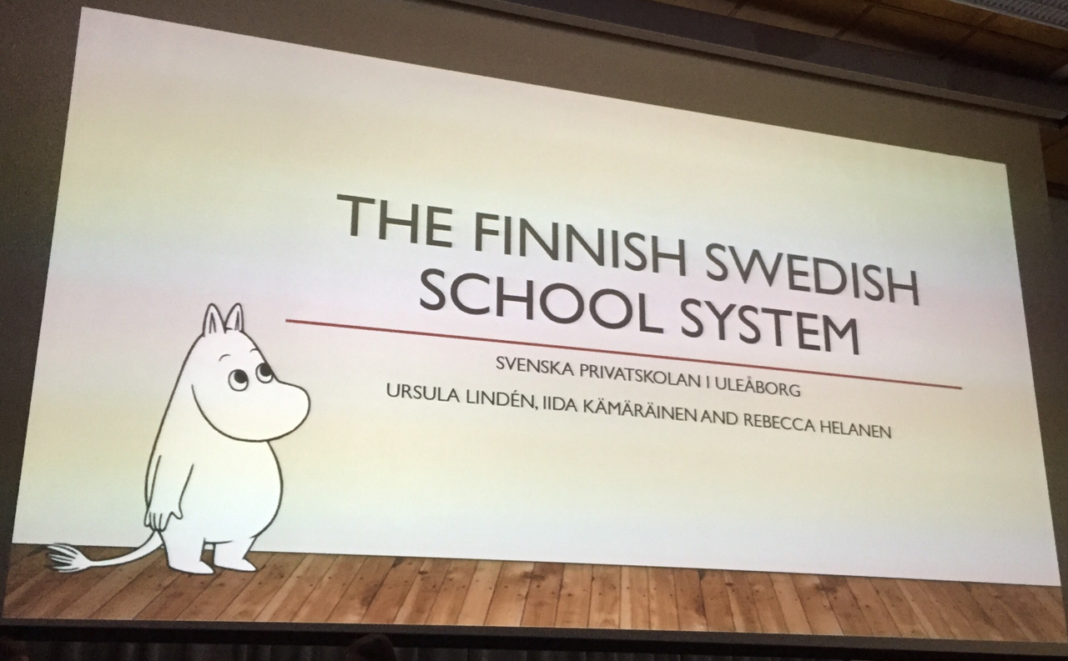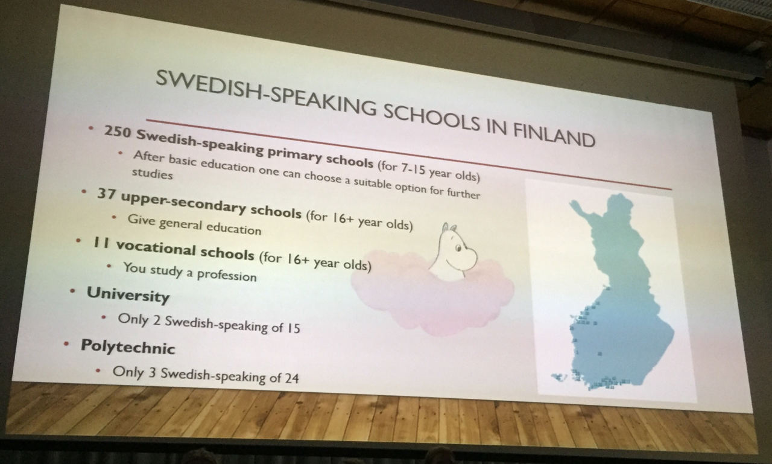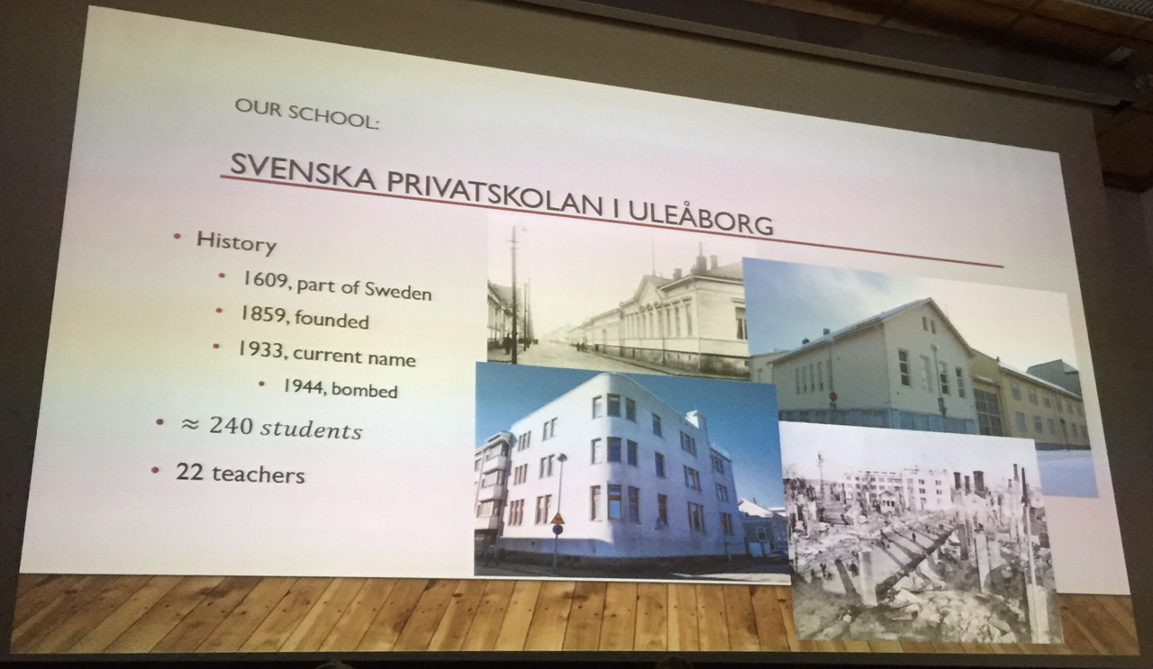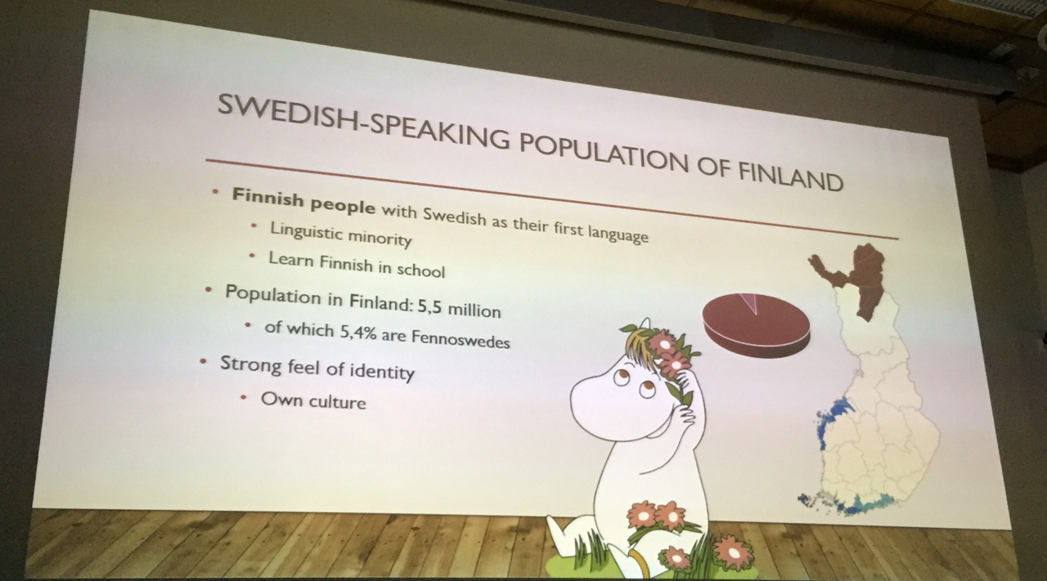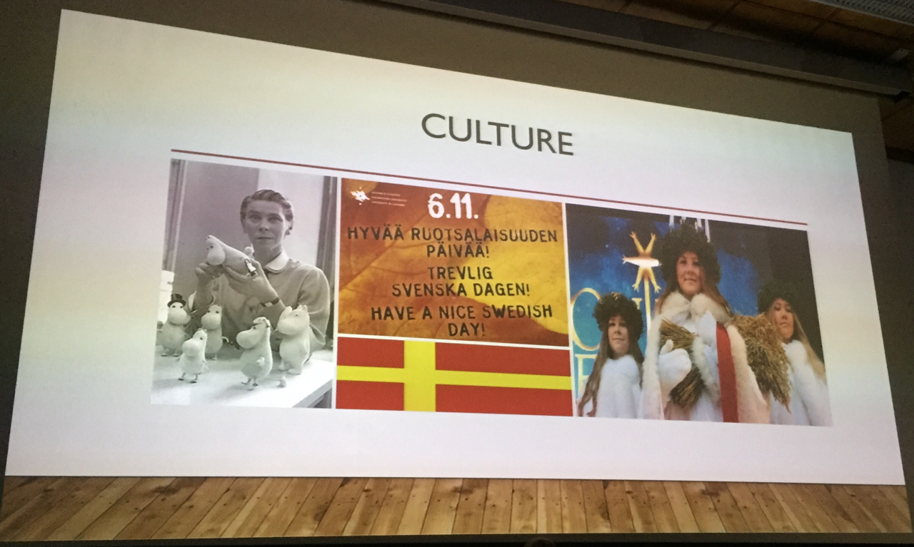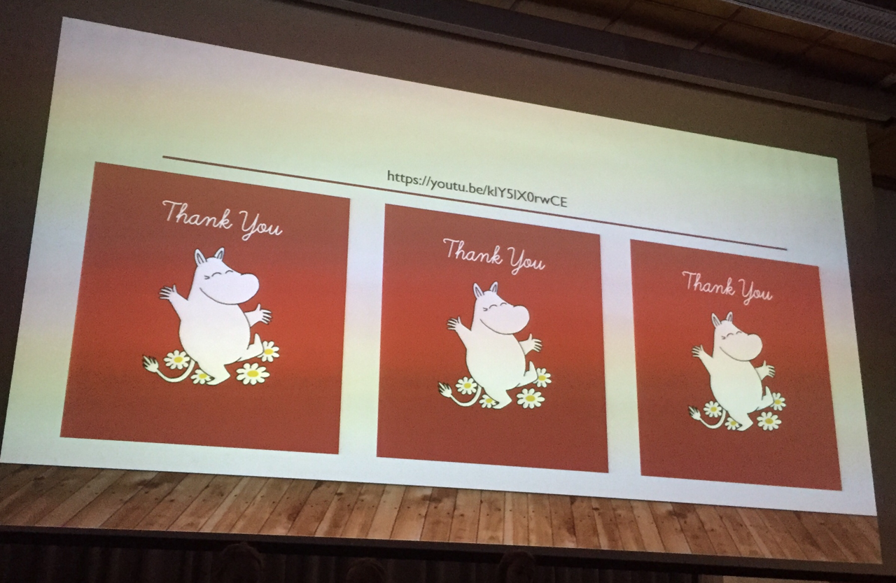
￼
￼
- The Moomins (Swedish: Mumin) are the central characters in a series of books and a comic strip by Swedish-speaking Finnish illustrator Tove Jansson.

- Kahoot game about Finland history

- Education in Oulu videos

Lunch was a delicious traditional Carelian stew with mashed potato.

Afternoon:
- Teachers maths lesson
- Students baking traditional Swedish pulla. Then everyone ate the lovely traditional pulla.

Tuesday - Rovaniemi

- Visit to Santa Claus village to deliver student equality wishes letters.

- Visit to Arktikum museum - history of the Sami people and life within the Arctic Circle and Rovaniemi and the effects of Climate Change on the Arctic region.

- Visit to Kemi Snow Castle.

Wednesday - Laanila High School

Morning:

- ‘Living Library’ panel discussion:

￼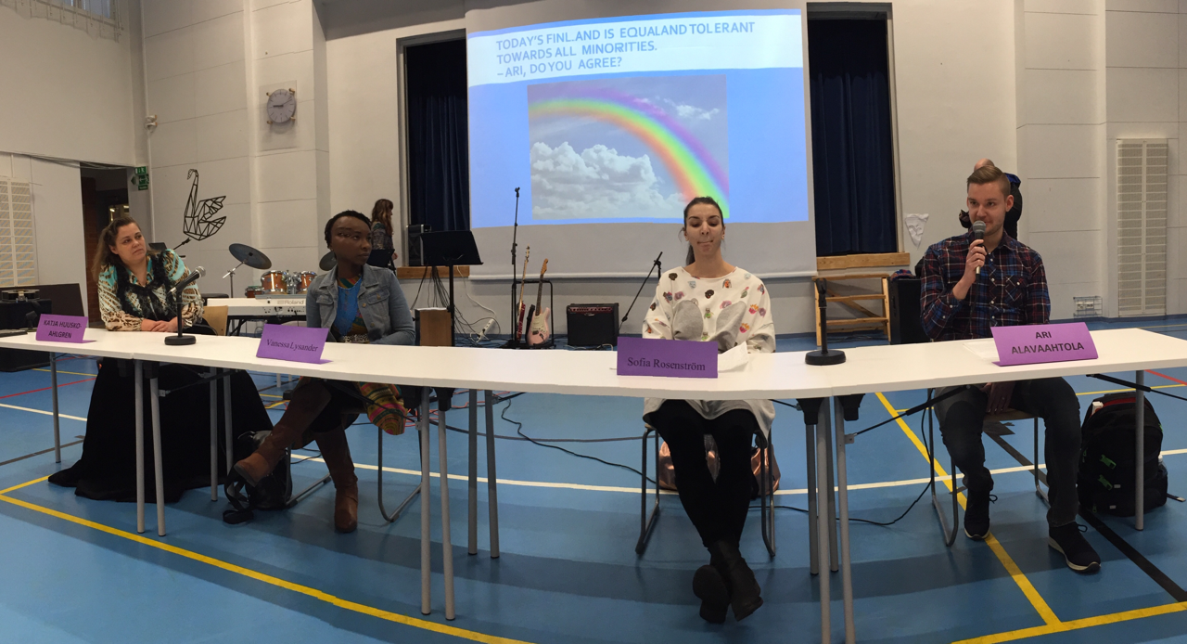

- Ari Alavaahtola (LGBT representative) - Finnish teacher at Svenska Privatskolan and at multicultural school. Also teaches immigrants.

- Sofia Rosenström (Swedish speaking Finn representative) - works at Svenska Privatskolan

- Vanessa Lysander (diversity representative) - from Malawi worked in development work there and moved to join her husband last year who is half Senegalese and half Finnish. Has a trainee ship with Save the Children.

- Katja Huusko-Ahlgren (Romani minority representative) - social service worker in a special school.

Afternoon:

- Tour of school

- Best equality news from Europe - student equality videos and discussions:

￼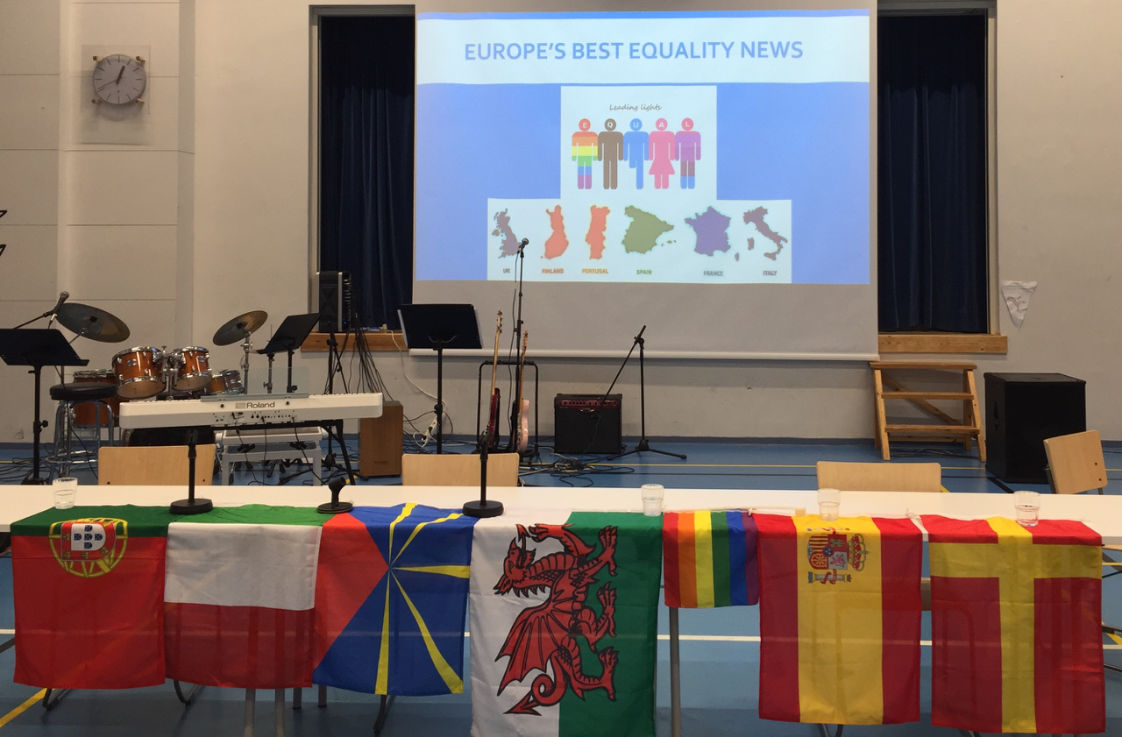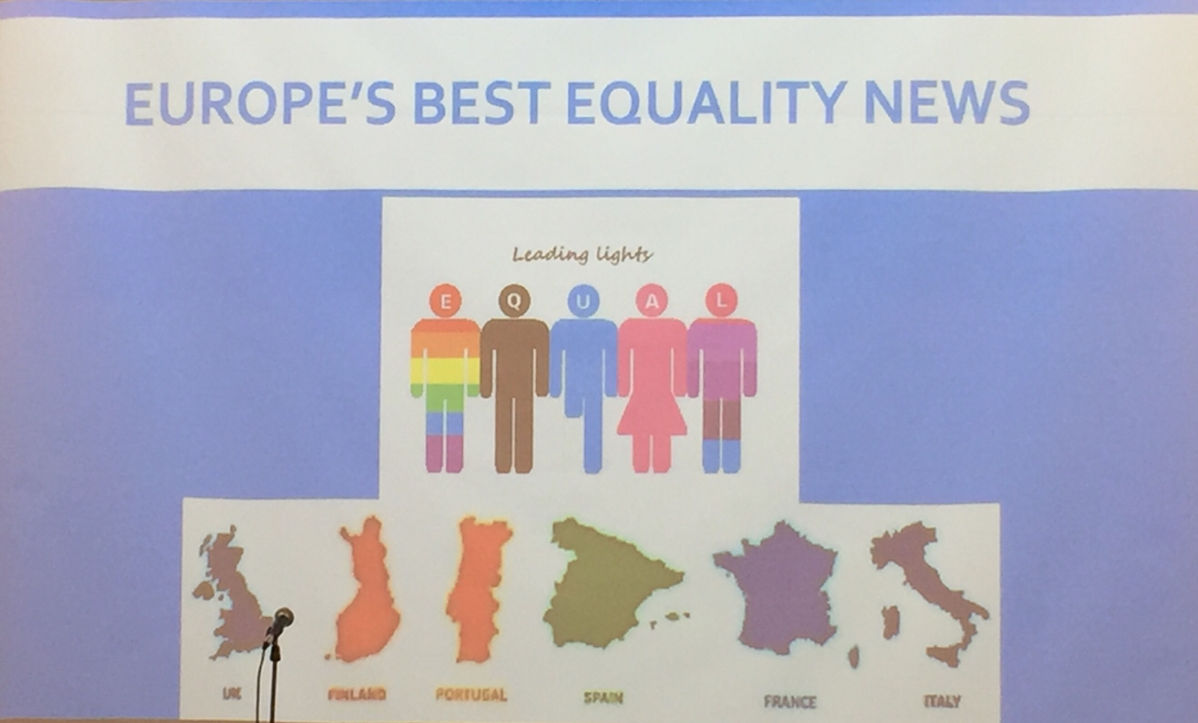
￼
Video Themes:

- La Reunion - yellow vests
- Portugal - equality in Braga
- Spain - gender equality
- Finland (Laanila) - Finland equality developments 2018
- Italy - bullying & time
- Finland (Svenska) - equality in Finland
- Wales (Dyffryn Taf) - Brexit & lowering the voting age
- Wales (Strade) - disability equality in Wales

Thursday - Svenska Privatskolan

Morning:

- 3rd year students (Abi students) final day farewell show. They play pranks on teachers and school. Teacher parodies and mess up the classrooms/corridors. Get teachers to do silly things as part of national tradition. All final year students in all schools do the same and they all then get in trucks and parade through the town (Abi trucks).

Afternoon:

- Abi trucks parade (final year students on trucks through city centre as part of leaving celebrations). Rain in the afternoon made the roads and paths very icy! Sign of climate change to have rain so early in the season!

- Shopping & dinner at Timo’s.

Friday - Svenska Privatskolan - Final Erasmus meeting & planning ahead

Morning:

June final reporting for Leading Lights project

All need to have an equality plan for the school. Plan shared via Facebook.

UK Equality act 2010 & schools advice: https://assets.publishing.service.gov.uk/government/uploads/system/uploads/attachment_data/file/315587/Equality_Act_Advice_Final.pdf

New project exchange visit dates:

- Melilla - 11th -15th Nov 2019
- Portugal - 20th -24th April 2020
- La Reunion - 5th-9th October 2020
- Finland - 15th-19th February 2021
- Wales - 4th-8th October 2021

Afternoon:

- Ice swimming Tuira beach & old school dances in Oulu Hall.

- Farewell dinner and Erasmus+ party (European guests, host families and Finnish teachers). Singing, dancing and quizzes provided by students (guests and Finnish).

