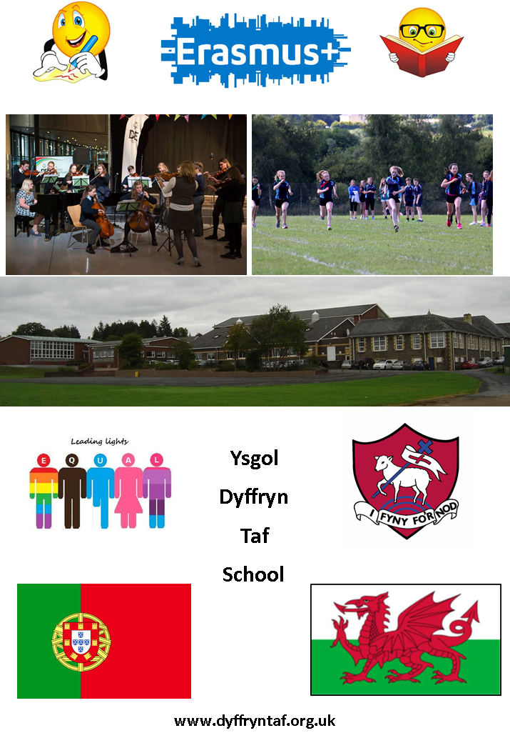
Inclusive Learning Resource
A room where students from year 7 through to year 13 go to when they are dis-applied from a specific lesson that is not accessible to that student. Some students in key stage 4 will do a reduced timetable due to their additional learning needs, so they will go to this room where their needs will be met. This room is supervised during lunch time and break time ensuring our most vulnerable students have a safe environment to go to.
Support in the ILR is tailored to the student’s specific needs. Pre-learning new topics, over-learning current topics, homework support and numeracy and literacy basic skills. This raises the student’s confidence, gives them the strategies to cope within the classroom environment and encourages the student to become a more confident and independent learner.
The routine in this room is the same as any other classroom to maintain continuity. There will be a lesson starter for all students before the individual tailored work is delivered and then a plenary session to end.
The Cool Zone is a small room for students to come to periodically when they find the classroom environment difficult to cope with or have behavioural issues. These students are identified over time or have specific needs identified during their time at primary school. These students carry a “Cool Zone” pass which they need to show to the class teacher or the LSA. The student is then escorted to the Cool Zone where they will remain for the rest of the lesson or until they feel able to cope within the classroom environment once again.
Testing to identify student levels.
Students are tested in year 7 during the first four weeks for their specific individual needs.
Reading, spelling and working memory are tested collectively; this is a computer based test which takes approximately one hour. The working memory includes auditory, visual and verbal memory.
Scores
65 or less – lots of support/scaffolding needed. This will include an intervention and classroom support. Tested at the end of year 7 to monitor progress.
66 to 85 – support not so intense. A morning intervention monitored to track progress.
86 to 95 – monitored for continued progress, no intervention needed.
95 to 135 – average and above ability.

Handwriting
This is tested by how many words they can write within 10 minutes. If the score for a Year 7 is less than 10 words per minute then some intervention is needed. Students would attend a morning intervention, support and scaffolding would also be given in class. The student’s progress would be monitored. The scores are shared on the school system with other members of staff for them to access and support accordingly.
Interventions
During the registration period (20 mins) we have interventions for literacy and numeracy through the medium of Welsh and English depending on the student’s first language. These interventions are delivered by the LSAs who are supported by the students in the 6th form
We also have interventions which run during lesson time:-
Talk about - once per week for 30 minutes
This targets students with poor communication skills, so the students work in small groups following a specific programme. This programme is designed to increase self-awareness and improve self-esteem. These are taught first before moving on to more complex skills of making and maintaining friendships.
Read Write Ink - once per week
This literacy programme is designed to create fluent readers, confident spellers and willing writers. This is achieved through using phonics, stories and workbooks.
Teen Talk - once per week 20 minute sessions
Teen talk is another group intervention based on the Teen Mental Health and Life Skills programme. This programme aims to increase student’s confidence, self-esteem and self-awareness and helps with their willingness to work as part of a team. The Teen Mental Health and Life Skills Workbook series covers self-esteem, anger, stress, friendship, aggression and bullying.
Social Stories
Social stories are short visual descriptions of situations, skills or scenarios that a pupil will encounter in the school setting and the expected outcomes. According to Educate Autism (2017) social stories help Autistic who lack a “Theory of Mind” (Baron-Cohen, Leslie Firths, 1985) which allows us to understand other peoples’ views and beliefs.

Buddy/Mentoring System
A buddy system is in place for year 5 and 6 students during their transition to secondary school. This enables students to have a positive welcoming experience from Primary school to Secondary.
It helps promote friendship and support between younger and older students. This helps promote a whole school community. Not only does it improve the confidence of the younger student but also that of the older student giving them responsibility and a sense of privilege. It improves the behaviour and appearance of students because they know that their actions can have an effect on the younger more impressionable students. I feel our Buddy System has a very positive effect on the student community as a whole.
MAT (More Able and Talented)
DofE Young Leaders
Where students take an active role in planning and running the activities which develops their leadership skills whilst they help others.
Mandarin
The Confucius Classroom program partners with local secondary schools or school districts with the aim to promote the Chinese language and culture.
Seren Programme

Studying a university level module alongside your AS or A2 studies can help broaden academic knowledge, bridge the gap between school and university and enhance your personal statement for the UCAS application.

Astro Pi
To show the possibilities of computer programming and encourage students to improve their digital literacy.

Language Perfect
This is a competition where students from around the world learn vocabulary online, earn points and compete for awards and prizes. Students compete against each other, compete for their school and compete for their country! It's fast paced, exciting, and very competitive.
Spelling Bee
The aim of the Routes into Languages Cymru Spelling Bee is for students in year 7 to practise and improve their vocabulary, spelling and memory skills in another language (French, Spanish, German and Welsh 2nd Language).The competition consists of four stages over the three school terms. Students will be given 25 words to learn at the first stage of the competition and a further 25 words will be added at each subsequent stage. Vocabulary is relevant to the curriculum and the competition is launched at the beginning of the autumn term in order to practise the alphabet in the foreign language. Different to a monolingual Spelling Bee, students have the option to be given a word in English or in Welsh. They first have to translate it into the Target Language and then spell it out correctly using the alphabet in the Target Language. When participating, students are given one minute to correctly spell as many words as possible. The annual National Final takes place at the end of the summer term in a welsh university (usually Cardiff or Aberyswyth). This is a very motivational competition for our competitors who may only just be starting to learn a second language.

Math’s Challenge
The Maths challenge is a National competition which is held throughout the UK. Each year a group of Dyffryn Taf students enter.

Early entries
Early entries from a school perspective is done to improve school performance. From a student point of view, the government is expecting our students to undertake an increased number of exams. In order to reduce exam pressure, early entries allow the students more time to prepare for each exam and concentrate on core subjects.

Engineering Scheme Wales
Engineering Scheme Wales is a scheme across Wales to inspire and motivate young people to choose a career in Science, Technology, Engineering and Mathematics (STEM).

Rotary
Our local Rotary club support the youth in our community, getting them involved with a number of different projects, including;
- Young Chef
- Young Musician (Vocal & Instrumental)
- Young Writer
- Youth Speaks (Public Speaking)

As well as academic pathways Dyffryn Taf offers a wide range of Arts and Sports which gives students the opportunity to develop and showcase their skills. For example we have talented Art students who have had their work displayed in local Art Galleries and Drama students have joined national choirs and found work on the big stage. We are also very proud of our sports students who have attended school trials which have led to them playing at County level and some have gone on to play for Wales, The Lions and competed in the Olympics.

Lego Intervention
This intervention is designed to suit all students’ needs. It helps develop/reinforce play and social skills;
Verbal/nonverbal communication
Joint attention
Task focus
Sharing and taking turns
Collaborative problem solving

With this intervention each student is assigned a role,
Engineer- oversees the design
Builder- put the bricks together
Supplier – keeps track of the needs of the builder, colour of brick and size
Director – makes sure the team are working together and communicating
An adult facilitator is there to support positive interaction, suggest compromise and keep group on task.

