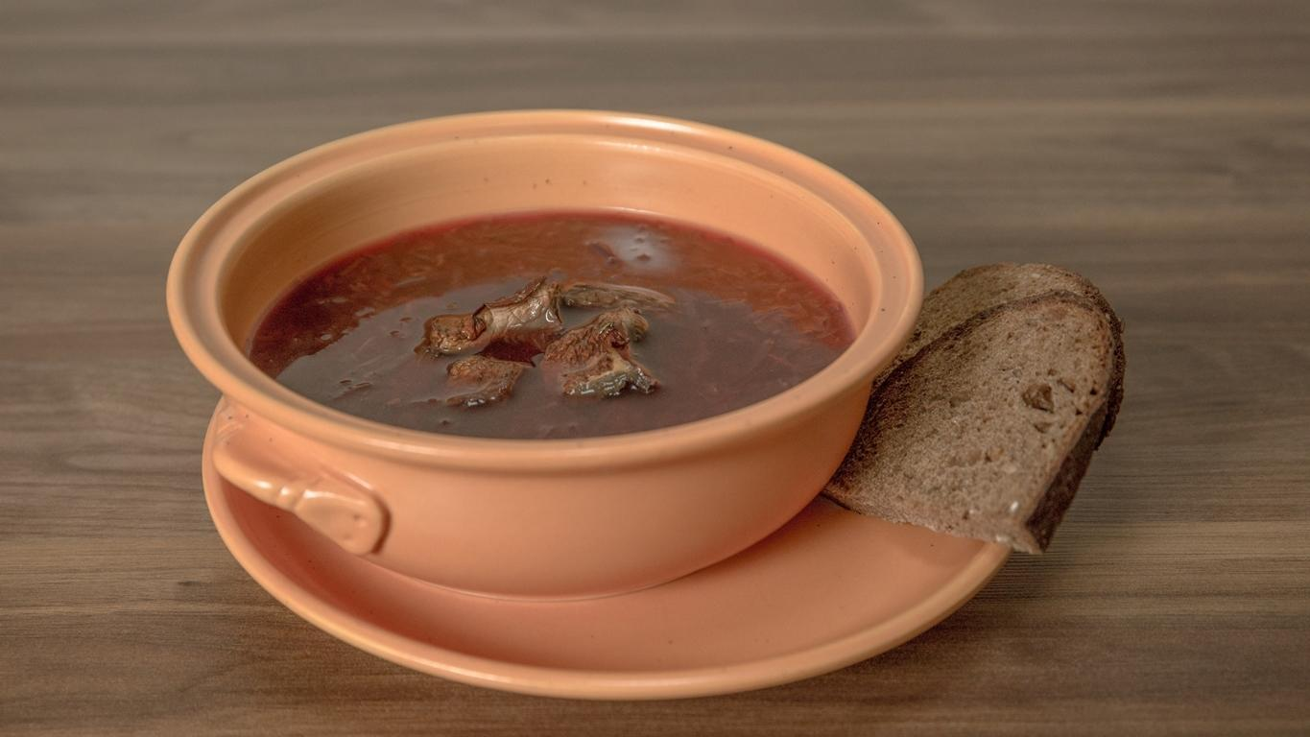Lithuanian borscht with boletus
Lithuania is famous for it‘s soups. Even before XX century they where called wirral.
In the past, this dish was eaten on brekfast, lunch and dinner, sometimes during the day several types of soups were made. One of the most popular soup was beet, called borscht. Mushrooms are added for seasoning soup.

INGREDIENTS
1 handful of dried mushroom
2 carrots
2 red beets
Pepper
Bay leaves
Salt
1l water
1 onion
1. Soak mushrooms and cook them. When they are cooked, put them out and in their decocition put cut carrots, onions and spices.
2. When vegetables are cooked, put separately cooked grate beet and simmer all again.

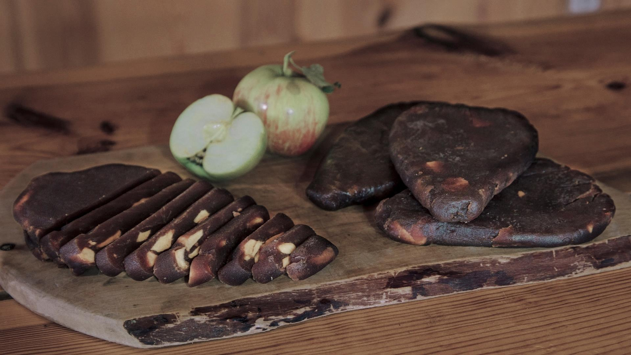
Apple cheese
Apple cheese is derived from the middle ages rulers and noblemans manor houses.
This is due to the fact that apple cheese need a lot of sugar or honey. Honey was
and still is enough expensive product. Sugar also wasn‘t very cheap in those times.
Perhaps one of the oldest apple cheese recipe we find in Radvila‘s cook XVII century
notebook.

INGREDIENTS
5kg of apples
1kg sugar
cinamon

1. Peel and cut apples, pour them with sugar, mix everything up and leave 1 or 2 days untill the juice come out.
2. Then pour the juice to the pot and cook till it gets thick, and the volume will decrease by half.
3. Add apples and cook stirring for about an hour until it gets thickened.
4. Later, put everything in the dry cheesebag, press and hang in a ventilated room that it could dry.

Cold borscht
INGREDIENTS
Kefir- 500g.
Pickled beeds- 100g.
Hard boiled egg- 2
Cucumber-2
Green onions- 100g.
Pinch dash and parsley
Salt according to the taste

1. Boil two eggs. Peel them. Cut into pieces.
2. Cut cucumbers. Chopp the dash and parsley.
3. Por out the liquid from the pickled beeds and put them in a big boul. Add chopped cucumber, greens, egg.Pour over kefir. Hire.
4. Supply with cooked potatoes.

