ŞEN BERBER

( Cheerful Barber Shop )

The word museum is derived from the Greek word &quot;mouseion&quot;. It means &quot;the place where the muse
lives&quot; or &quot;temple of sciences&quot;
This fairy who inspired us was the start of our project.
While writing the project, we dreamed that young people create their own museums considering
their recent cultural heritage in their chosen themes and open their museums to everyone through
virtual tours using technology.
After the idea of the museum matured, we decided to limit it on the profession.
We thought that the profession is a large educational institution passed from generation to
generation and this education is sometimes transferred from father to son and sometimes according
to the master apprentice relationship.
Of course, not only skills and knowledge are transferred but also materials and shops, and most
importantly, a name is left to the next generation.
In the light of these thoughts, we decided that the profession that proceeds by transferring
completely without being affected by technology is barbership
And so the muse started to work.
First of all, we have compiled all the books about Turkish hairdressing written in Turkish literature.
As the oldest barber in our city, we found İsmet Usta (master )who continues the tradition
completely.
We lived one day of İsmet master together and presented it to you via a video.
In the meantime, we started to read the books we compiled and talk to the Manisa Chamber of
Barbers

Our museum which we give birth to with new ideas every day has aroused great excitement. As we searched the history of barbering, we decided to put barber pictures on our museum walls from past to present. These paintings which we printed on canvases, enriched our museum.
We prepared a short documentary about the history of barbering. We turned the video that we combined with the video of Ismet Usta into a simulation for the museum.
We painted our museum walls, made our cabinets done. We placed the objects one by one that came from the chamber of barbers, the objects that we bought from the auction and the ones that Ismet Usta, who is retired, has donated to us.
We left a corner to the future about today’s barber shop.
We hung the hair pictures which varies over the years on the walls of our museum so that we saw the art the barbers have created over the years.
As a result of this feverish work
We had so much fun
We established a museum

OBJECTS FROM OUR MUSEUM

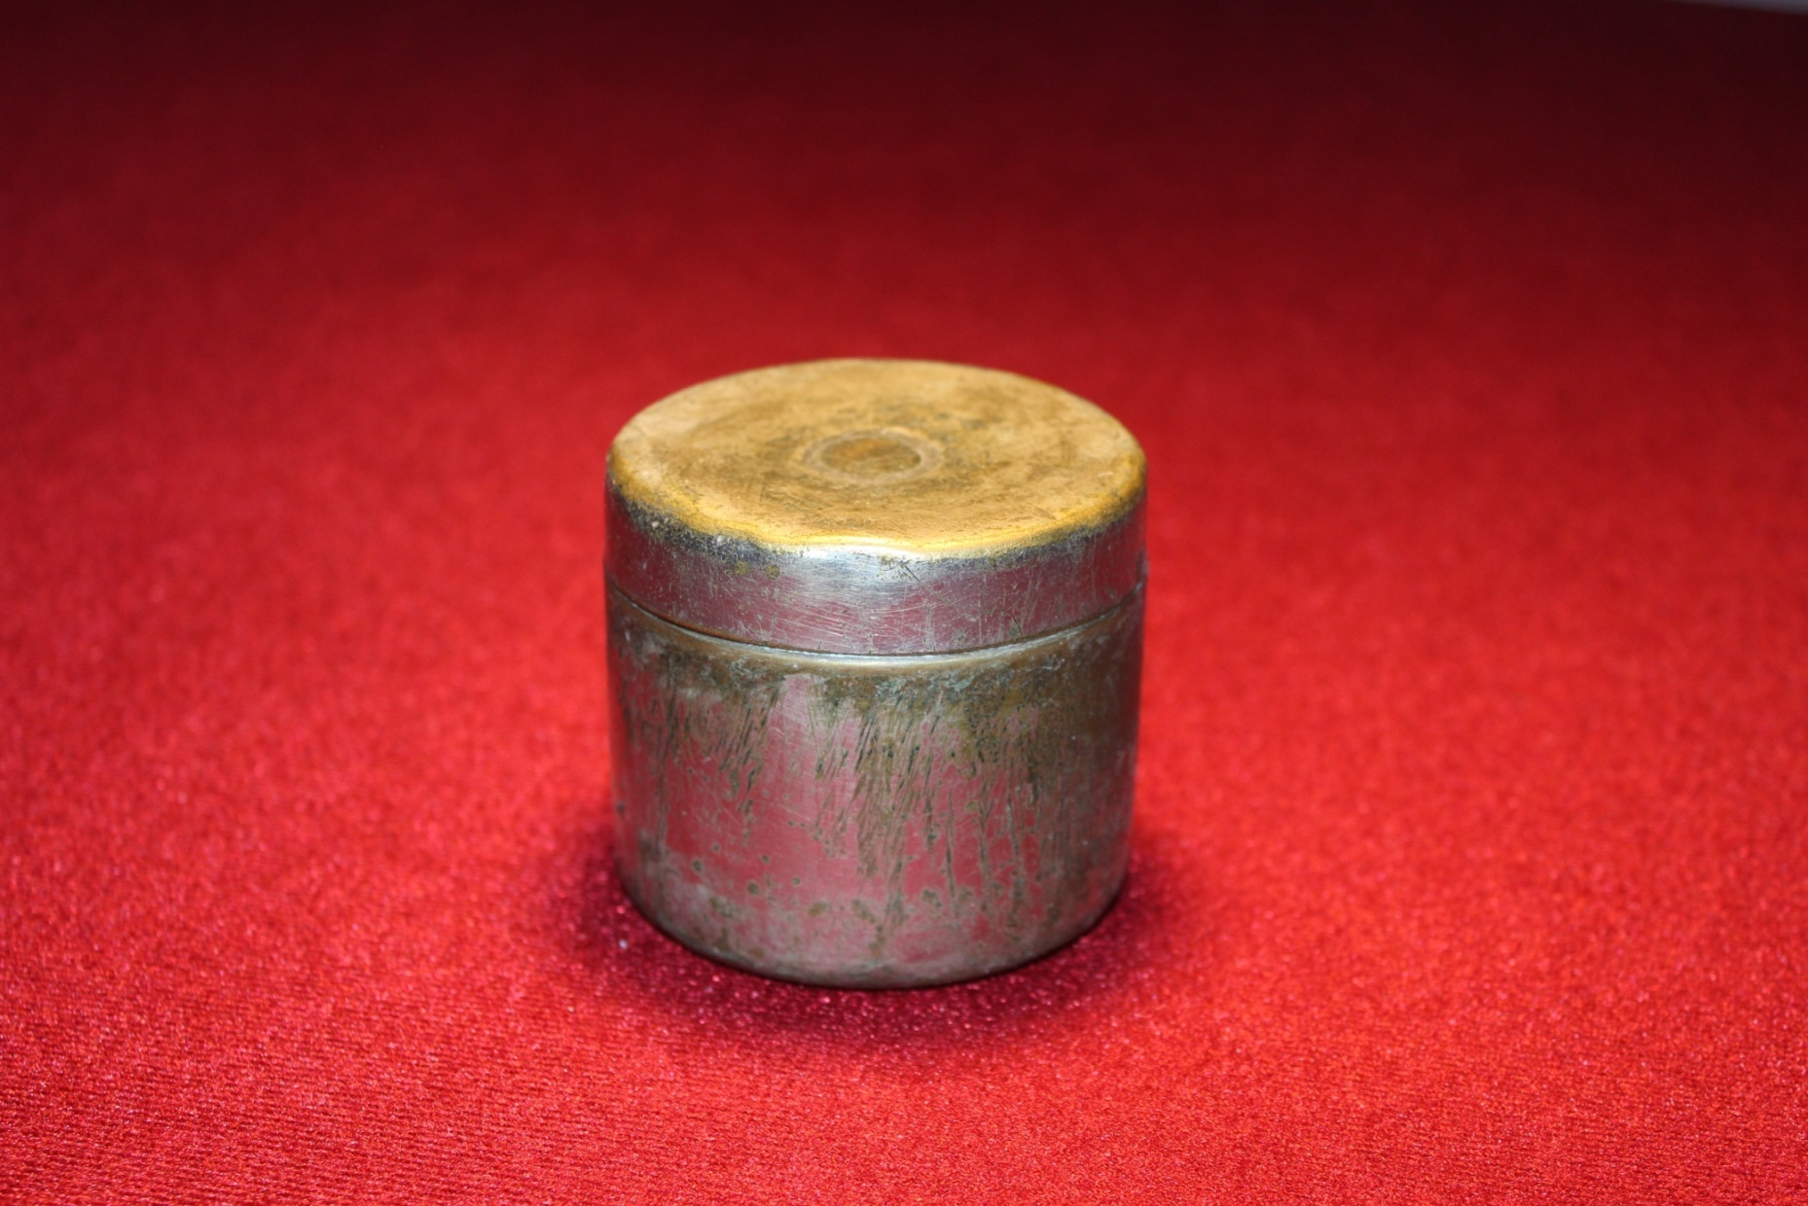
AND OLD COTTON BOX that we found from the auction

K KUTUSU

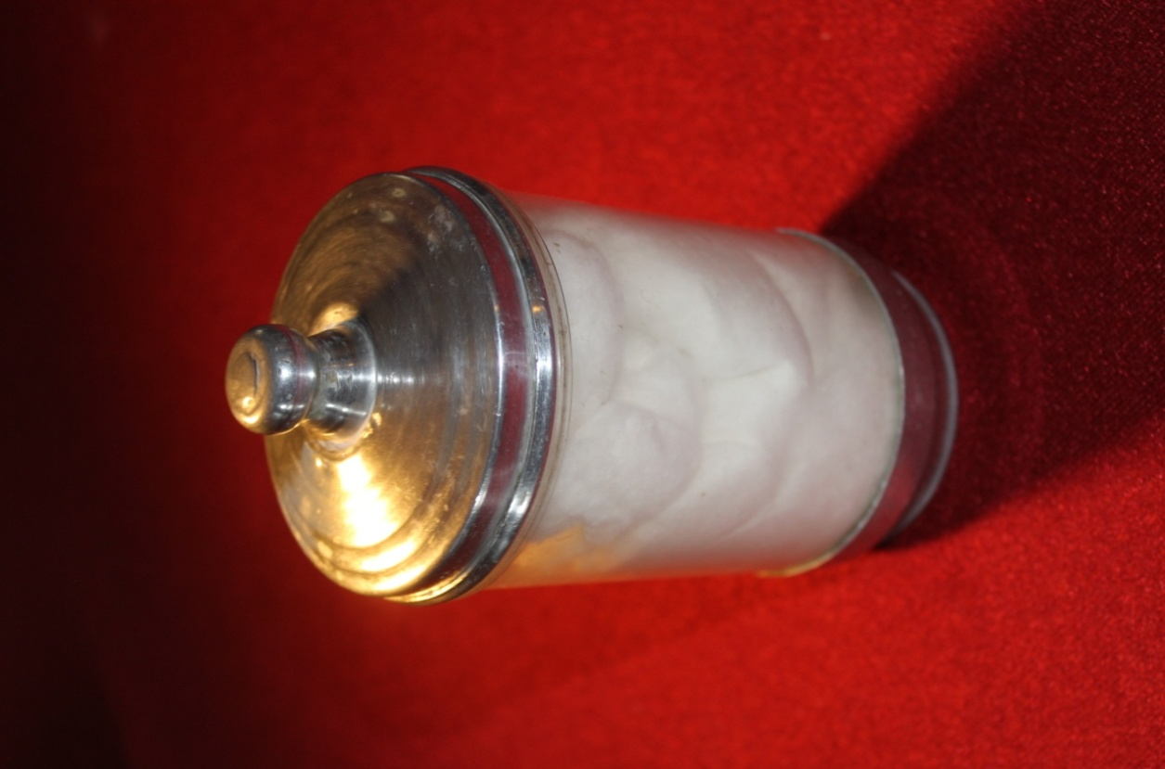

Cotton is a must material
for the barbers.

LEECH
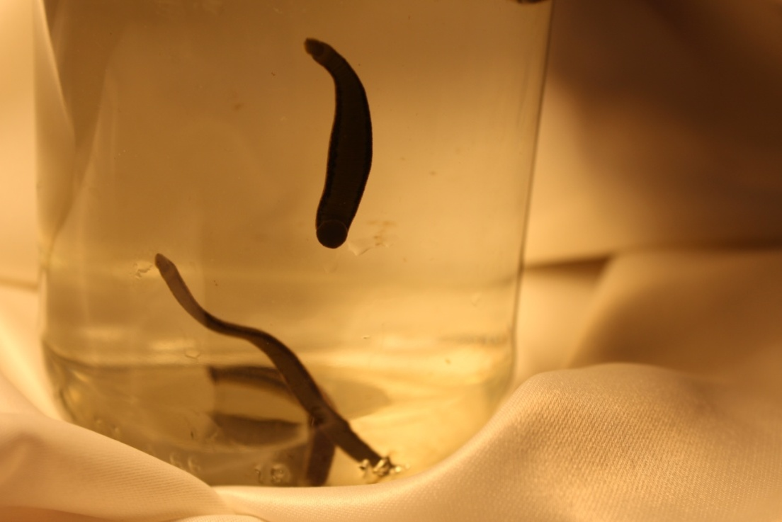
These cute friends used in alternative medicine are the regulars of our museum
Leeches known for their bloodsucking properties are fed by absorbing bad blood in the body. As you get rid of your bad blood, the leeches are full.
Of course, those who practice leech therapy are the barbers, who are former sanitarians.
Leeches are thought to be good for baldness.

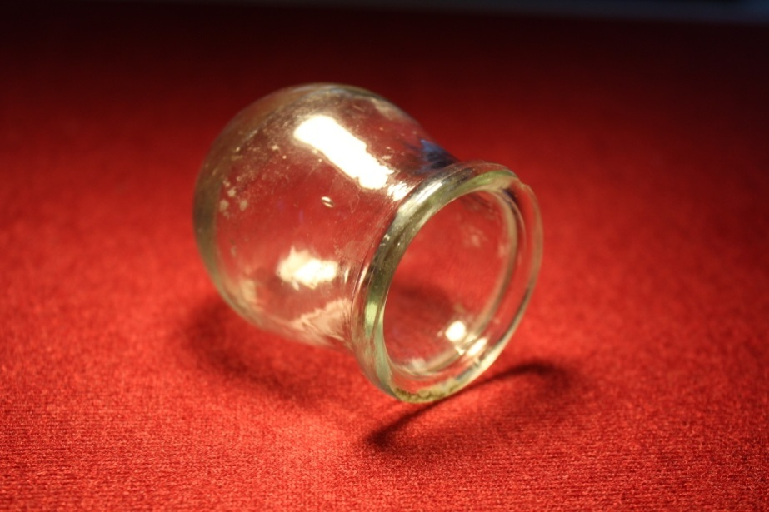
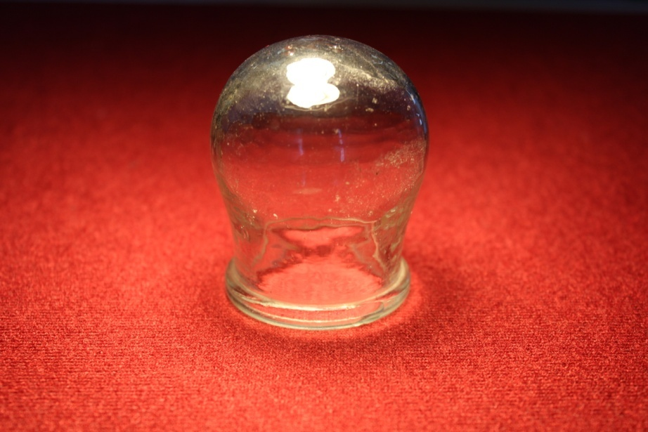
CUP
Another alternative medicine material, the mug is heated and held to the body.

SYRINGE

It is used to treat ingrown hair.
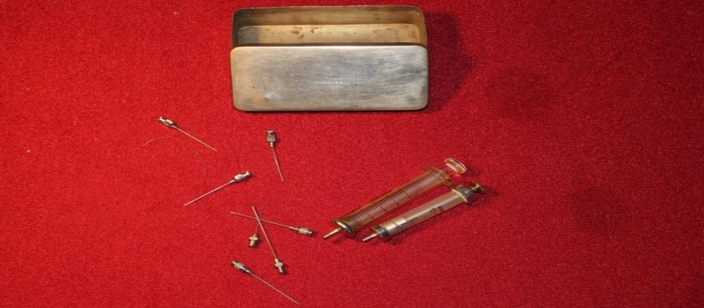
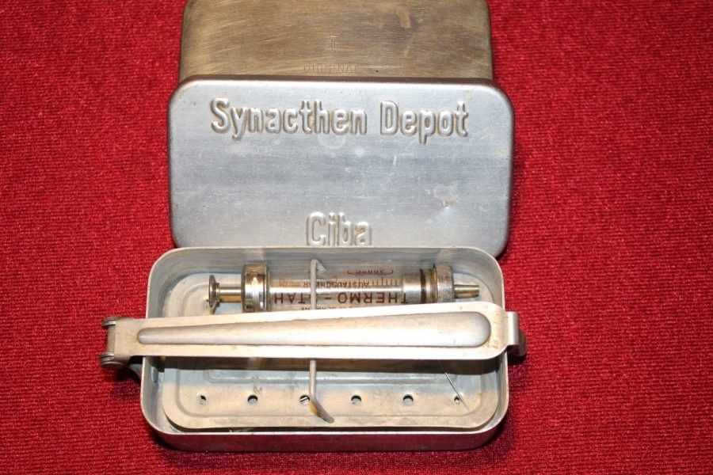
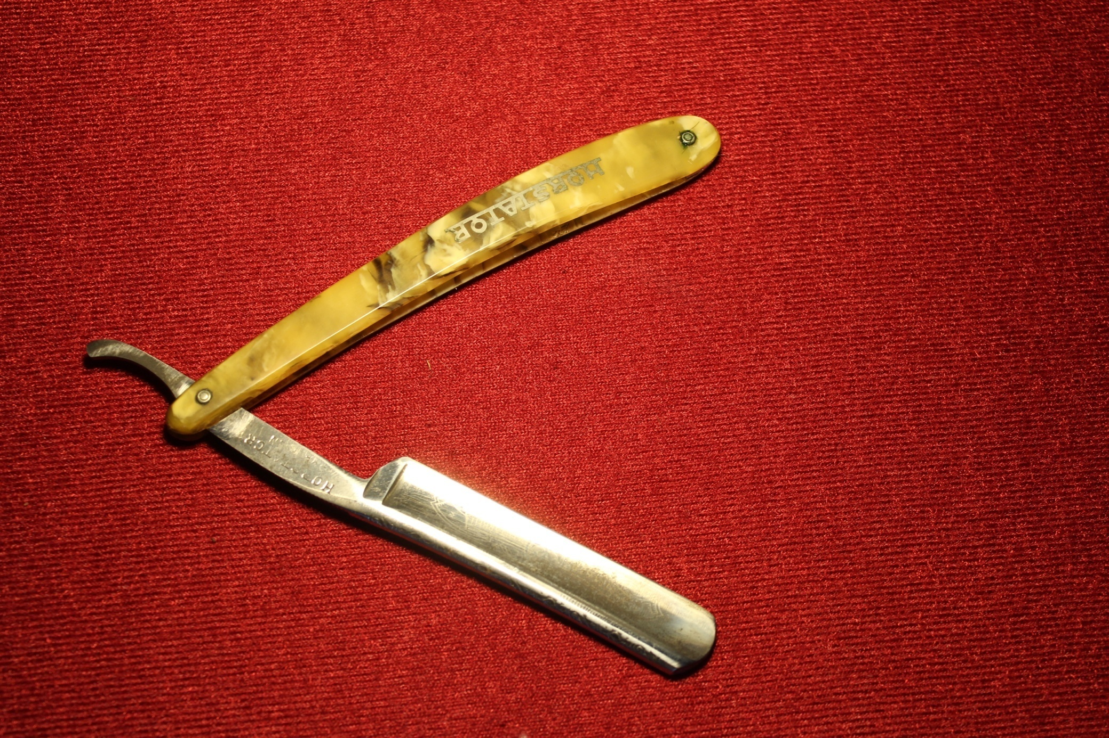
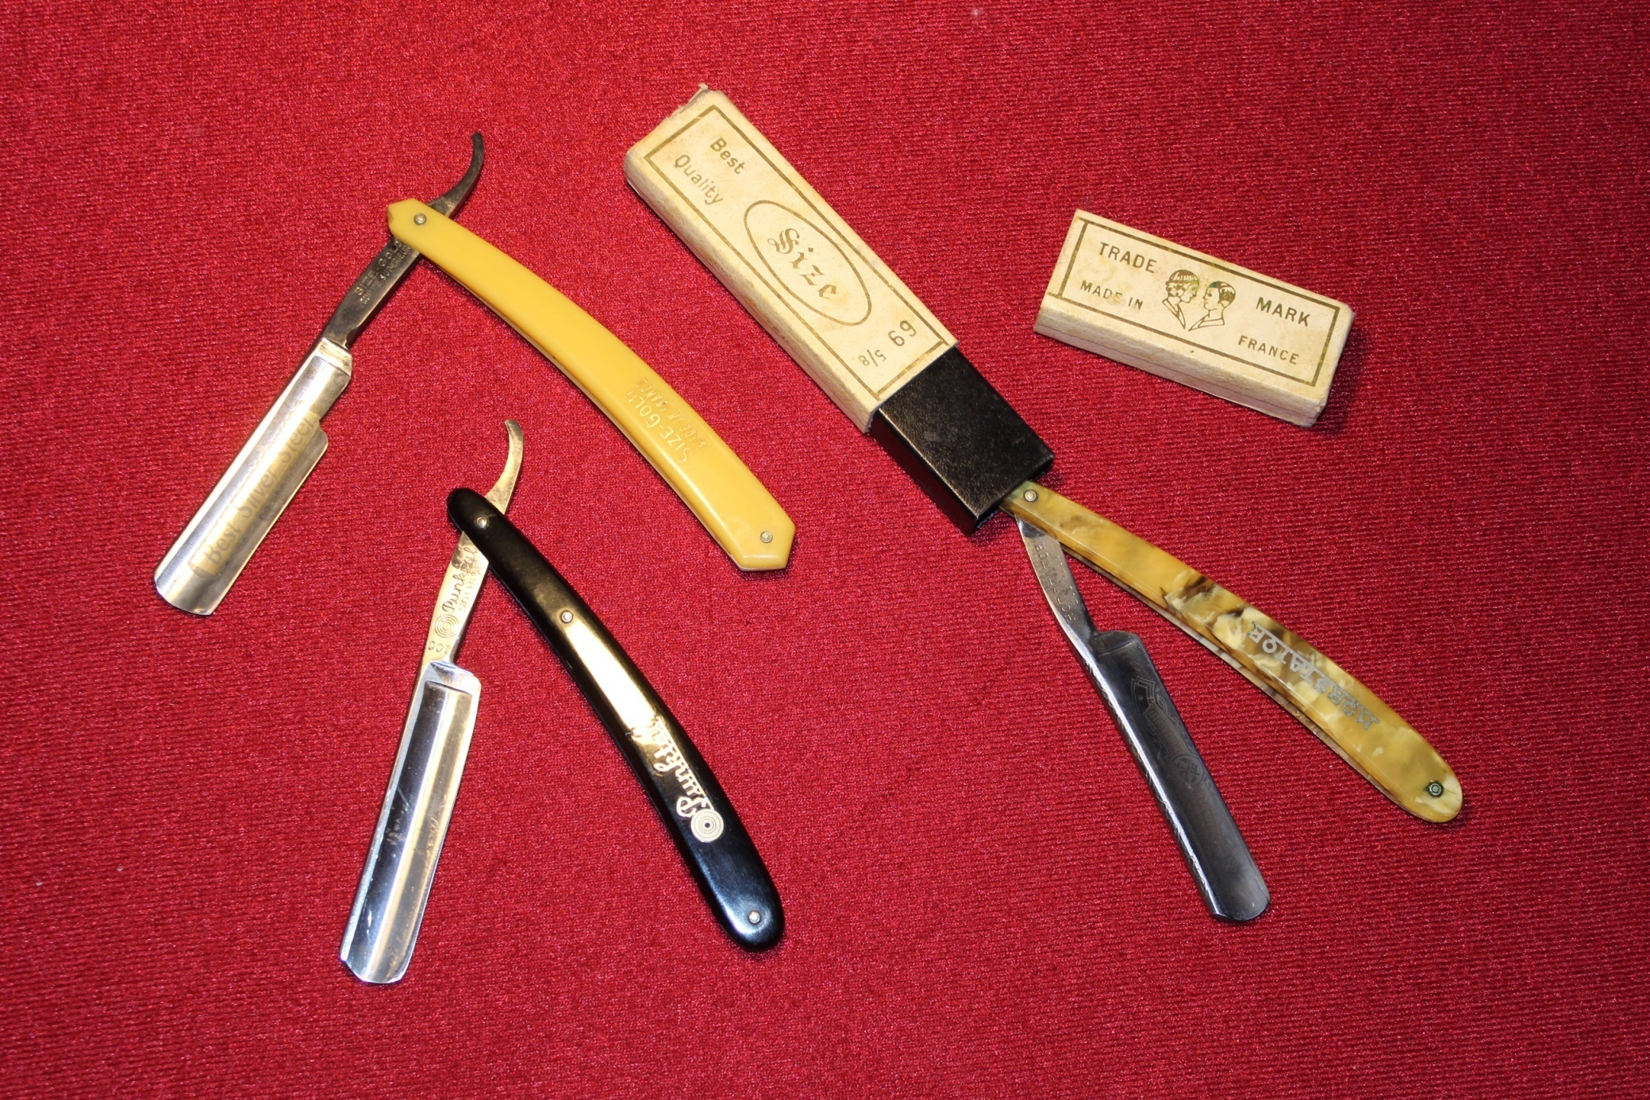
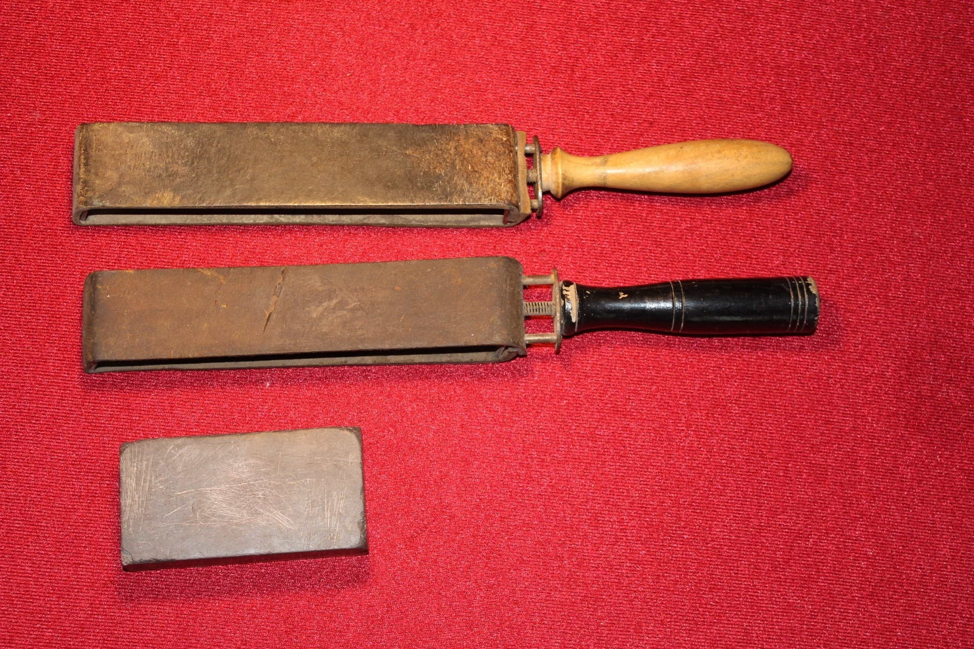
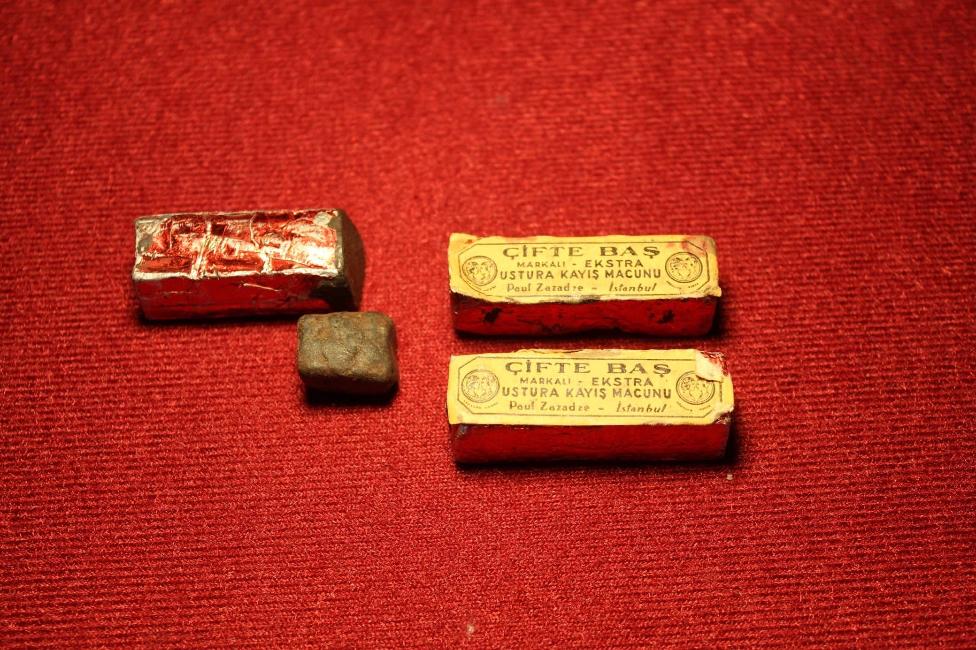
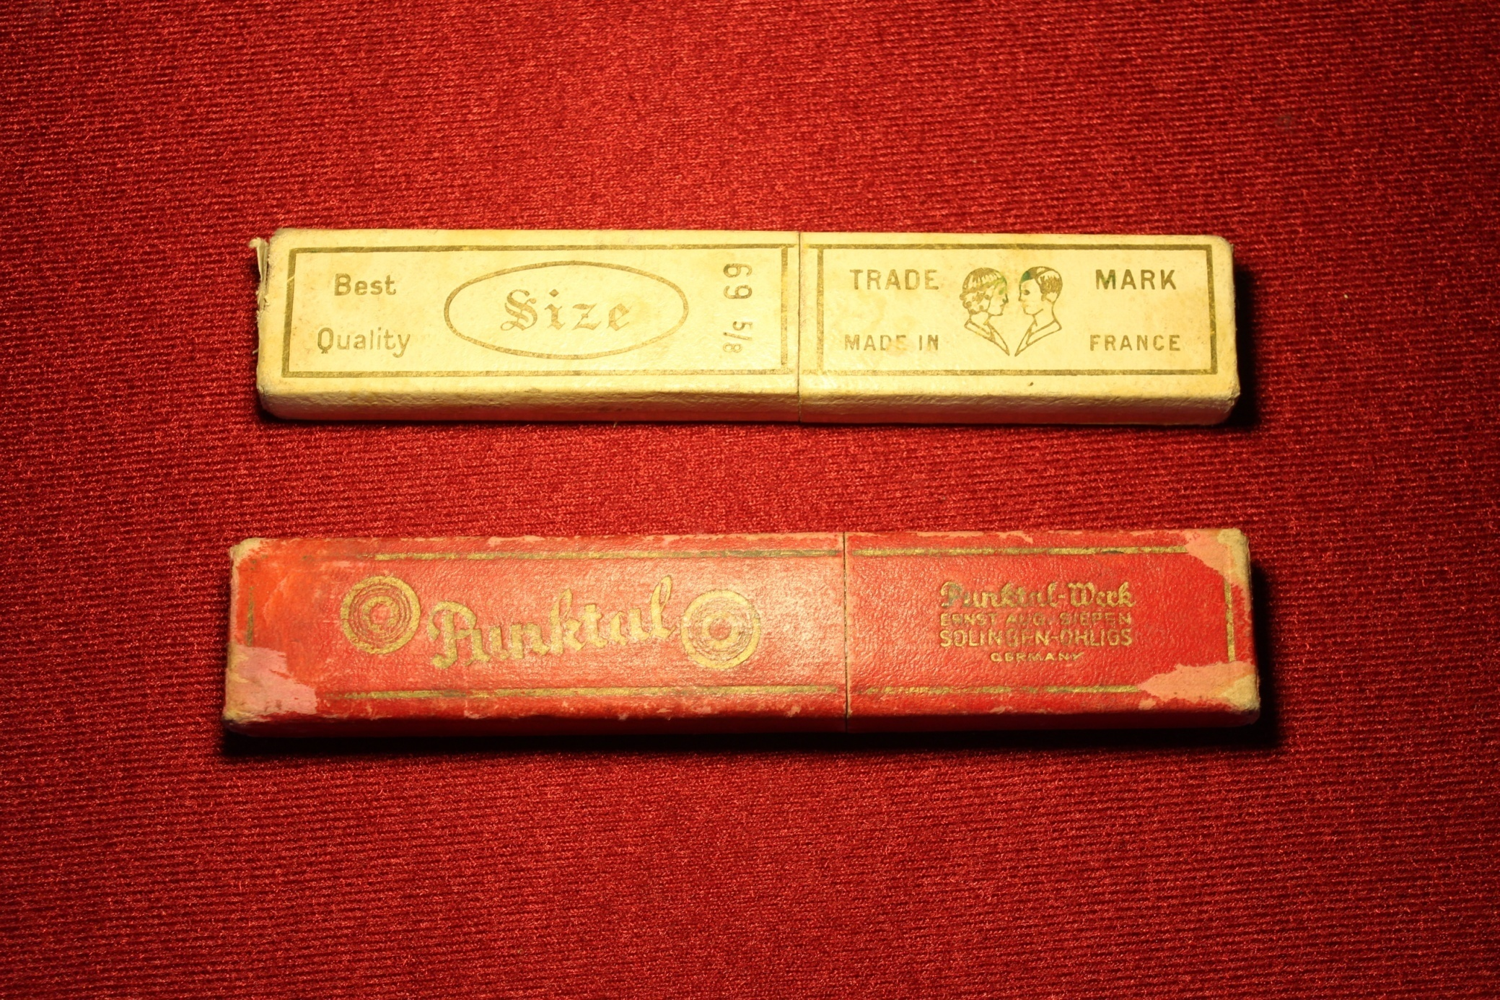
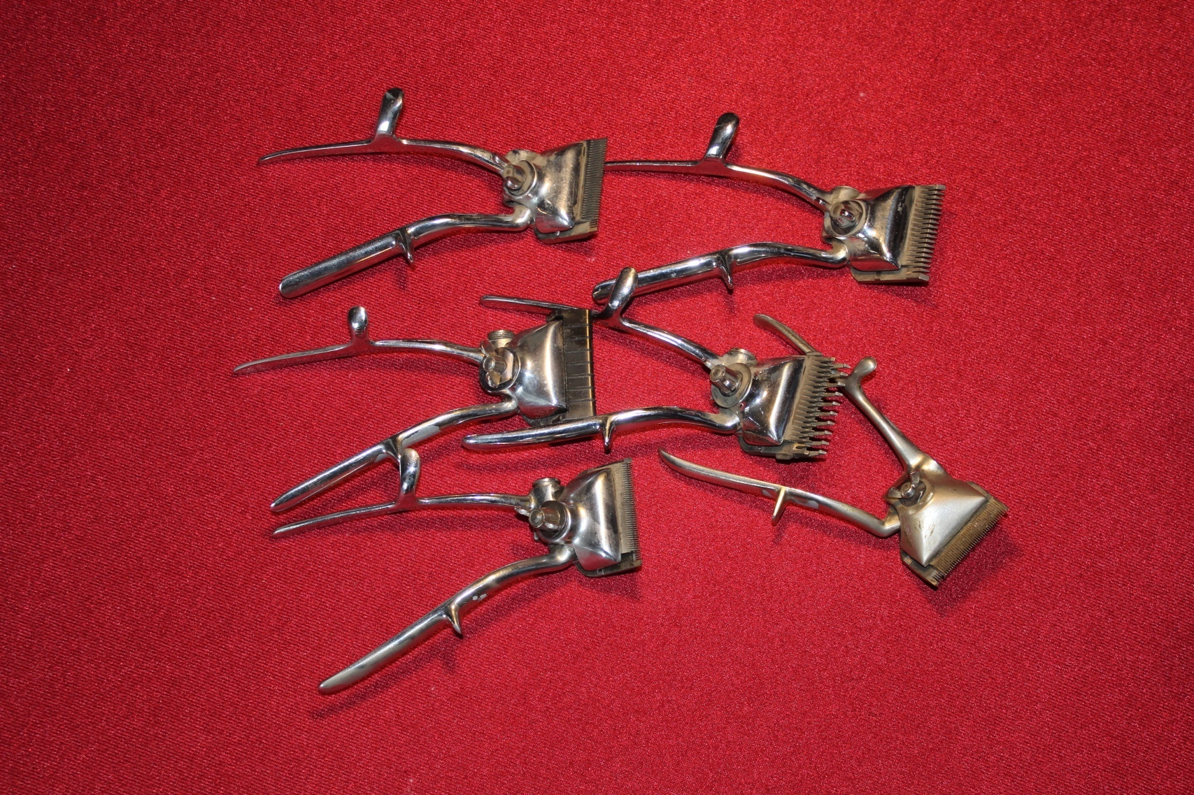
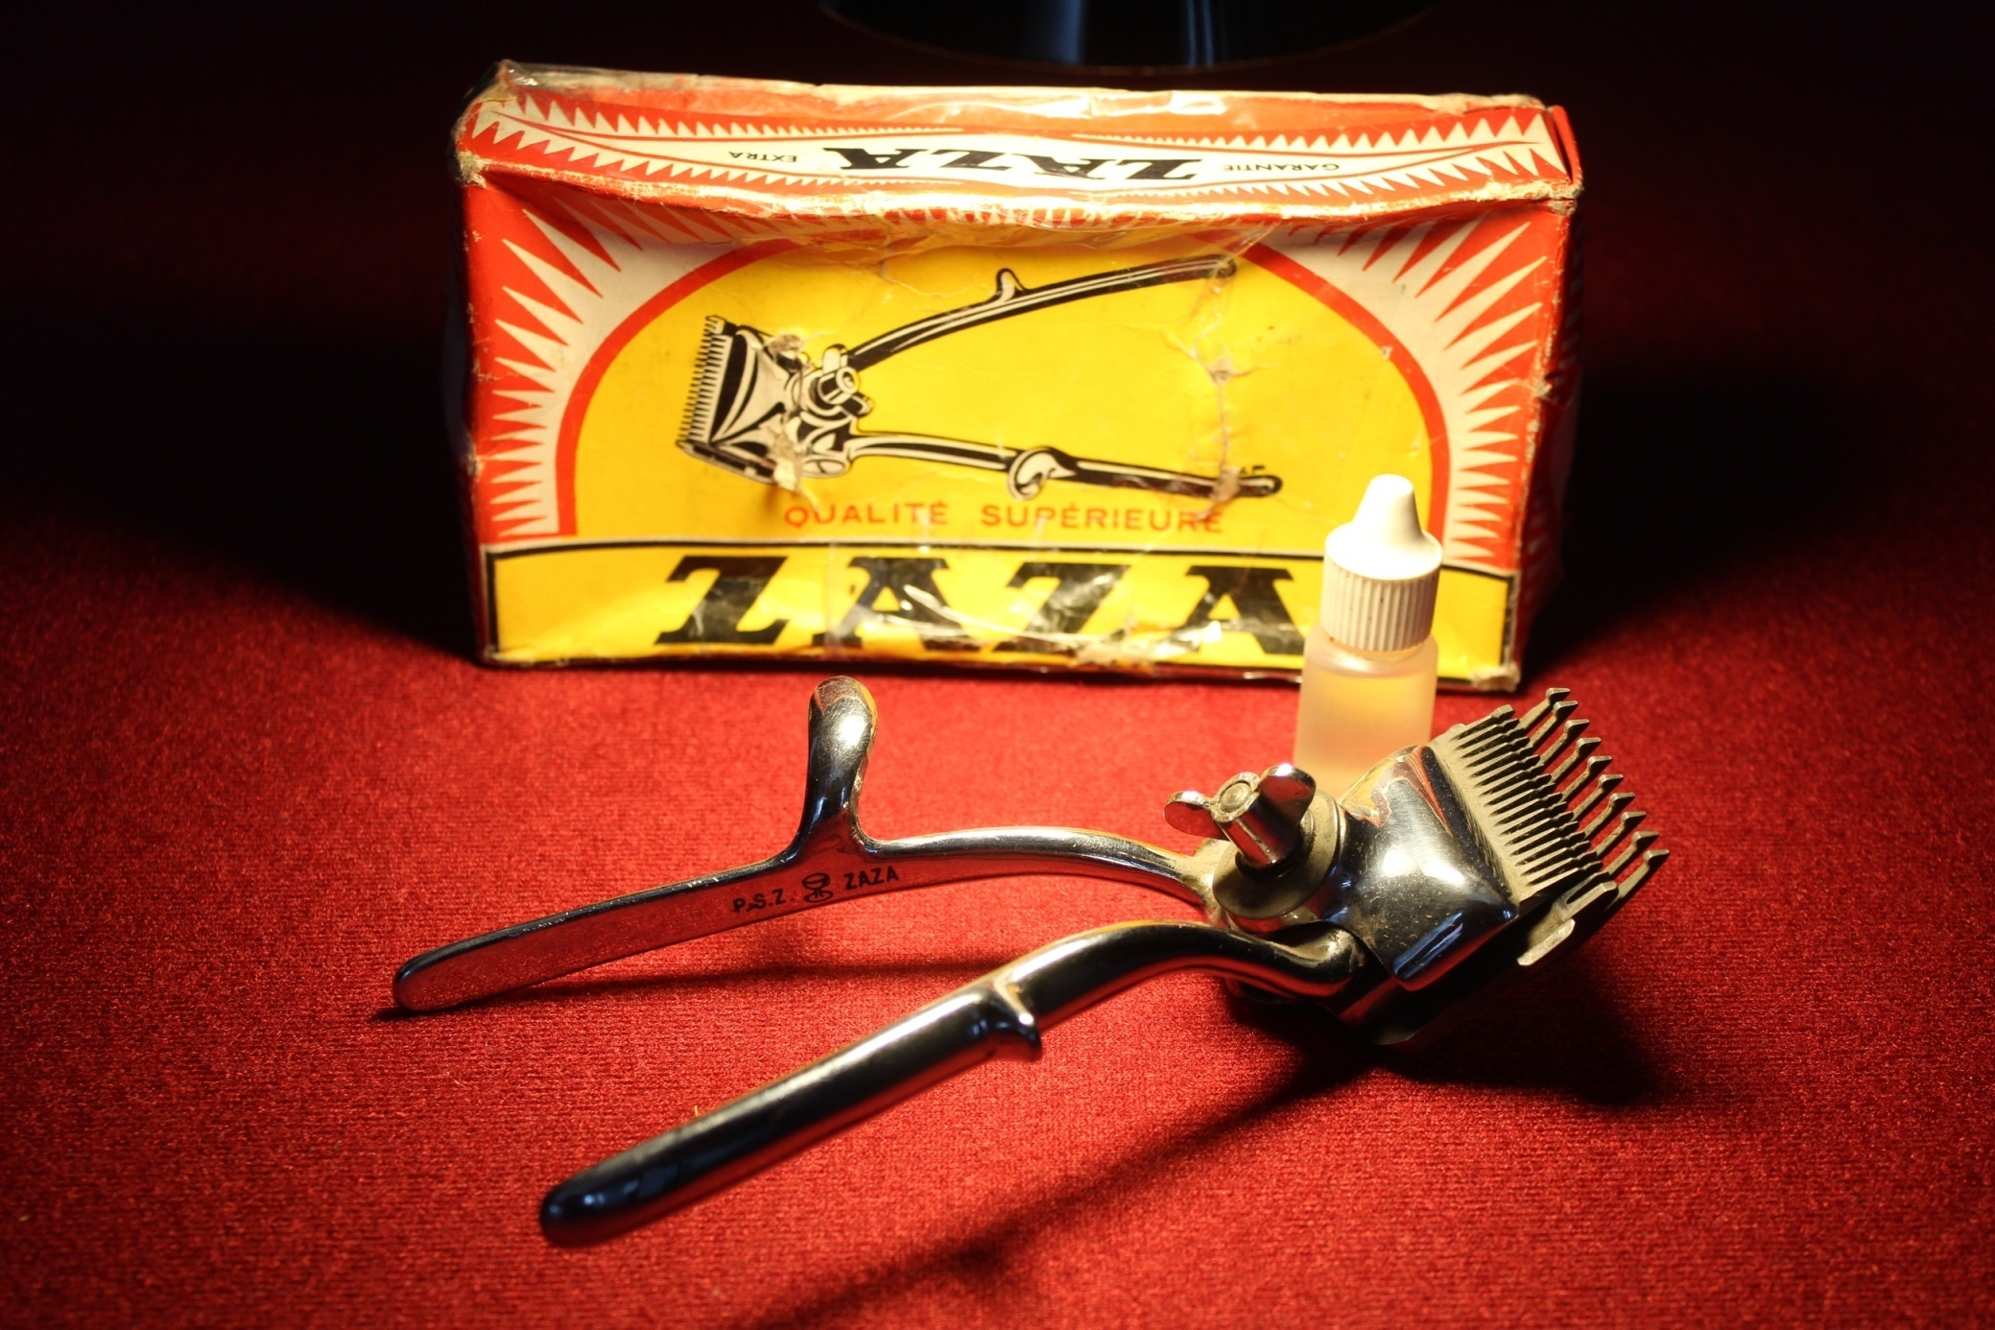
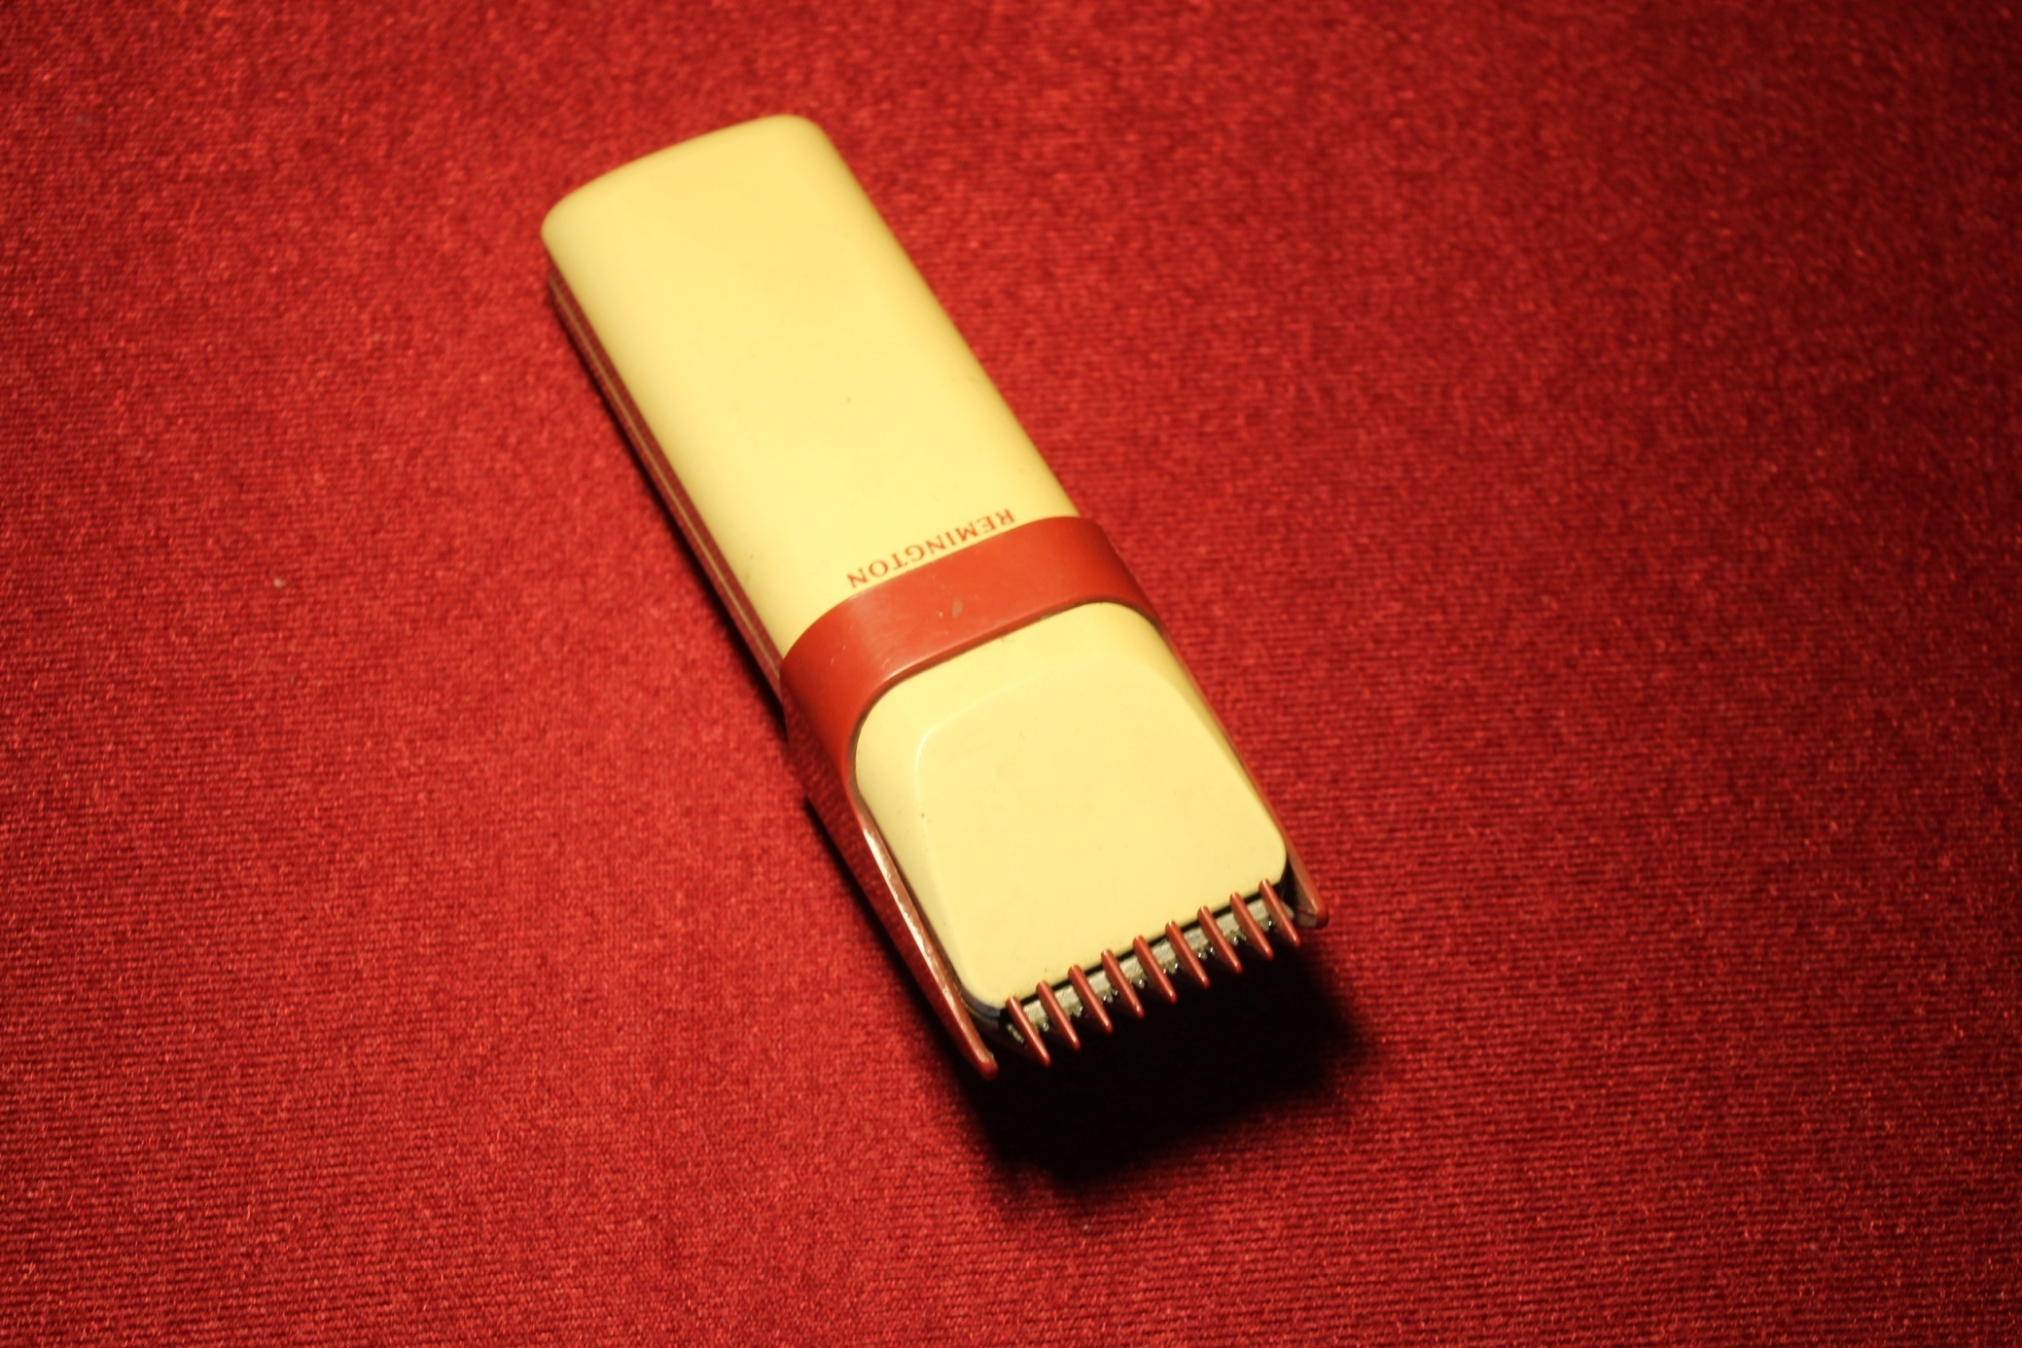

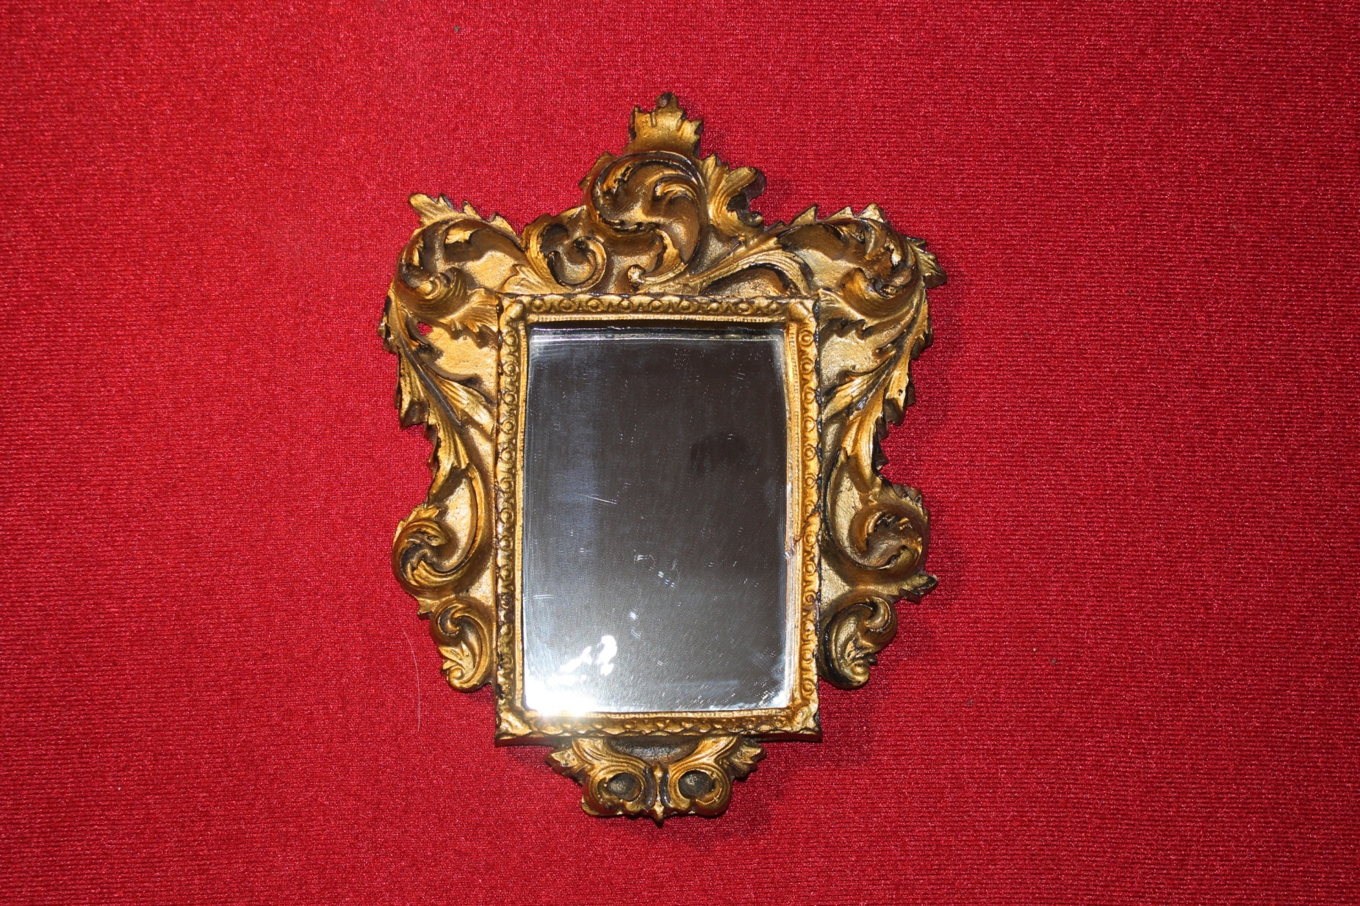
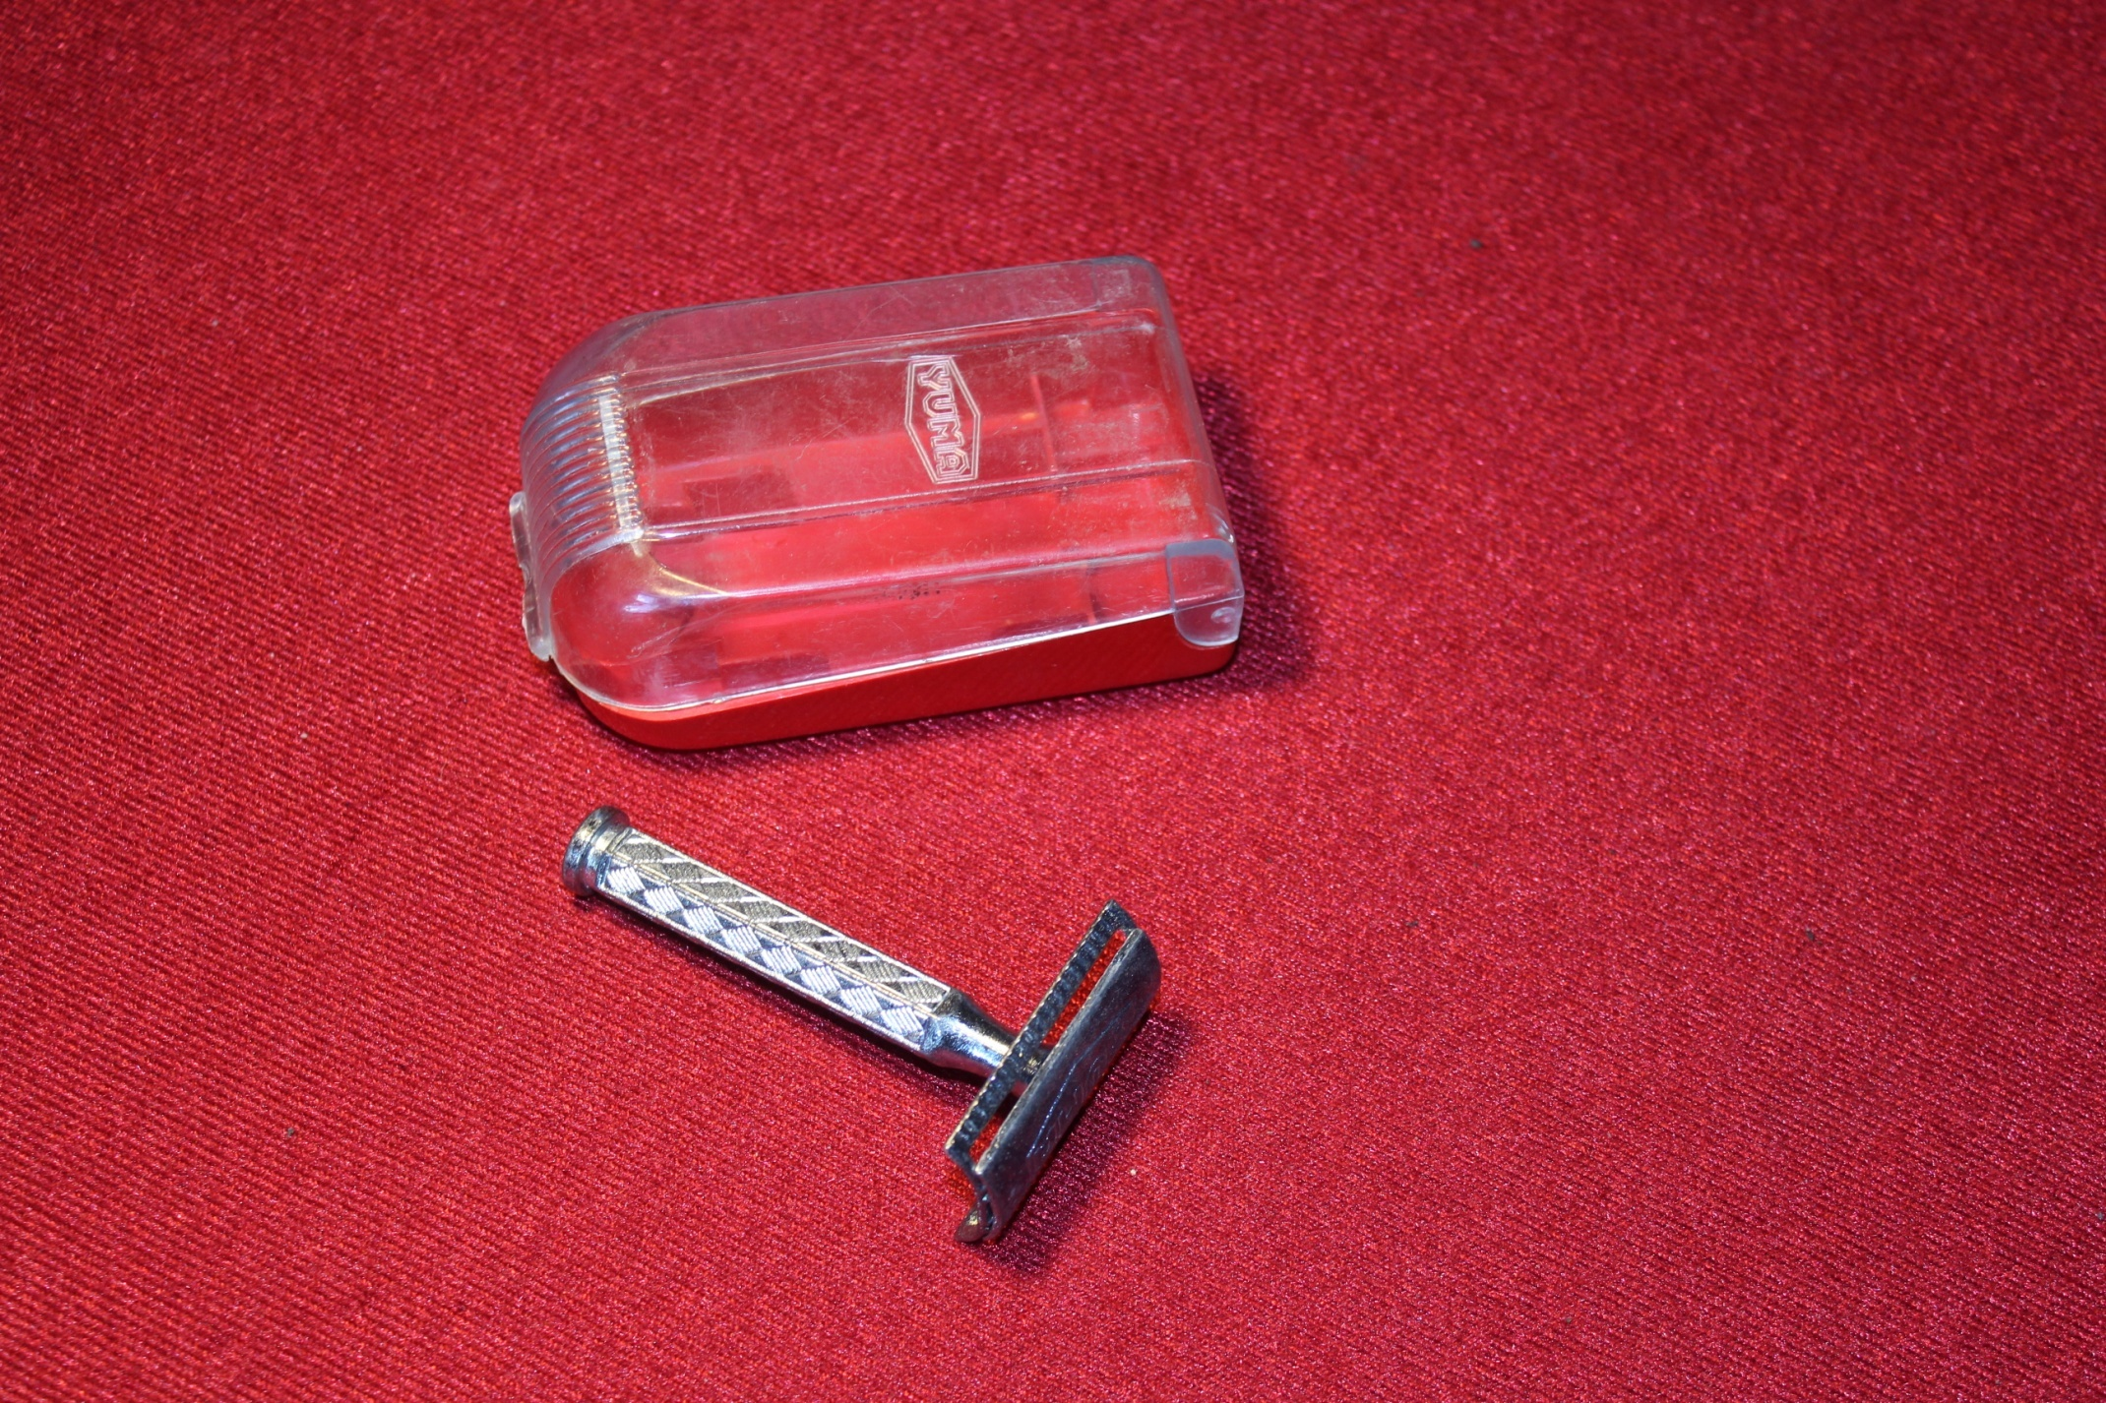
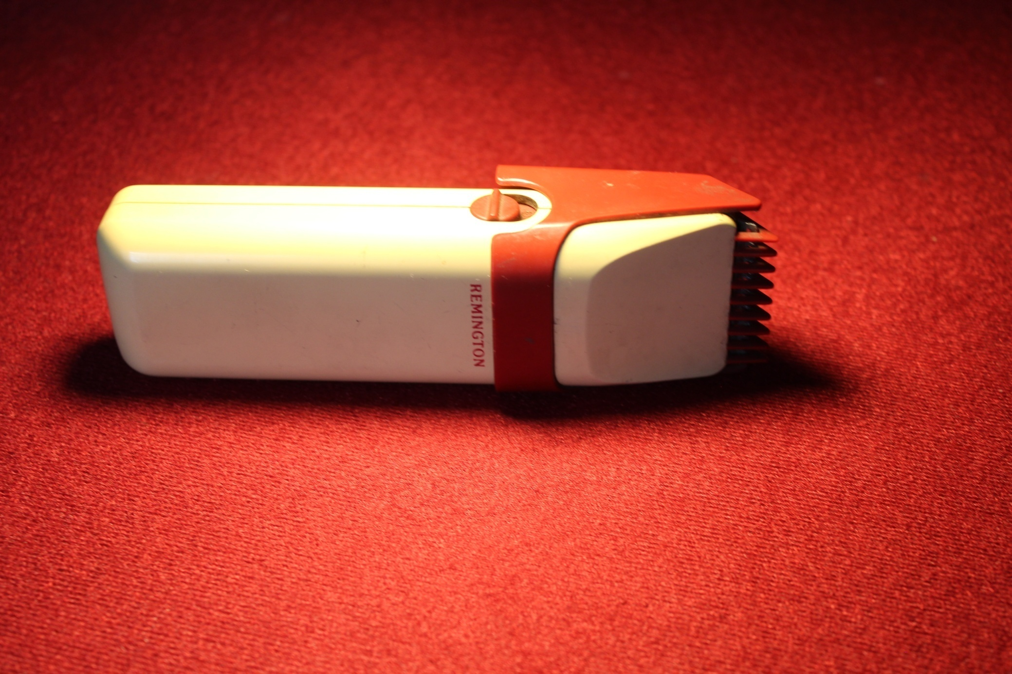

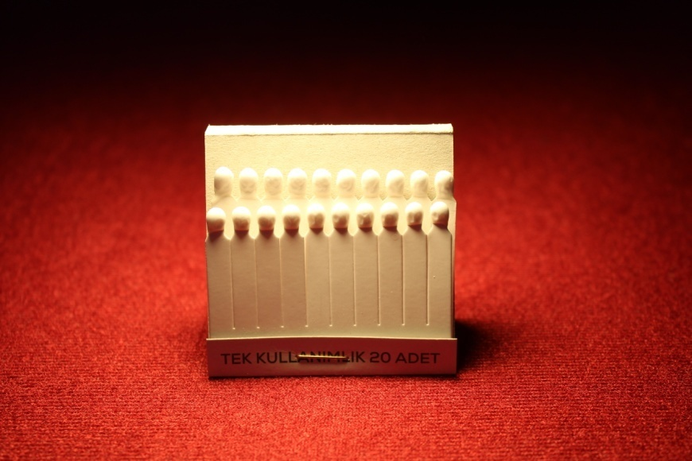
BLOODSTONE

The material used to stop blood.

