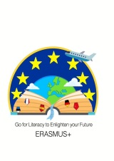

Estonia

Ask us where Estonia is or, even worse, what on Earth it is.
No, it’s not in the Middle East, has nothing to do with Albania, and is not spelled Astonia either. It is a country on the NorthEastern edge of the European Union about twice the size of New Jersey with six times fewer the residents, which means there are no traffic jams and you can enjoy our many forests and lakes without stepping over each other. If you really want to unnerve us, ask us if Estonia is part of the Russian territory.

Invade our country again.
Since 800 AD, we have been frequented by the Vikings, the Swedes, the Germans, the Danish, the Polish, and the Russians (we liked the Swedes the most). It is a miracle we still have our own traditions and language. So excuse us if we are proud of our national heritage or get annoyed when no one except five other people on the planet cares about us or knows anything about us at all. On second thought, it’s probably better this way.

Ask us if Estonia is as cold as Siberia.
No, we do not have polar bears and our climate is nothing like Siberia’s. Believe it or not, we do have short, yet beautiful summers when the sun barely sets, giving us close to 20 hours of daylight. Our winters are sometimes cold, but they can also be mild due to our country’s proximity to the Baltic Sea. What do you mean you have never heard of the Baltic Sea?

Confuse us with Finns.

We share common ethnic and language roots with Finland, and our wealthier neighbors to the North love taking weekend ‘booze cruises’ to Tallinn to stock up on cheap alcohol, occasionally wreaking havoc on our capital in the process. Still, we are not one and the same. Estonia and Finland have taken quite different historical paths, and to equate us would be offending (see points 1 and 2). While we have been exposed to many different cultures, Finns have been relatively isolated from outside influence and as such, are more quiet and reserved than we are (except for the ‘alkotourists’). If you really want to push it, confuse us with Latvians. Besides being our neighbor and a member of the Baltic states, Latvia has little in common with Estonia. It trails us in economic development, and its residents have six toes (not really, but this is a point for another article called “How to piss off a Latvian”). To better understand this complex geopolitical structure, think of it this way: Norway looks down on Sweden, Sweden looks down on Finland, Finland looks down on Estonia, and Estonia looks down on Latvia. So don’t confuse us with either.

Question our unshakable confidence in the fact that Estonia will someday, once again, win Eurovision.
2001 will forever be etched in our collective memory as the year we won Eurovision. And although we haven’t had good results since the times of MaarjaLiis Ilus, we stubbornly send our contestants year after year, because we are, after all, the Singing Nation. Question our ability to win again and you’re guaranteed to enter a hot debate. Mention that our nine placements in the Top Ten are still higher than what the other Baltic states, Latvia and Lithuania, can claim and you might just be redeemed.

Expect us to be friendly with you on the streets, at the restaurant, at the party where we just met.
We are polite and reserved. We don’t smile much, don’t talk to strangers, and never display our emotions in public. We keep to ourselves because we don’t want to impose on you. We will not approach you on the streets unless we are drunk, and will certainly not approach you in other social situations, because we are waiting for you to make the first move. The most extroverted of us look at your feet instead of our own when having a conversation. So don’t expect us to be anything other that what we are. Better yet, invest the time to get to know us. You will get to see our intimate side and may just get lucky to find a loyal best friend for lif

Tell us how slow we are or ask how far is the distance till Tallinn.
Those questions should really be addressed to the Finns. We have proven time and again that we are nothing like the ‘slow’ stereotype you gave us and this joke is getting old. We have become the world’s leaders in digital, mobile, and IT space, and have established fast free WiFi access points throughout the country just so you stop calling us ‘slow Estonians’.

Joke that Estonians have no sex and no future.

We have sex and we have a future. We just don’t use them in our language. We keep it simple so we can better focus on pronouncing words like “sünnipäevanädalalõpupeopärastlõunaväsimus.” Can you pronounce that? Thought so.
[taken from: https://matadornetwork.com]
Group 2: Travelling guide – Estonia 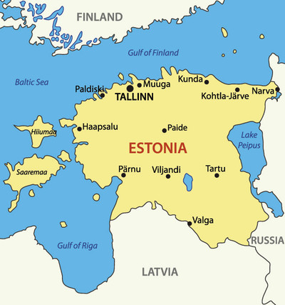
1. Read the text.
2. Every group member now deals with 2 paragraphs. Try to
derive some pieces of advice out of every paragraph what
you should do and what you shouldn’t do as a tourist in
Estonia.
3. Now write down your advice in the following list and create
a travelling guide out of all devices from the text.

Travelling guide Estonia
Do’s | Dont’s

