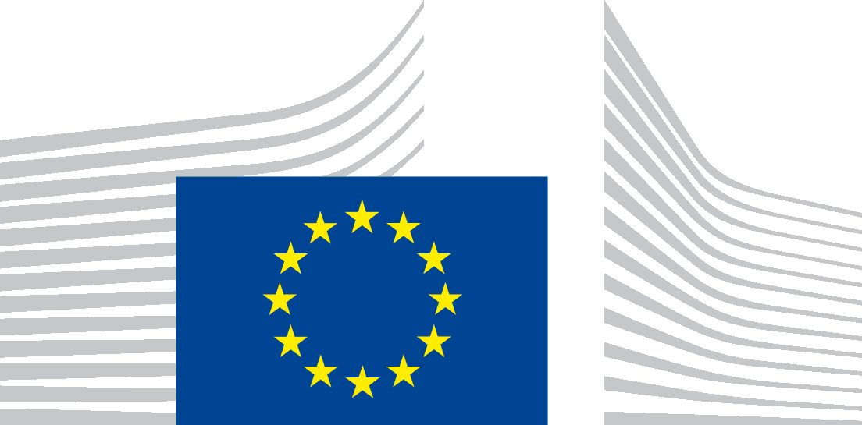 | EUROPEAN COMMISSION
London Representation
13 October 2016
The European Arrest Warrant
Your brief
The European Arrest Warrant (EAW) is an arrest warrant that operates in all Member States of the EU. It was created by Framework Decision (a type of EU legislative instrument no longer used since the Lisbon Treaty). Its official name is the Council Framework Decision 2002/584/JHA of 13 June 2002 on the European arrest warrant and the surrender procedures between Member States.

The question for the Mock Council is: "Following Brexit, should the UK be allowed to continue to be part of the European arrest Warrant system?"
NB – The UK delegation should consider whether the UK wants to continue to be part of the EAW system, and if so, why and how can this be achieved?

Background on the European Arrest Warrant:
A. EAWs replace extradition:
The EAW Framework Decision aims to improve and simplify judicial procedures to speed up the return of people from another EU country who have committed a serious crime. It replaced extradition proceedings within the European Union. Extradition proceedings could be very lengthy, sometimes taking up to 10 years. They were formal and involved a state asking another state for the return of a fugitive or someone who was wanted for trial. The EAW is issued by a judicial authority (judge or prosecutor) rather than by a state. The country hat issues the EAW is known as "the Issuing State". EAWs are addressed to another judicial authority in the state in which the wanted person is known to be; that country is known as "the Executing State".

B. EAWs have the following advantages:
The procedure is very quick – normally 30 days, sometimes up to 60 days, and exceptionally up to 90 days.
The procedure is simple – the authorities in the Issuing State do not have to produce any evidence of the offence. Under a system known as "mutual recognition" decisions of a judicial authority in one Member State are deemed equivalent to those of a judicial authority in another Member State, so no further checks are needed. NB In the UK – there has been "mutual recognition" between the judicial authorities of England and Scotland for 300 years, so that whilst the two countries have different legal systems, he recognise each other's arrest warrants, court judgments etc. This is the same idea as mutual recognition within the EU.
Requests can be processed quickly and efficiently, resulting in many more successful prosecutions than before and reflecting the higher numbers of people living and working in a country that is not their home Member State. Statistics for EAWs issued by the UK and executed by the UK can be found here.
The EAW requires each national judicial authority to recognise and act on, with a minimum of formalities and within a set deadline, requests made by the judicial authority of another EU country. A warrant asks for a person to be handed over so that:
- a criminal prosecution can be conducted;
- the person can be placed in custody or detention.
The warrant applies in the following cases:
- offences punishable by imprisonment or a detention order for a maximum period of at least 1 year;
- where a final custodial sentence has been passed or a detention order has been made, for sentences of at least 4 months.
C. Proportionate use of the EAW
EU countries must take the following into consideration (non-exhaustive list):
- the circumstances and the gravity of the offence;
- the likely sentence;
- less coercive alternative measures.
An EAW must only be used when it is proportionate to do so, so they cannot be used for very minor offences. In some cases, they have been used for e.g. theft of a map rom a motorway service station or theft of a bicycle. These case shave been criticised and the countries that used the EAW disproportionately have now agreed to reduce their use to more serious cases.
When an individual is arrested, he/she must be informed of the contents of the arrest warrant.
In what cases must EU countries refuse to act on a warrant?
- If an EU country has already handed down a final judgment on the person concerned for the same offence.
- If the offence is covered by an amnesty in the EU country asked to hand over the perpetrator.
- If the person concerned may not be held criminally liable by the EU country asked to act on the warrant, owing to his/her age.
A 2011 European Commission report found that the European arrest warrant was very successful in helping EU countries fight crime, but that several areas could be improved.
For further information, see European arrest warrant on the European Commission’s website.

D. EU legislation to safeguard the rights of people subject to an EAW
1) Directive 2010/64/EU on the right to translation and interpretation in criminal proceedings; (Official Journal L 280 of 26.10.2010, pp. 1-7).
2) Directive 2012/13/EU on the right of subjects to be informed of their rights; (Official Journal L 142 of 1.6.2012, pp. 1-10).
3) Directive 2013/48/EU on the right to have access to a lawyer and the right of persons in custody to communicate with family members and employers. (Official Journal L 294 of 6.11.2013, pp. 1-12).

E. EFTA/EEA countries
Ever since the EAW entered into force, there have been discussion between the European Commission and Norway, Iceland and Switzerland about extending its use to those countries. After lengthy negotiations, Norway and Iceland have been accepted into the EAW system. The legislation is in place as of 2016, but the technical details are still being worked out.
http://icelandmonitor.mbl.is/news/politics_and_society/2016/05/31/iceland_joins_european_arrest_warrant/

The discussions with Switzerland are still ongoing. Because it relies on a system of mutual trust, the EAW can only apply in countries that are signatories of the European Convention of Human Rights. There is now a substantial body of EU legislation on defence rights (see D above) and in order for the EAW to apply, the European Commission considers that only countries that comply with EU standards on procedural safeguards should be eligible to use the EAW.
Document prepared by European Commission , London Representation.
For further help or information contact:

- The NGO Fair Trials works on EAW cases and is able to help people who are wrongly the subject of an EAW. Alex Mik, Campaigns and Communications Manager with Fair Trials has kindly agreed to help with the project and may be contacted for assistance by delegations. Alex.mik@fairtrials.net Tel: +44 (0)20 7822 2370
For further information on a specific country please contact the relevant Embassy.

