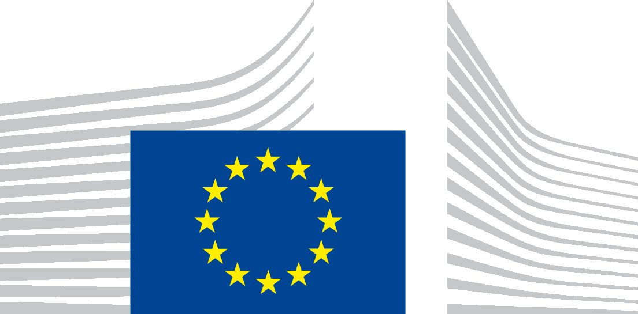 | EUROPEAN COMMISSION
London Representation
25 October 2016
The Erasmus+ Programme
Your brief

The question for the Mock Council is: "Following Brexit, should the UK to continue to be part of the Erasmus+ Programme? If so, why and how could this be achieved?"

WHAT IS ERASMUS+?
Erasmus+ is the EU's programme to support education, training, youth and sport in Europe. Its budget of €14.7 billion for 2014-2020 will provide opportunities for over 4 million Europeans to study, train, gain experience, and volunteer abroad.
You can find out more about the programme and its key figures here: https://ec.europa.eu/programmes/erasmus-plus/about_en and read more about the objectives and background of the programme in the Programme Guide Part A, p 7-12: http://ec.europa.eu/programmes/erasmus-plus/sites/erasmusplus/files/files/resources/erasmus-plus-programme-guide_en.pdf
What is the difference between the former Erasmus and the current Erasmus+ programme?

Erasmus used to be a self-standing programme to support the exchanges of higher education students and staff. However, as of 2014 Erasmus has been integrated into a new programme called Erasmus+ which brings together seven formerly existing educational programmes under a single umbrella. These include:

- The Lifelong Learning Programme (Erasmus, Leonardo da Vinci, Comenius, Grundtvig and Jean Monnet);
- The Youth in Action programme;
- The Five international cooperation programmes (Erasmus Mundus, Tempus, Alfa, Edulink, the programme for cooperation with industrialised countries);
- And the new sport action programme
WHO CAN BENEFIT FROM IT?
Erasmus+ provides opportunities for individuals (students, staff – teaching, staff – training, trainees, young people, and youth workers) and for organisations (education and training providers including schools education, further and higher education, adult education, the youth sector, think thanks, research and private businesses etc.).
You can find out more about the opportunities here: https://ec.europa.eu/programmes/erasmus-plus/about_en
and here: https://www.erasmusplus.org.uk/what-can-i-do
WHAT DOES IT SUPPORT?
In order to achieve its objectives, the Erasmus+ Programme implements the following Actions:
- Key action 1 – mobility of individuals: aims to encourage the mobility of students, staff, volunteers, youth workers, and young people. Organisations can arrange to send or receive students and staff to or from participating countries, as well as organise teaching, training, learning and volunteering activities.
- Key action 2 – cooperation for innovation and the exchange of good practices: is designed to develop the education, training, and youth sectors through five main activities.
- Key action3 – support for policy reform: aims to increase the participation of young people in democratic life, especially in discussions with policy makers, as well as developing knowledge in the fields of education, training, and youth.
- Jean Monnet activites: opportunities for teaching, research, and policy debate on the EU and its policies.
- Sport: designed to develop and implement joint activities to promote sport and physical activity, identify and implement innovative activities in the field of sport, and manage not-for-profit events to increase participation in sport.
You can find out more about the actions here: https://ec.europa.eu/programmes/erasmus-plus/organisations_en and in the Programme Gide Part A, p 13-15: https://ec.europa.eu/programmes/erasmus-plus/organisations_en
WHO CAN TAKE PART?
The eligibility of individuals and organisations depends on the country in which they are based. The programme differentiates between two main groups of countries:
1. Programme countries: These can take part in all actions of the Erasmus+ programme. They include all EU member states and five non-EU countries: the Former Yugoslav Republic of Macedonia (FYROM), Iceland, Liechtenstein, Norway and Turkey. All non-EU programme countries provide a financial contribution towards Erasmus+.
2. Partner countries (or third countries): These can only take part in certain actions of the programme, and are subject to specific criteria or conditions. They cover the rest of the world and are divided roughly into 12 geographically coherent "regions". Most of these countries do not contribute financially to the programme, but are funded through instruments related to other policies such as development cooperation or policies for the European Neighbourhood. These funding instruments have a much broader remit than education and are only very partially used for Erasmus+. Please note that in addition special limits, rules and conditions may apply for individual countries. The participation of partner countries is funded by the European Union.
You can find out more about the Programme and Partner countries here: https://ec.europa.eu/programmes/erasmus-plus/about_en (Tab: Who can take part) or in the Programme Guide Part A, p 21-24 http://ec.europa.eu/programmes/erasmus-plus/sites/erasmusplus/files/files/resources/erasmus-plus-programme-guide_en.pdf
You can find information about the financial contribution of EEA and EFTA countries to EU programmes here: http://www.efta.int/eea/eu-programmes
You can also read about Norway’s financial contribution to EU programs here: https://www.regjeringen.no/en/topics/european-policy/Norways-relations-with-Europe/financil-contribution/id684932/
HOW IT IS MANAGED?
The actions of the Erasmus + programme are divided into decentralised actions and centralised actions.
- The centralised actions are managed at a European level by the Education, Audiovisual and Culture Executive Agency (EACEA) located in Brussels: http://eacea.ec.europa.eu/erasmus-plus_en
EACEA is in charge of the complete life-cycle management of projects, from the promotion of the programme, the analysis of the grant requests, the on-the-spot monitoring of projects, up to the dissemination of the projects' and programme's results.
- The decentralised actions are managed in each programme country by National Agencies that are appointed by their national authorities.
The Commission provides funding to the National Agencies, who use these funds to manage the programme's "decentralised" activities. This allows the Agencies to adapt the programme to suit their national education, training, and youth systems.
The Erasmus+ UK National Agency is a partnership between the British Council and Ecorys UK.
You can find out more about the program’s management here: https://ec.europa.eu/programmes/erasmus-plus/about_en (tab: How is it managed?) and you can visit the Erasmus+ UK website: https://www.erasmusplus.org.uk/
You can find statistics about the UK’s participation and received grants from the programme here: https://www.erasmusplus.org.uk/statistics-0
You can find the Erasmus+ country factsheets and further studies and charts here: http://ec.europa.eu/education/resources/statistics_en
http://ec.europa.eu/dgs/education_culture/repository/education/library/statistics/2014/united-kingdom_en.pdf

ADDITIONAL READING:
Please note that the views expressed in these articles may not reflect the position of the European Commission. They are solely included to offer a wider background on the topic.
You can read about the possible outcomes for the Erasmus+ after the Brexit referendum; and you can also find out more about the case of non-EU programme and partner countries such as Norway and Switzerland here: http://www.eua.be/Libraries/publications-homepage-list/after-the-brexit-referendum-possible-outcomes-for-horizon-2020-and-erasmus
You can learn about to extent to which UK sport organisations benefited from ERASMUS+ here: http://eose.org/2016/09/erasmus-and-the-uk-sport-sector-the-chance-to-collaborate-and-learn-is-the-real-benefit-of-this-eu-funding-programme/
Follow Ministers questioned on the implications of leaving the EU:
https://www.parliament.uk/business/committees/committees-a-z/commons-select/science-and-technology-committee/news-parliament-2015/leaving-the-eu-ev3-16-17/

Document prepared by European Commission , London Representation.
For further information on a specific country please contact the relevant Embassy.

