URBAN GAME „Po Biłgoraju”

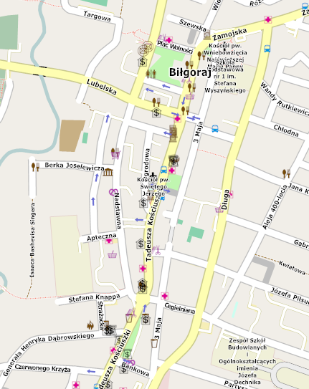
5
8
7
6
4
3
1
2.

1. Father Jan Twardowski Primary School No.5 in Biłgoraj START / FINISHING-LINE
Time: 120 mins
Route: about 3100 m
2.
- What is the name of the park ? ………………………………………………………………………………………………………………..…………………
- How many monuments are there in the park ? ………………….…………………………………………………….………………………………..
- Count the wooden houses at Kopernika Street ……………………………….………………………………………………………………………….
3.
- What is the name of the park on the south and the east of the church of św. Jerzy ( saint George ) ? ……….................
- Which tree species dominates in the part of the park by the Singer’s bench ?……………………………………………….………..…
- How long did Isaac Bashevis Singer live for ?.................................................................................................................
4.
- To whom the bench in front of the Biłgoraj Cultural Centre is dedicated ? …………………………………………………………………
- When the monument was created ? ……………………………………………………………………………………………………………………………
- Who is the author of the monument? ………………………………………………………………………………………………….…………………….
5.
- What year the monument designed by Lech Kwieciński was unveiled and consecrated ? ………………..…………………….
- The faithful from the parishes in which places were the donors of the monument ? ………………………………………………….
- How many major donors have sponsored the monument ? ……………………………………………………………………………………….
- From the plaque at the Plac Wolności ( Freedom Square ) read where are the sources of the river ‘STOK’ ? …………………………………………………………………………………………………………………………………………………………………………………….
6.
- The oldest of Biłgoraj’s monument is located in the fence of the church. What year is it from?………………………………..
- How many of the murdered, whose names are on the plaque on the front wall of the church, came from Biłgoraj ? ………….…………………………………………………………………………………………………………………………………………………………………………
- Rewrite all the surnames beginning with the letter J and N from the plaque of those murdered on July 4, 1944 by the Nazis ……………………………………………………………………………………………………………………………………………….………………………….
…………………………………………………………………………………………………………………………………………………………………….………………
………………………………………………………………………………………………………………………………………………………………………..…………..
- How many tanks are there on the fresco inside the church depicting the burning of Biłgoraj ? ……………………………......
7.
- At the junction of which two streets is there Zagroda Sitarska ? ( Sitarska Farm )………………………………………………..………
- How many stone stairs lead to the door of the building ? (door through the porch ) ………………………………………………….
- How many windows are there in the north wall of the building ? ……………………………………………………………………………….
8.
- From the mid-19th century to the 60’s of the 20th century, the popular female name in Poland was MARIA . The common Polish male name since the 18th century is Jan. Rewrite other frequently used names from other countries located by the larch trees.…………………………………………………………………………………………………………………………….
…………………………………………………………………………………………………………………………………………………………………………………………..

